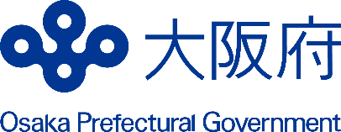
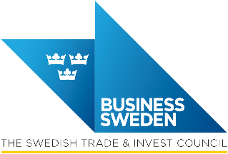
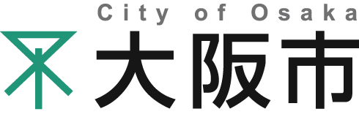

Memorandum of Understanding on Promotion of Economic Exchanges between
The Swedish Trade & Invest Council (Business Sweden),
Osaka Prefectural Government, and City of Osaka

The Swedish Trade & Invest Council, the Osaka Prefectural Government, and the City of Osaka hereinafter referred to individually as “Participant” and collectively as the “Participants”, with a view to developing economies of their regions by advancing economic exchanges in mutual respect and good faith, and by deepening their mutual understanding and friendly ties, have reached the following recognition:

The Participants collaborate in both regions within sustainability and innovation, more specifically within the ﬁelds of life sciences, startups, smart manufacturing, robotics, automation, energy efficiency and other fields to bring about mutual beneﬁts on the basis of reciprocity.

1. The Participants will promote the creation of new business opportunities by mutually offering information on economic policies and industrial trends of respective regions, and providing the concerned information to enterprises, etc.

2. The intended collaboration includes
2.1 To promote economic exchanges between the two regions in the designated fields, which can include providing information on facilities receiving an economic delegation consists of respective government agencies, economic organizations, or enterprises so that the delegation’s purpose will be efﬁciently achieved.

2.2 To provide information that will facilitate activities, such as delegations, trade fairs, business meetings and investment surveys, for enterprises based in both regions.

2.3 To provide possible support, such as consultation services and referrals to appropriate agencies, when enterprises based in both regions invest in the other region.

This Memorandum is not exclusive and does not create any legally binding obligations on the Participants.
Each Participant will bear its own costs in carrying out the purposes stated herein.

All Coordination and information exchange activities outlined in this Memorandum will be determined by the following organizations:
-For the Swedish Trade & Invest Council, reg under the laws of Sweden, having its principal office at Klarabergsviadukten 70, P.O. Box 240, SE 101 24 Stockholm, Sweden.
-For the Osaka Prefectural Government, International Business and Start-up Support Division, Growth Industry Promotion Office, Department of Commerce, Industry and Labor.
-For the City of Osaka, International Relations Department, Business and International Promotion Division, Economic Strategy Bureau.
The Participants will pursue the development of specific exchange projects through ongoing dialogue and regular review and shall convene annually (online or in-person) to identify and pursue strategic opportunities and collaborative activities aimed at strengthening business development and innovation capabilities within the areas outlined herein.
This Memorandum will be continued for one year from the date of signature and may be extended another two years, if the consensus of the Participants to do so is reached three months prior to the discontinuation of the initial term by written notiﬁcation.

In witness whereof, the undersigned representing the Participants hereto have executed this Memorandum by signing the English and Japanese versions in Osaka, on October 10, 2025. Each Participant will retain one copy of the English and Japanese originals, and all texts are equally authentic.

Signed and Dated: October 10, 2025

Vice President
APAC, Business Sweden
Sweden

Mr. Emil Akander
Director General
Department of Commerce, Industry and Labor
Osaka Prefectural Government, Japan

Mr. BABA Hiroyuki
Director General
Economic Strategy Bureau
City of Osaka, Japan

Mr. OKAMOTO Keiji

