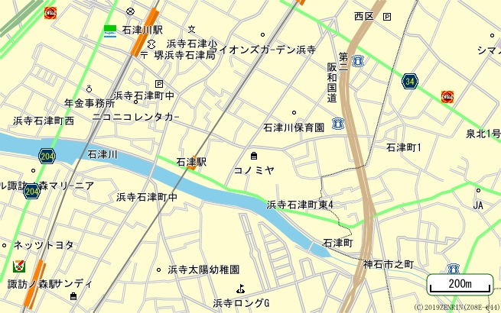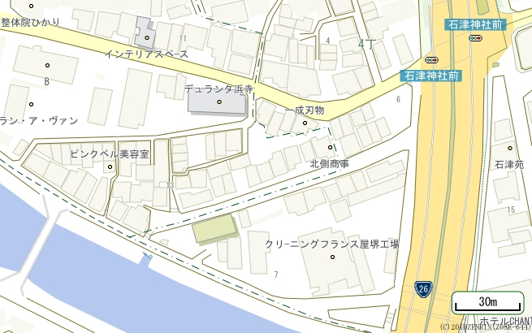

|  |  |  |
| --- | --- | --- |
| 物件番号 | **１** | **（１）位　置　図** |
| 広域図 | | |
|  | | |
| 詳細図 | | |
|  | | |