**Osaka Prefectural Schools Online Application System Manual (2024)**

Login（First Login） 2

Login（2nd and Subsequent Logins） 6

Password Notification 7

My Page 9

Logout 11

Change Password 12

Change EMail Address 14

Register Applicant Information 16

Register Face Photo 20

Register Application Information (Junior high School) 25

REGISTER APPLICATION INFORMATION (High School) 29

REgister Application information (School for Needs education) 33

Payment of application fee and admission fee 36

Download the admission ticket 45

How to download and print the admission ticket 47

Announcement of successful applicants (junior high School) 51

Announcement of successful applicants (High School) 53

How to attach a file 56

Login（First Login）

# STEP１

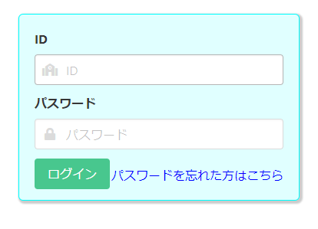

When you scan the QR code of the document "My Page Guide" distributed by your school with your smartphone or PC, the browser will open and the screen where your ID and temporary password are entered will be displayed, so press the login button.

* Please do not forget your ID.

* If you register the URL in the "Favorites" of the browser, it will be easier to access the online application system.

ンライン出願システムへの接続が簡単になります。

# STEP２

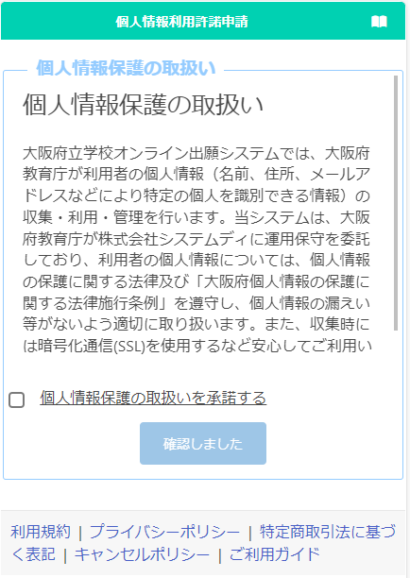

Read the description regarding personal information protection, check "I agree", and press the "Confirmed" button.

# STEP３

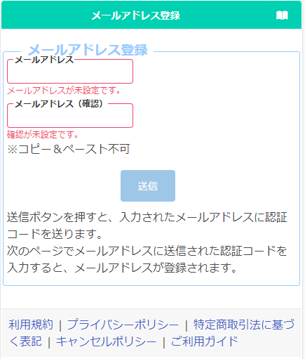

Register an email address to receive the verification code.

Enter your email address in "E-mail address" and "Confirm" and press the send button.

# STEP４

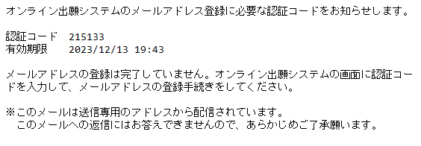

You will receive a verification code from  
 info@osaka-online-app-mail.schoolengine.jp  
to the email address you entered in Step 3.

When you log in to the system, the two-step verification screen will be displayed. Enter the verification code (6 numbers) in the email and press the register button to complete the registration of your email address.

* If you have set up a spam filter, please designate the domain @ osaka-online-app-mail.schoolengine.jp as legitimate.

* If you do not receive the verification code after a few minutes, please check your spam folder. If it is not in your spam folder, please contact the call center.

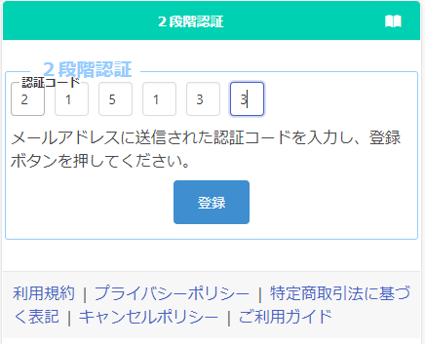

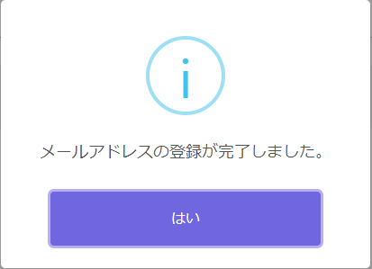

# STEP5

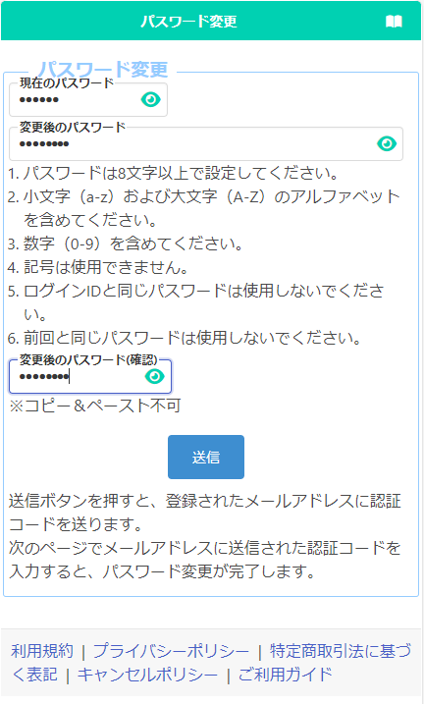

Register a new password.

In the "Current Password" field, enter the temporary password listed in the "My Page Guide" document distributed by your school.

Enter the new password in "Changed Password" and "Confirm Changed Password".

* The input content is displayed with ●, but you can check the input content by pressing the button 　　　.

When you're done, press the submit button.

A verification code will be sent to the email address you entered in Step 3.

The two-step verification screen will be displayed, so enter the verification code in the email and press the register button to complete the password change.

* Please do not forget the password after the change.

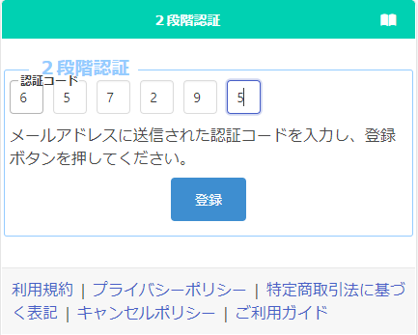

# STEP6

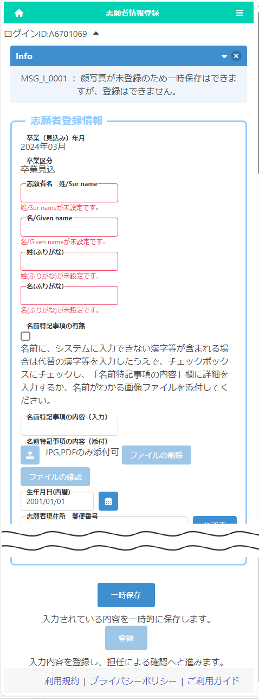

When the "Applicant Registration" screen appears, enter the applicant's surname and given name in kanji or alphabet, phonetic name in hiragana or katakana, and date of birth, and press the temporary save button at the bottom of the screen. (These items must be registered first.)

* Please enter the name of the applicant as it appears on the certificate of residence.

* The name of the applicant entered here will be written on the admission ticket.

* If the applicant's name is in English, please enter it in half-width alphabets, and enter phonetic name in full-width katakana.

* If the name contains kanji that cannot be entered, please enter its alternative kanji and save it temporarily.

* If your name contains kanji that cannot be entered, please refer to "Registration of Applicant Information".

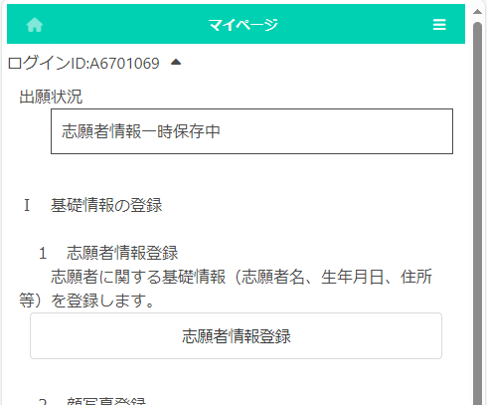

When the temporary save is completed, the My Page screen is displayed. The next time you log in, you will start from the display of the My Page screen.

Login（2nd and Subsequent Logins）

# STEP１



When you read the QR code of the document "My Page Guide" distributed by your school with your smartphone, PC, etc., the browser will open and the screen with your ID and temporary password will be displayed. You need to enter your new password and press the login button.

If you proceed from "Favorites" on the browser with your smartphone, etc., enter your ID and password and press the login button.

# STEP 2



When the login is completed, the My Page screen will be displayed.

Password Notification

# STEP１

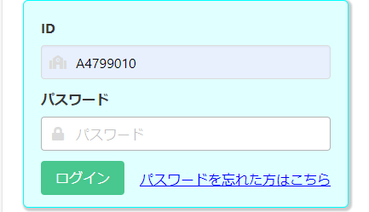

If you have forgotten your password, select "Forgot your password?" on the login screen.

# STEP２

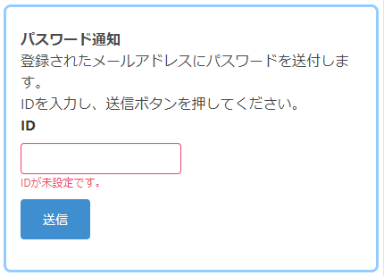

When the password notification screen is displayed, enter your login ID in [ID] and press the send button.

# STEP３

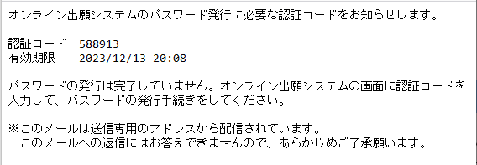

　A verification code will be sent to your registered email address.

On the two-step verification screen, enter the verification code written in the email and press the register button.

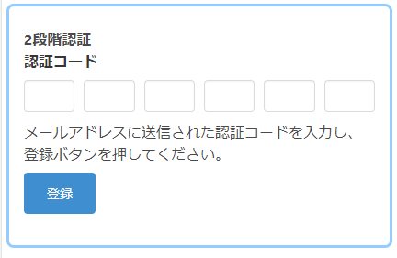

# STEP4

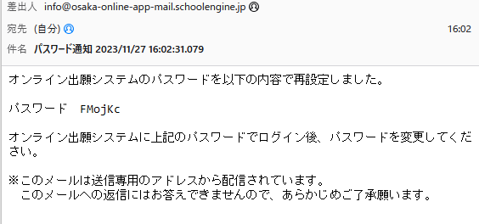

You will be notified of a temporary password to your registered email address.

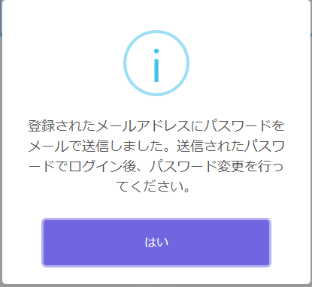

If you select "Yes" in the confirmation message, the login screen will be displayed, so enter the temporary password written in the email in [Password] to log in.

* Please change your password after logging in. Refer here to change your password.



My Page

# 

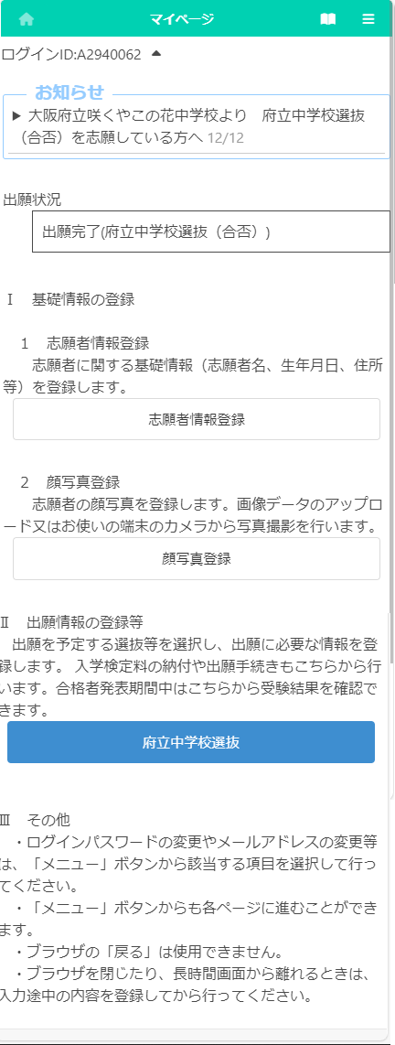

In “II. Register Application Information”, a button for selection (including admission decision) that can be entered or confirmed at the time of login is displayed. Under the name of the selection, the status such as “during the application period” and “on the announcement of the results” is displayed.

If the application information is registered, it will be displayed in blue, and if it is not, it will be displayed in white.

Press　　　　　　(Menu) button in the upper right corner to display the following menu.

In the “Notices” section, you will see communications from the school you are applying to and the Board of Education.

“Application Status” displays the current status of the application information registered by the applicant at the school where the applicant is enrolled and the school to which he or she is applying.

From “I. Register Basic Information”, you can proceed to "Register Applicant Information" and "Register Face Photo".

　　　　　　Display My Page.

　　　　　　Display the manual.



|  |  |  |
| --- | --- | --- |
| Change Password | Change Password at login. | Details |
| Change email address | Change the email address where you want to receive the verification code. | Details |
| Register Applicant Information | Register and modify applicant information. | Details |
| Register Face photo | Register and change the face photo of the applicant. | Details |
| Register Application Information | Register and modify application information, and send it to the school where you want to apply. | Details |
| Change selection  (Not available now) | Change the selection to copy the application. | ― |
| Return to the Top Page | Display My Page. | ― |
| Log out | Log out of the online application system. | Details |

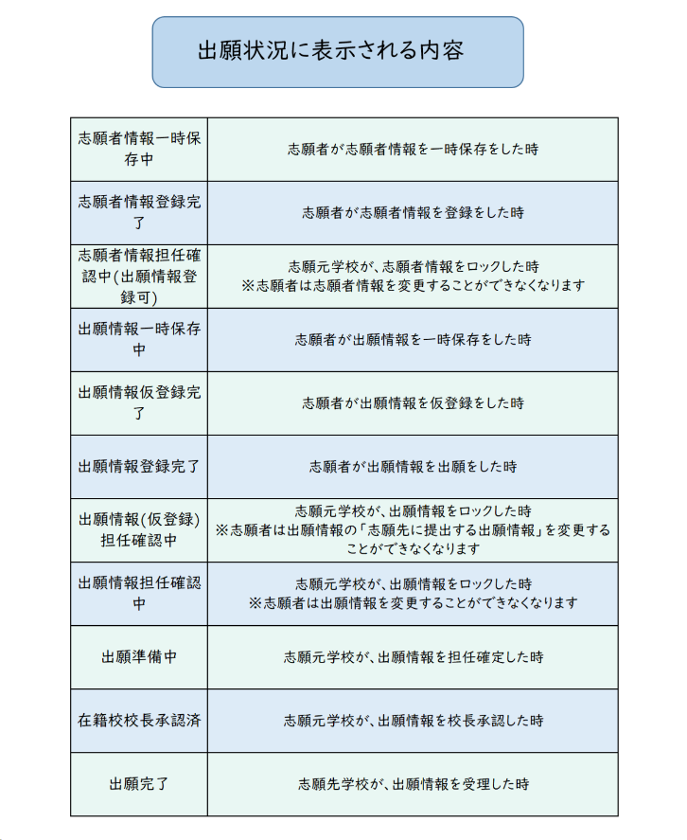

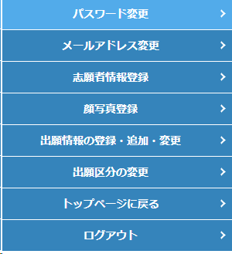

Logout

# STEP１

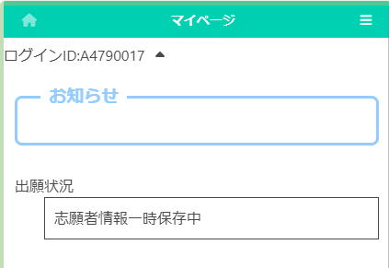

On the My Page screen, the Menu button.

Select Logout.

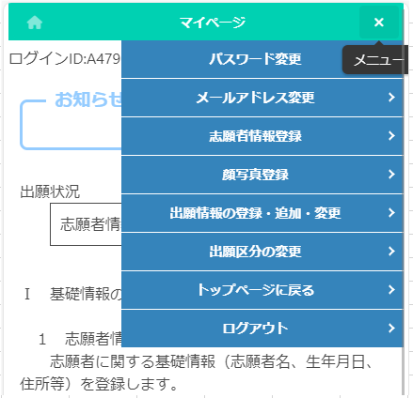

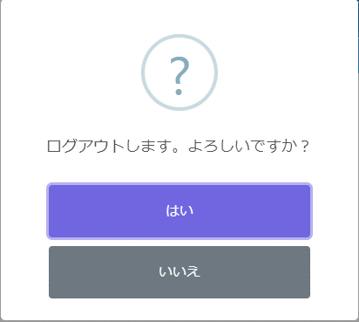

A confirmation message will be displayed, so select "Yes" to log out and return to the login screen.

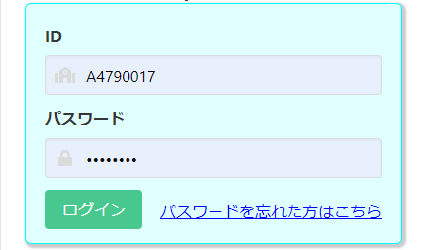

Change Password

# STEP１

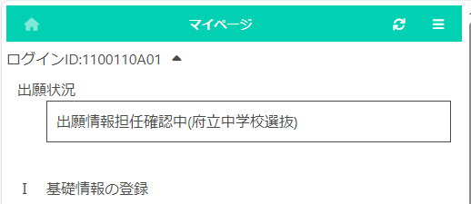

On the My Page screen, select　　　 (Menu).

Select “Change Password”.

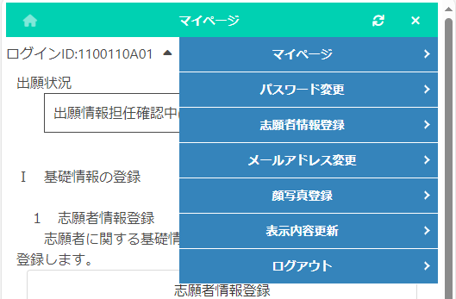

# STEP２

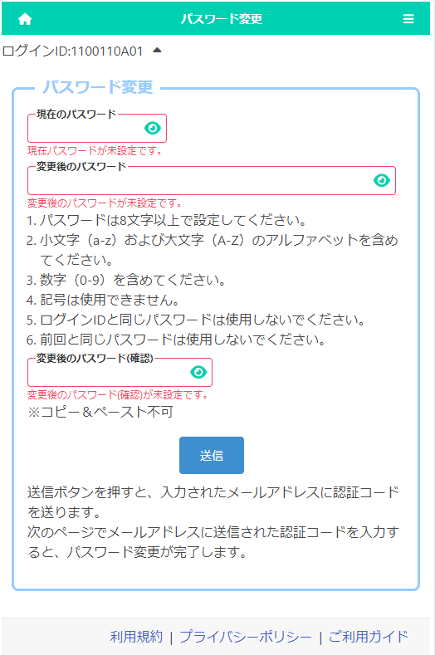

Enter the password you have currently registered in the "Current Password" field.

Enter the new password in "Changed Password" and "Changed Password (Confirm)".

* The input content is displayed with ●, but you can check it by pressing the button 　　　　.

When you're done, press the submit button.

# STEP３

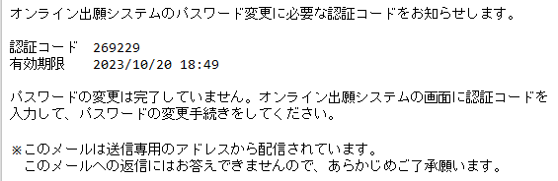

　A verification code will be sent to your registered email address.

Enter the verification code in the email and press the register button to complete the password change.

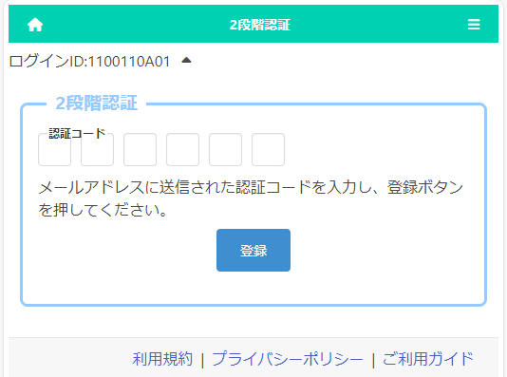

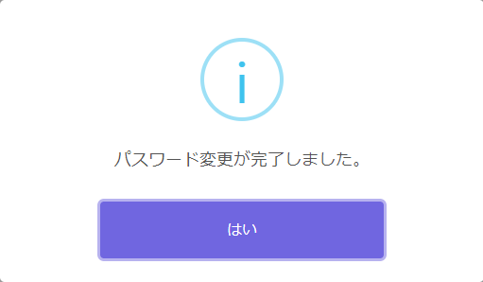

On the confirmation message, press Yes.

Change EMail Address

# STEP１



On the My Page screen, select　　　(Menu).

Select “Change Email Address”.



# STEP２

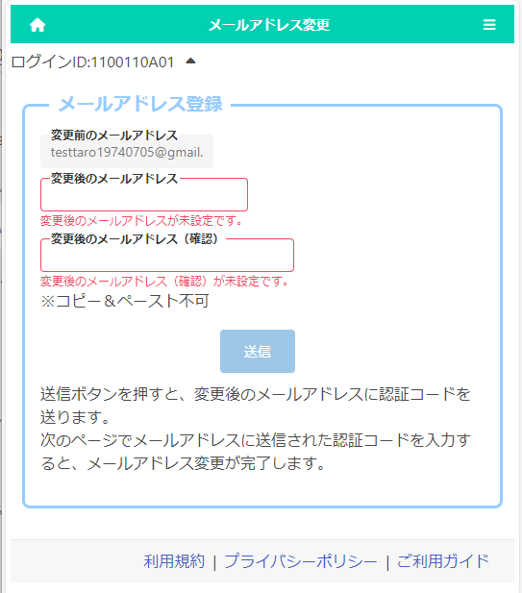

The email address currently registered in the "Old Email Address" field will be displayed.

Enter your new email address in the "New Email Address" and "Confirm New Email Address" fields.

When you're done, press the submit button.

# STEP３

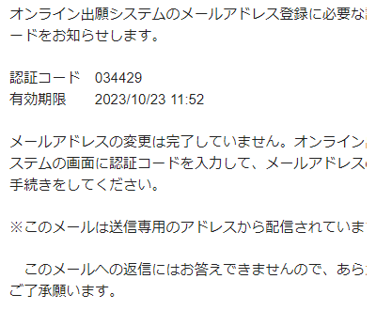

　A verification code will be sent to your new email address.

Enter the verification code in the email and press the register button to complete the change of your email address.

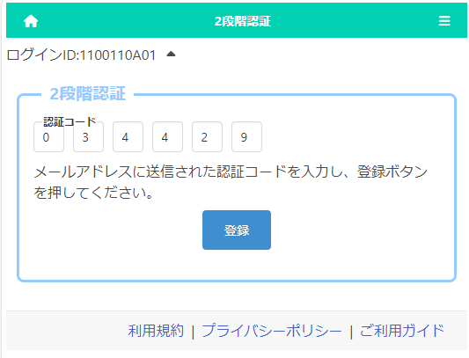

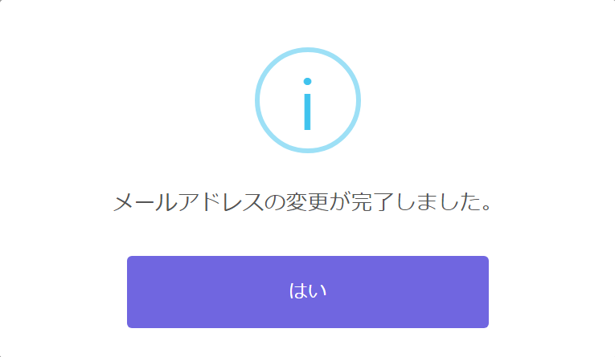

On the confirmation message, press Yes.

Register Applicant Information

# STEP１

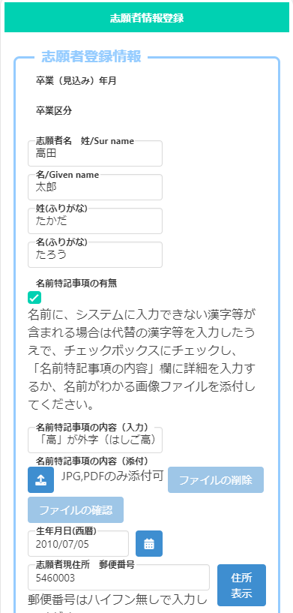

(2) Press the "Special notes for name (Attached)" 　　　　 button and attach a document that shows the contents that should be noted.

Example: Image file of kanji that cannot be entered

* If you have a middle name, please enter it in the “Special notes for name (Input)”.

* Please refer here for information on attaching files.

　If the name contains kanji that cannot be entered on a PC, etc., enter alternative kanji etc., check the "Presence of special notes for name" box, and do one or both of the following.

(1) Describe the contents that should be noted in "Special notes for name (Input)".

e.g. The upper part of the character "Yoshi" is "Tsuchi", etc.

Enter the applicant's name in kanji or alphabet and phonetic name in hiragana or katakana.

* Please enter the name of the applicant as it appears on the certificate of residence.

* The name of the applicant entered here will be written on the admission ticket.

* If the applicant's name is in English, please enter it in half-width alphabets, and enter phonetic name in full-width katakana.

* If you enter the required items such as applicant's name, phonetic name, and date of birth, you can save it temporarily.



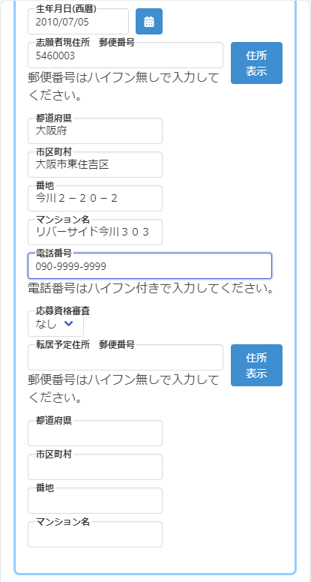

If the applicant plans to move by the time of enrollment, enter the planned address of the new residence.

When you enter your zip code and press the address display button, the name of the municipality will be automatically displayed, so enter the street number, etc.

For "Eligibility Screening", select "Yes" if you are required to submit an approval letter at the time of application, such as taking the exam from outside Osaka Prefecture.

Enter the phone number with single-byte numbers and hyphens (-), such as 06-1234-5678 or 090-1234-5678.

*The phone number field is shown to an applicant from a junior high school.

Enter the applicant's current address.

When you enter the zip code and press the address display button, the name of the municipality will be automatically displayed, so enter the street number, etc., to complete the address entry.

* The address is the address listed on the certificate of residence.

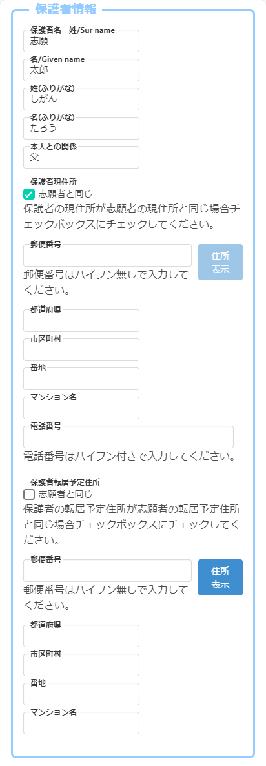

If the parent plans to move by the time of enrollment, enter the parent's planned address of the new residence.

If the parent plants to move to the same address as the applicant, check "Same as the applicant".

When you enter your zip code and press the address display button, the name of the municipality will be automatically displayed, so enter the street number, etc.

Enter the phone number with single-byte numbers and hyphens (-), such as 06-1234-5678 or 090-1234-5678.

Enter the parent's current address.

If it is the same as the applicant, check "Same as the applicant".

When you enter your zip code and press the address display button, the name of the municipality will be automatically displayed, so enter the street number, etc.

Enter the parent's name, phonetic name, and relationship with the applicant.

* If the parent's name contains kanji that cannot be entered, please enter alternative kanji.

# STEP２

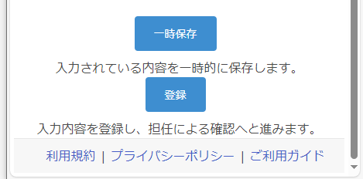

* When registering for the first time, you can only save temporarily. After registering your face photo, you will be able to register.

If you press the temporary save button, you can save the information that is being entered.

When you have entered all the applicant information and registered your face photo, click the register button.

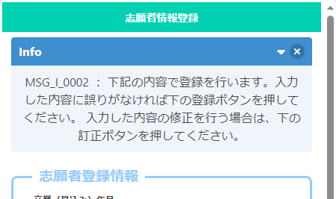

A confirmation message will appear, so please make sure that the information you entered is correct.

If there is an error in the entry, press the correct button to correct it.

If the information you have entered is correct, press the register button.

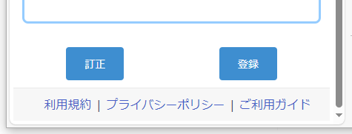

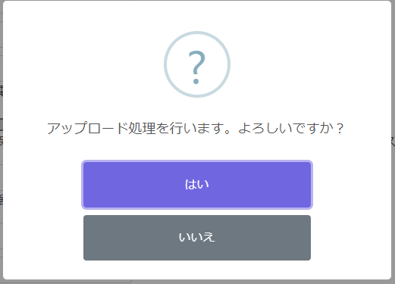

Select Yes to complete the registration.

Register Face Photo

[Important!] The face photo will be an ID photo for identity verification. When shooting, please pay attention to the following points.

1. Only the upper body of the applicant must be shown.

2. The face must be facing forward (the eyes must be visible) and the image must be clear.

3. As a general rule, do not wear a hat.

4. The background must be plain (white, light blue, gray, etc.).

5. The image has not been processed.

* The face photo can be either monochrome or color.



[Good example]



・ Face sideways  
・ The eyes are closed



・ Pictured with other people



・ The eyes are hidden  
・ Hide a part of the face

[Bad example]

# STEP１

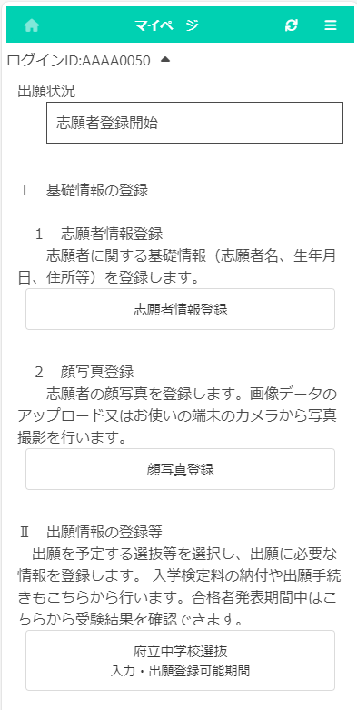

On the My Page screen, press “Register Face Photo”.

# STEP２

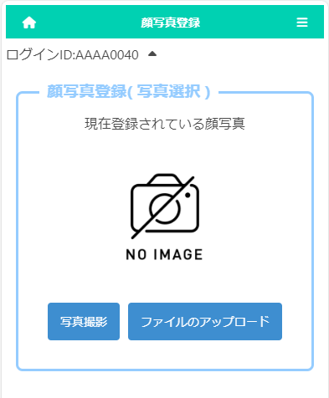

Select either taking a photo or uploading a file to register a face photo of the applicant.

If you choose to take a photo, you can use the camera function of your smartphone or tablet.

* It cannot be used on PC without a camera function.

If you choose to upload a file, you can upload an image that you have prepared in advance.

* The upload operation differs depending on the model of the smartphone or other device you are using.　Please check here.

# STEP３　**\* If you choose to take a photo**

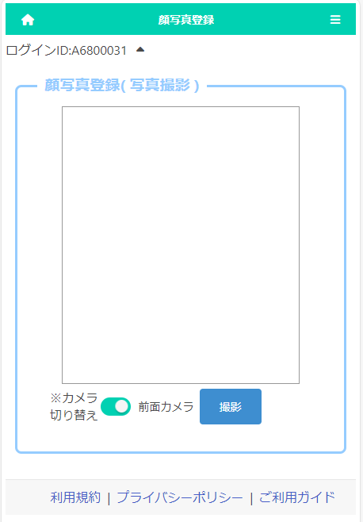

　By pressing the "Switch Camera" button, you can select whether to use the front or rear camera of a smartphone or other device.

Press the Shoot button to take a photo.

# STEP4

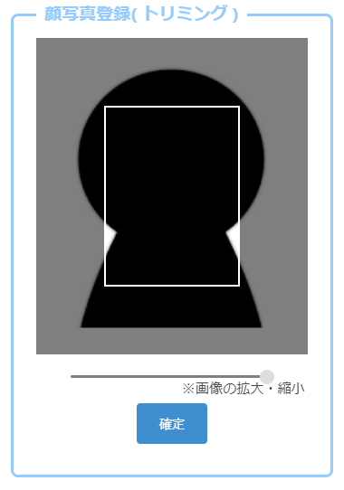

　When you take a photo or upload a file, the left screen will be displayed.

Move the slider below the image to adjust the image so that it fits within the white frame, and press the OK button.

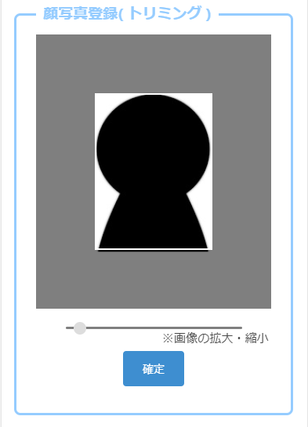

# STEP5

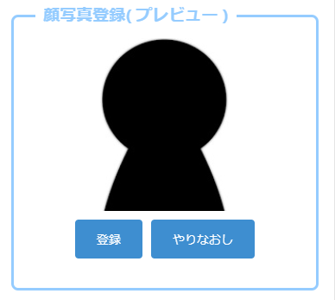

A preview image will be displayed, so if you are satisfied with the displayed image, click the register button.

If you want to rescale the image, press the Redo button.

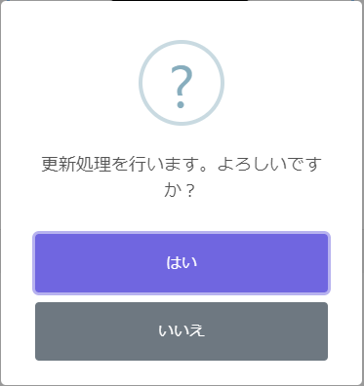

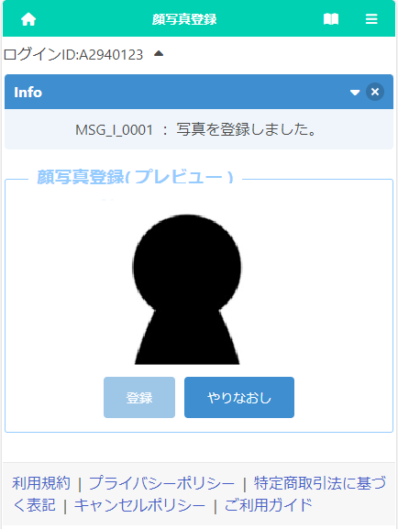

If you press Yes on the confirmation message, the registration of the face photo is completed.

Click the 　　　　　[Home Mark] home button in the upper left corner of the screen to return to the My Page screen.

Register Application Information  
(Junior high School)

# STEP１

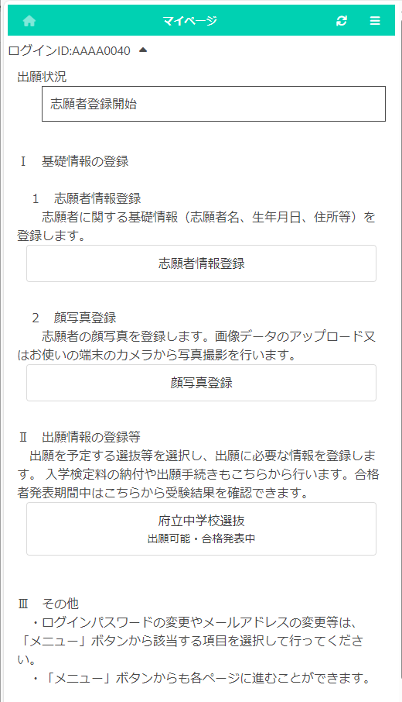

On the My Page screen, click "II. Register Application Information" and press the button for the selection you are going to apply for.

(In the figure on the left, the prefectural junior high school selection button.)

# STEP２

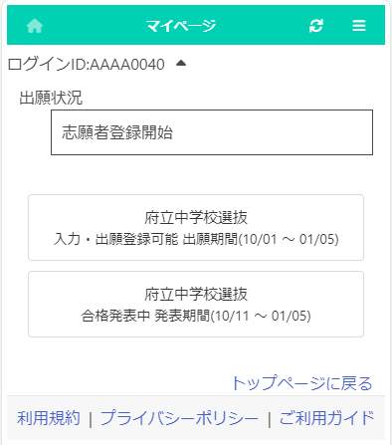

Press the button for the selection you are going to apply for.

* You can only select selections with an "Input/Application Registration" indication.

* When the day comes to the determined period, the status "on the announcement of the results " will be displayed and you will be able to check the results of the admission.

# STEP３

[Current status]  
Under the title of "Register Application Information," the current status of the applicant's registered application information at the school where the applicant is enrolled or the school to which the applicant is applying is displayed.

[Download admission ticket]  
Once the school where the applicant is applying has issued an admission ticket, you will be able to print it from the “Print Admission Ticket” button. Please refer to this page for information on printing it.

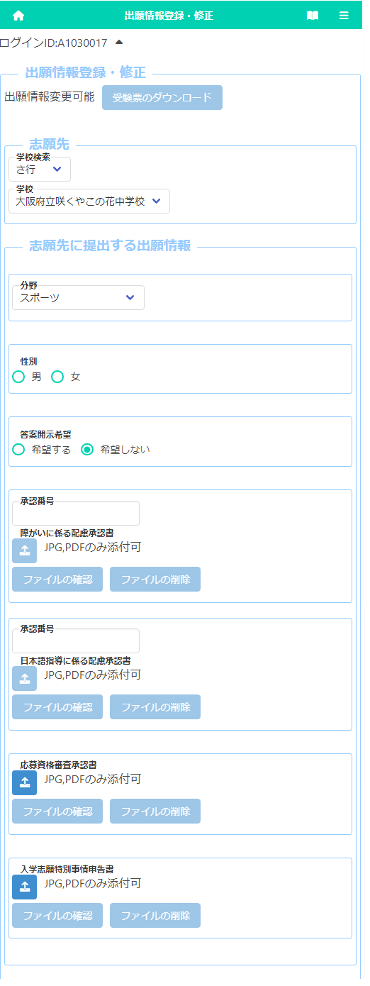

[Approvals of Consideration]

If you need to submit the "Approval of Consideration for Disabilities" or "Approval of Consideration for Japanese Language Skill," enter approval number and press the attach button to attach the approval letter.

* Please refer here for how to attach files.

［Request to disclose answers］  
If you select "Request", you will receive a copy of your answers after the successful applicants are announced.  
　 *Only the applicant himself / herself can receive it. Details such as the date and time will be indicated by the school to which you are applying.

[School to apply for]  
For "School / Department to apply for", select the line of the initial letter of the name of the school you want to apply to in "School Search", and then select the “School.”

[Field/Gender]   
If you apply to Sakuyakonohana Junior High School, select the "Field" you want to apply for. Also, if you have selected sports field, select the "Gender."

咲くやこの花のみ

[Approval of Eligibility] [Application for Special Circumstances]

If you need to submit the "Approval of Eligibility for Admission" or "Application for Special Circumstances for Admission", press the attach button to attach the approval letter.

* Please refer here for how to attach files.

# STEP4

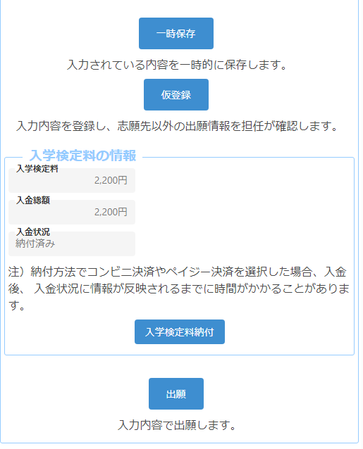

[Important!] After depositing, it may take some time for the deposit information to be reflected in the system. Payment must be made at least 2 hours before the application deadline.

When you select the application information, the application fee will be displayed.

When you press the “Application Fee Payment” button, you will be taken to the payment website, where you will be asked to pay the application fee. Once the payment is completed, it will be reflected in the "Total Amount Deposited" and "Payment Status" of the online application system, and you will be able to apply.

# STEP5



Enter your application information and press one of the following buttons:

Temporary save : Save the information that is being entered.

Temporary registration　:　 Register the entered information so that the homeroom teacher of your enrollment school can check the registered contents. If you have not decided about the school where you want to apply or paid the application fee, please select this option.

Application　: Apply with the information you entered (it will be sent to the school you are applying to after being confirmed by your enrollment school). In order to press this button, you must have paid the application fee.

REGISTER APPLICATION INFORMATION (High School)

# STEP１

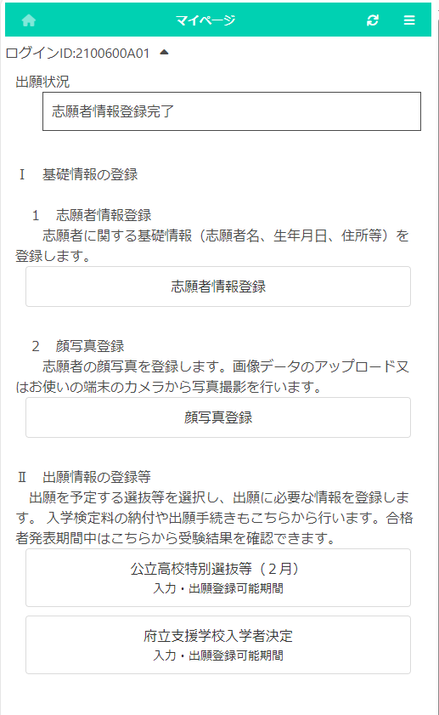

On the My Page screen, click "II. Register Application Information" and press the button for the selection you are going to apply for.

(On the left, the Public High School Special Selection (February) button.) ）

# STEP２

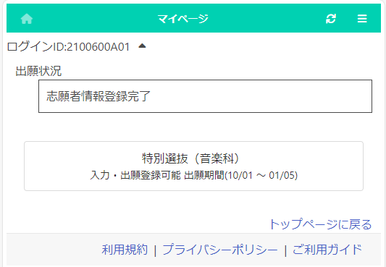

Press the button for the selection you are going to apply for.

* You can only select selections that have an "Input/Application Registration" indication.

* When the day comes to the determined period, the status "on the announcement of the results " will be displayed and you will be able to check the results of the admission.

# STEP３

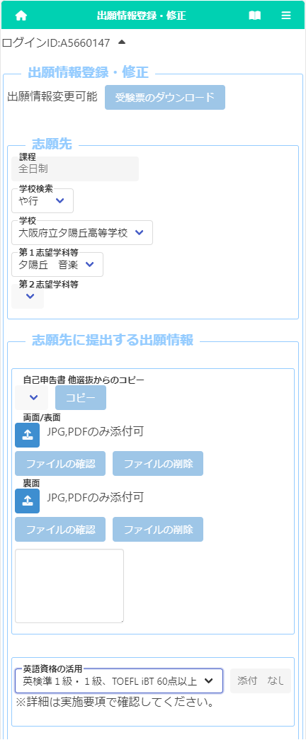

[Current status]  
Under the title of "Register Application Information," the current status of the applicant's registered application information at the school where the applicant is enrolled or the school to which the applicant is applying is displayed.

[Download admission ticket]  
Once the school where the applicant is applying has issued an admission ticket, you will be able to print it from the “Print Admission Ticket” button. Please refer to this page for information on printing it.

[School to apply for]  
For "School / Department to apply for", select the line of the initial letter of the name of the school you want to apply to in "School Search", and then select the “School.”  
Select the first-choice department and the second-choice only if it is available.

[Motivation letter]  
Enter the letter directly in the input field or attach a PDF/JPG file prepared in advance.

* If you have already submitted a motivation letter in another selection, you can select the name of the selection and press the copy button to copy it.

[English qualifications]  
If you apply with your English qualifications, select the appropriate item.

* Please submit the certificate to the teacher of your school.

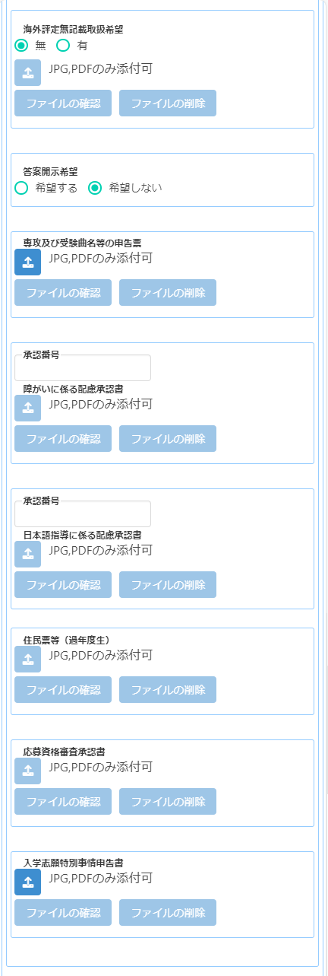

[Approvals of Consideration]  
If you need to submit the "Approval of Consideration for Disabilities" or "Approval of Consideration for Japanese Language Skill," enter approval number and press the attach button to attach the approval letter.  
* Please refer here for how to attach files.

[Certificate of Residence, etc.]  
An applicant who has already graduated need to attach the image data of a copy of the certificate of residence.

[Approval of Eligibility] [Application for Special Circumstances]

If you need to submit the "Approval of Eligibility for Admission" or "Application for Special Circumstances for Admission", press the attach button to attach the approval letter.

* Please refer here for how to attach files.

[Major and music for test]  
Press the "Attach" button to attach a file about your major and music for test.　  
*If you need to submit a music score, please send its copy by postal service to Yuhigaoka High School by the specified date.

[No report from overseas school]  
If you don’t have a school report, you wish to handle the product without an overseas evaluation, select "Yes" and press the (Attach file) button to attach the image data of the approval letter.   
* It is necessary to obtain the approval of the Board of Education that establishes the Osaka Prefectural Public High School in advance.

［Request to disclose answers］  
If you select "Request", you will receive a copy of your answers after the successful applicants are announced.  
*Only the applicant himself / herself can receive it. Details such as the date and time will be indicated by the school to which you are applying.

# STEP4

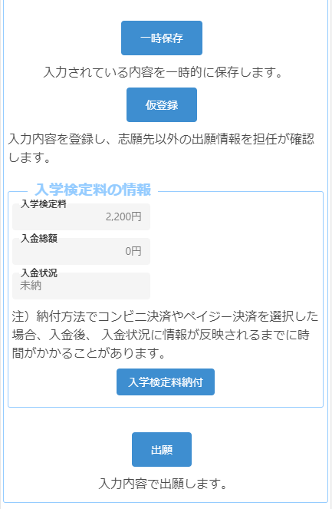

[Important!] After depositing, it may take some time for the deposit information to be reflected in the system. Payment must be made at least 2 hours before the application deadline.

When you select the application information, the application fee will be displayed.

When you press the “Application Fee Payment” button, you will be taken to the payment website, where you will be asked to pay the application fee. Once the payment is completed, it will be reflected in the "Total Amount Deposited" and "Payment Status" of the online application system, and you will be able to apply.

# STEP5



Enter your application information and press one of the following buttons:

Temporary save : Save the information that is being entered.

Temporary registration　:　 Register the entered information so that the homeroom teacher of your enrollment school can check the registered contents. If you have not decided about the school where you want to apply or paid the application fee, please select this option.

Application　: Apply with the information you entered (it will be sent to the school you are applying to after being confirmed by your enrollment school). In order to press this button, you must have paid the application fee.

REgister Application information  
(School for Needs education)

# STEP１

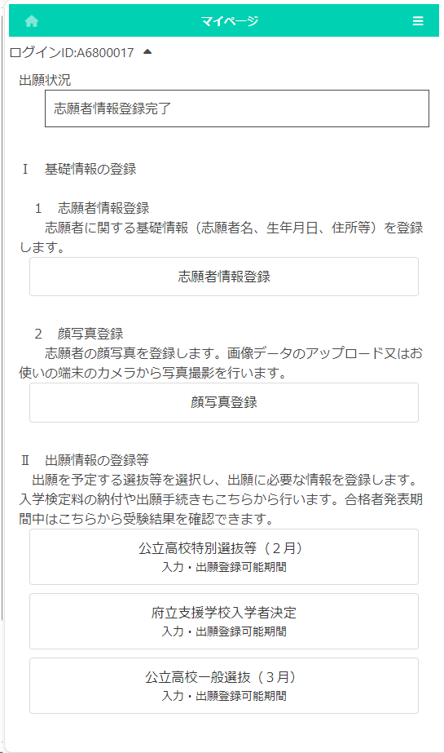

On the My Page screen, click "II. Register Application Information" and press the button for the selection you are going to apply for.

(In the figure on the left, the school for needs education admission button.)

# STEP２

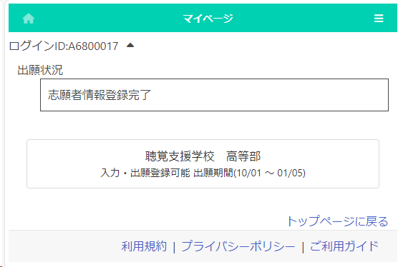

Press the button for the admission you are going to apply for.

* You can only select selections that have an "Input/Application Registration" indication.

* When the day comes to the determined period, the status "on the announcement of the results " will be displayed and you will be able to check the results of the admission.

# STEP３

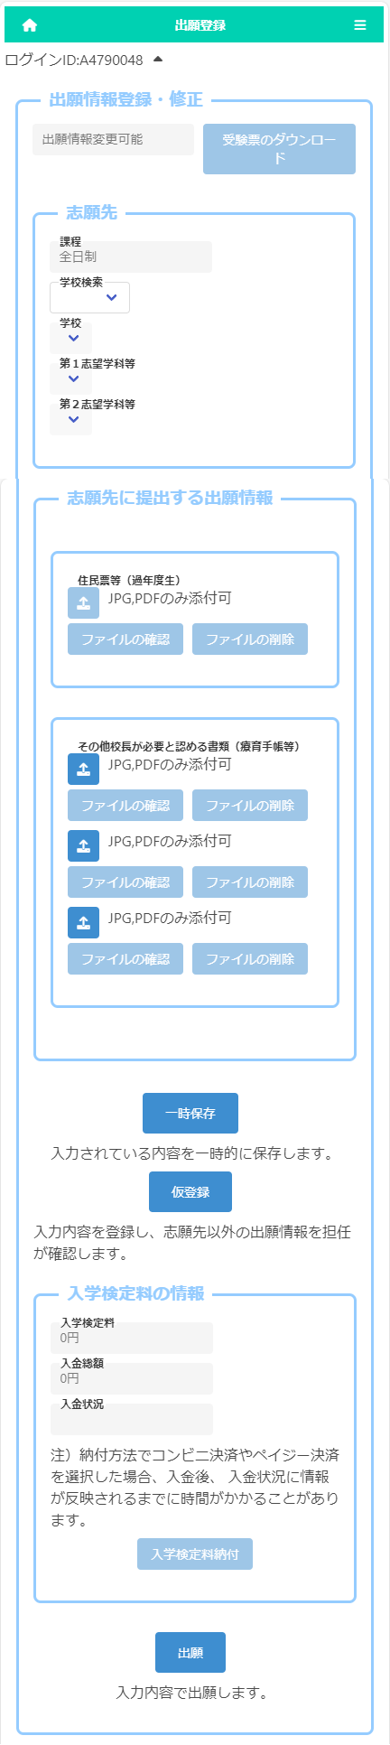

For "School", select the line of the initial letter of the name of the school you want to apply to in "School Search", and then select the “School.”  
 Select the first-choice department after selecting the school.

An applicant who has already graduated need to attach the image data of a copy of the certificate of residence.

If you need to submit a medical certificate or other documents that the principal regards as necessary, click the "Other documents" button and attach the files.

* Please check here for how to attach files.

Every applicant doesn’t need to pay the application fee to apply for prefectural special-needs schools.

Under the title of "Register Application Information," the current status of the applicant's registered application information at the school where the applicant is enrolled or the school to which the applicant is applying is displayed.

Once the school where the applicant is applying has issued an admission ticket, you will be able to print it from the “Print Admission Ticket” button. Please refer to this page for information on printing it.

# STEP4

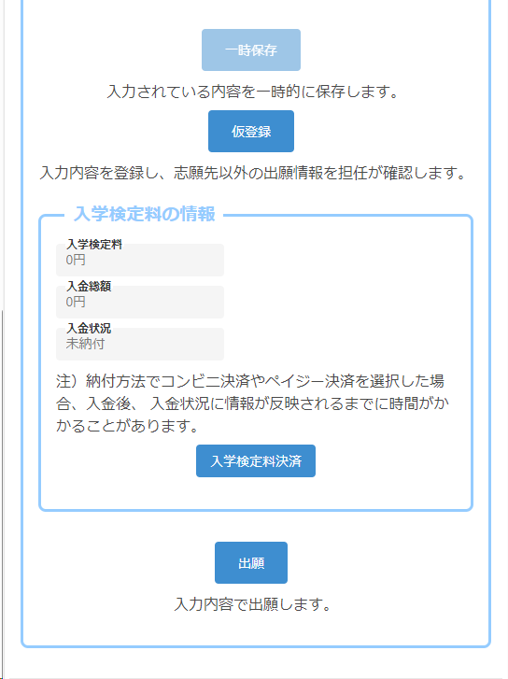

Enter your application information and press one of the following buttons:

Temporary save : Save the information that is being entered.

Temporary registration　:　 Register the entered information so that the homeroom teacher of your enrollment school can check the registered contents.

Application　: Apply with the information you entered (it will be sent to the school you are applying to after being confirmed by your enrollment school).

Payment of application fee and admission fee

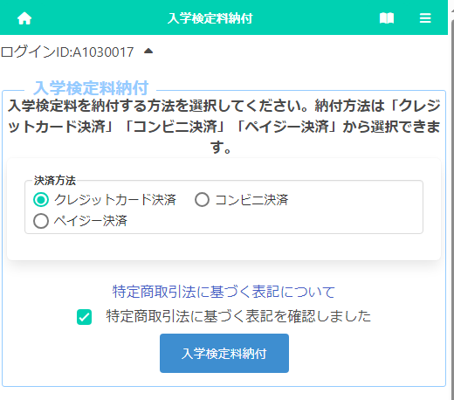

When you press the "Application Fee Payment" button on the application registration screen or the “Admission Fee Payment" button on the successful applicant announcement screen, the screen for selecting the payment method is displayed.

For details on the payment method, please refer to the following page.

1. Credit card payment
2. Convenience store payment
3. Pay-easy payment (ATM)
4. Pay-easy payment (online bank)

[Important!] After depositing, it may take some time for the deposit information to be reflected in the system. Payment must be made at least 2 hours before the application deadline.

# ＜When "Credit Card Payment" is selected＞

* The figure on the left shows the screen for payment of the application fee, but the screen for payment of the admission fee is almost the same.

After selecting "Credit Card Payment", click "Notation based on the Specified Commercial Transaction Act" to confirm the contents, check "Confirmed" and press the button “Application Fee Payment.”



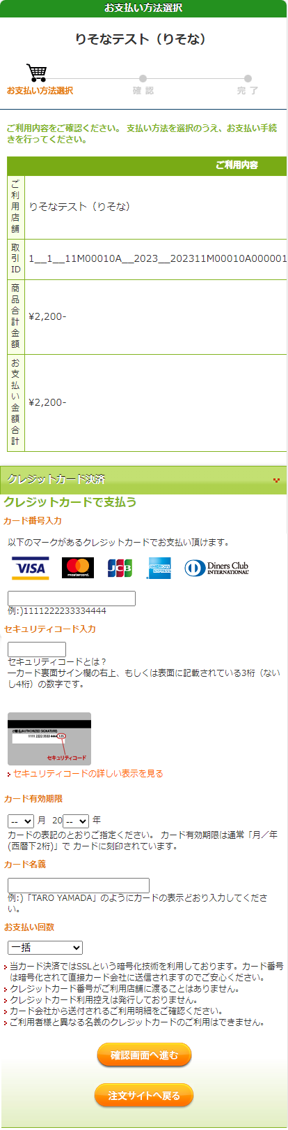

Enter the following fields for the credit card you use to pay:

[Enter Card Number]

Enter the number on the front of the card without hyphens.

[Enter Security Code]

Enter the security code on the back of the card (or on the front right side of the card).

[Card expiration date]

Enter the month/year of the expiration date on the front of the card.

[Cardholder Name]

Enter the name of the cardholder on the card in single-byte alphabetic characters.

[Number of payments]

Select one-time payment or pay in installments.

After filling in all the fields, press the “Confirm” button.

* If you press the "Return to the website to order" button, you will return to the screen of the online application system without making a payment.

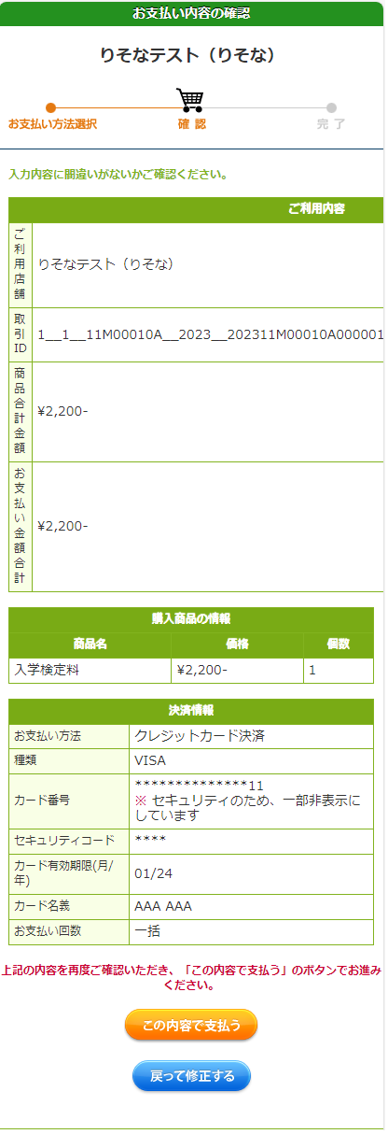

A confirmation screen will be displayed, so after confirming the contents, press the “Pay” button.

If there is a mistake in the entry, press the “Correct the entry” button.

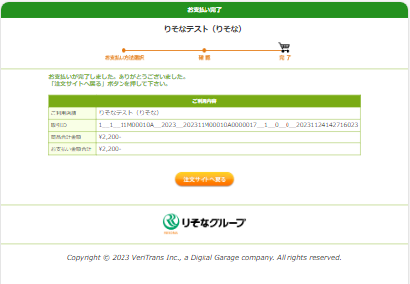

When the payment is completed, the completion notice will be displayed, so press the “Return to the website to order” button.

The system shows the application fee payment is completed. Press the “Return to My Page” button.

* Within 2 hours, the payment information will be reflected in the system.

Please check the payment status on the screen of the application information or the announcement of successful applicants.

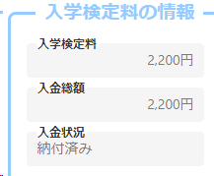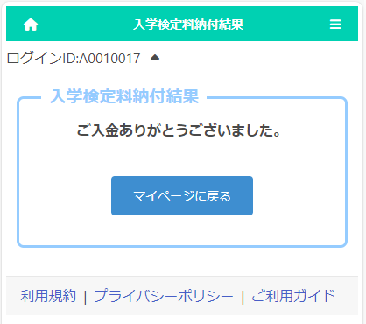

# ＜When "Convenience Store Payment" is selected＞

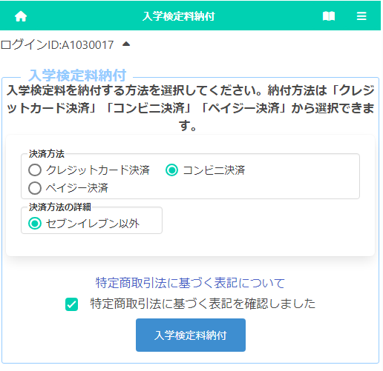

* The figure on the left shows the screen for payment of the application fee, but the screen for payment of the admission fee is almost the same.

After selecting "Convenience Store Payment", select "Other than Seven-Eleven" in the payment method details. (Payment at Seven-Eleven is scheduled to be handled from next year.)

Click "Notation based on the Specified Commercial Transaction Act" to confirm the contents, check "Confirmed" and press the button “Application Fee Payment.”

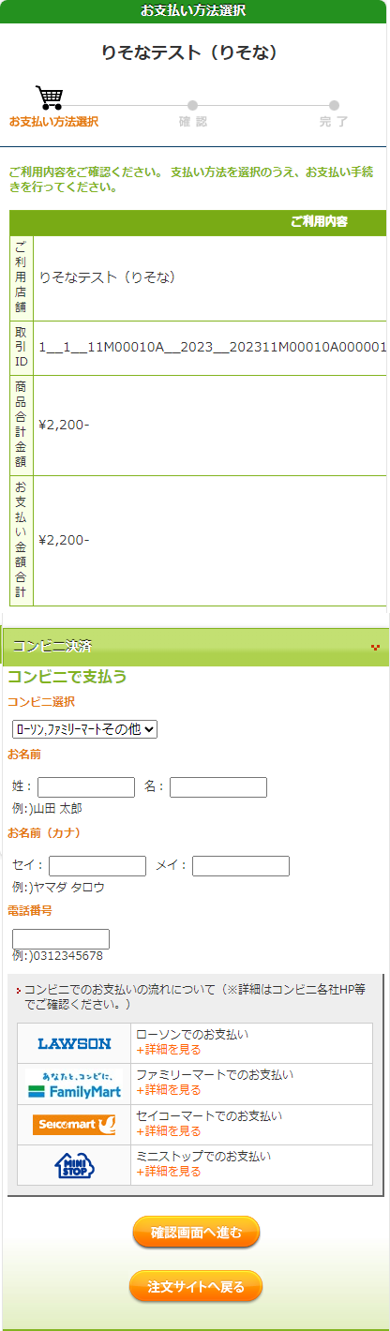

We will issue a receipt number that will be required for payment at convenience stores. Enter the following items:

[Name]

Enter the name of the applicant.

* Please be careful not to enter the name of the parent or guardian who will make the payment.

[Name (Kana)]

Enter the applicant's name in full-width katakana.

[Phone Number]

　　　 Enter a phone number where you can be contacted if you have a payment inquiry, without hyphens.

* Used for payment at convenience stores.

The operation method of the reception terminal at the convenience store is different. Please check the payment method from the link of each convenience store.

After filling in all the fields, press the “Confirm” button.

* If you press the "Return to the website to order" button, you will return to the screen of the online application system without making a payment.

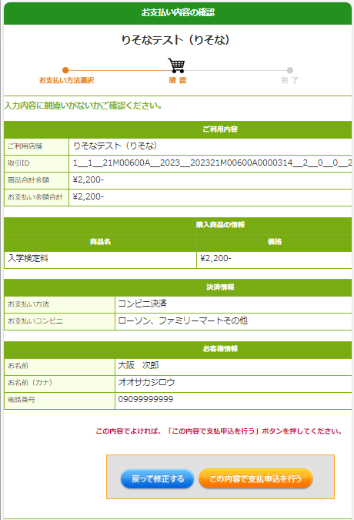

A confirmation screen will be displayed, so after confirming the contents, press the “Pay” button.

If there is a mistake in the entry, press the “Correct the entry” button.

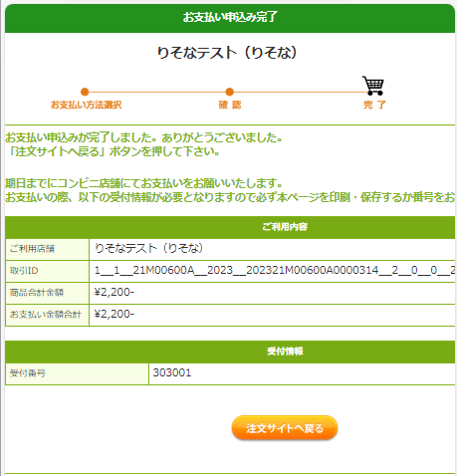

The result of the application fee payment will be displayed.

[Important!]

At this point, the deposit process has not yet been completed.

At the convenience store you selected, please process the payment with the "receipt number" and "phone number".

After payment, it may take some time for the payment information to be reflected in the system. Please be sure to pay the application fee at least 2 hours before the application deadline.

When the process is completed, a "receipt number" will be issued.

Make a note of the "receipt number" and the "phone number" you entered earlier, and press the “Return to the website to order” button.

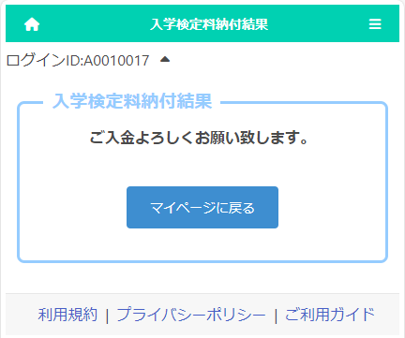

# ＜When "Pay-easy Payment" (ATM) is selected＞

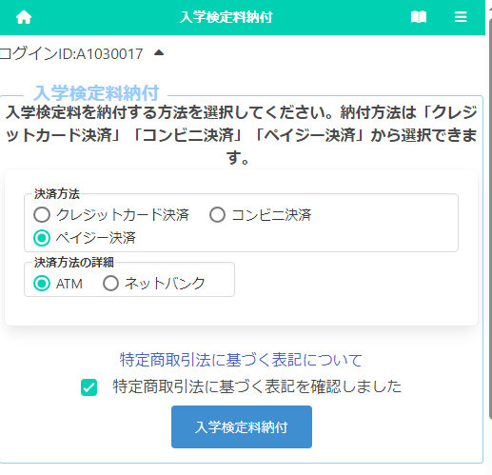

* The figure on the left shows the screen for payment of the application fee, but the screen for payment of the admission fee is almost the same.

Select "Pay-easy Payment" and then select "ATM" in the payment method details.

* In principle, there is no fee, but an additional fee of 110 yen is required for cash payment at Japan Post Bank ATMs. Other financial institutions may also charge ATM overtime fees.

Click "Notation based on the Specified Commercial Transaction Act" to confirm the contents, check "Confirmed" and press the button “Application Fee Payment.”

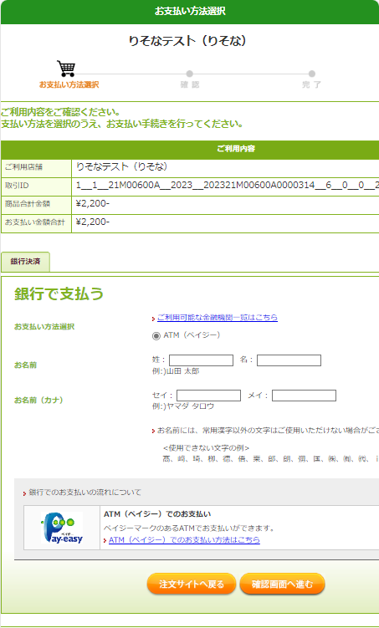

Fill in each of the items required to pay at the ATM.

[Name]

Enter the name of the applicant.

* Please be careful not to enter the name of the parent or guardian who will make the payment.

[Name (Kana)]

Enter the applicant's name in full-width katakana.

After filling in all the items, press the “Confirm” button.

* If you press the "Return to the website to order" button, you will return to the screen of the online application system without making a payment.

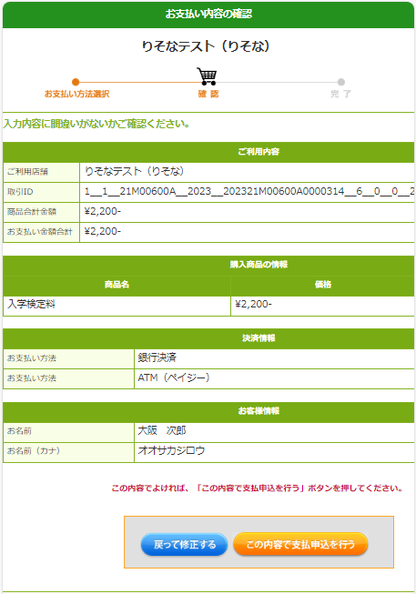

A confirmation screen will be displayed, so after confirming the contents, press the “Pay” button.

If there is a mistake in the entry, press the “Correct the entry” button.

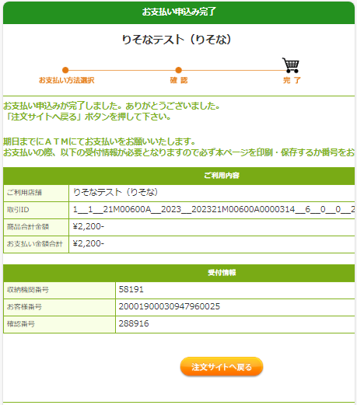

When the process is completed, the "Reception Information" will be displayed, so make a note of the "Storage Period Number", "Customer Number", and "Confirmation Number" and press the "Return to the website to order" button.

The result of the application fee payment will be displayed.

[Important!]

At this point, the deposit process has not yet been completed.

At a bank ATM, please process the payment with the "Receipt Period Number", "Customer Number" and "Confirmation Number."

After payment, it may take some time for the payment information to be reflected in the system. Please be sure to pay the application fee at least 2 hours before the application deadline.

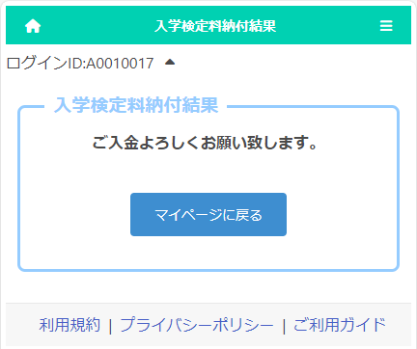

# ＜When selecting "Pay-easy Payment" (online bank)＞

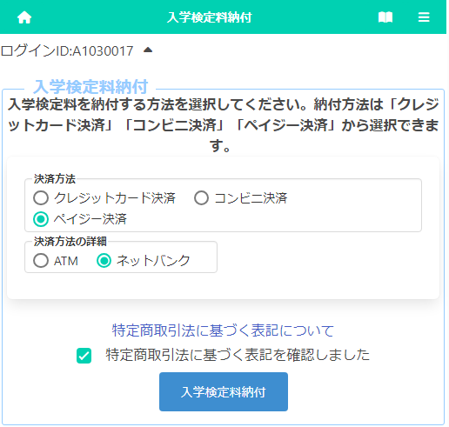

* The figure on the left shows the screen for payment of the application fee, but the screen for payment of the admission fee is almost the same.

Select "Pay-easy Payment" and select "Online Bank" in the payment method details.

Click "Notation based on the Specified Commercial Transaction Act" to confirm the contents, check "Confirmed" and press the button "Application Fee Payment. "

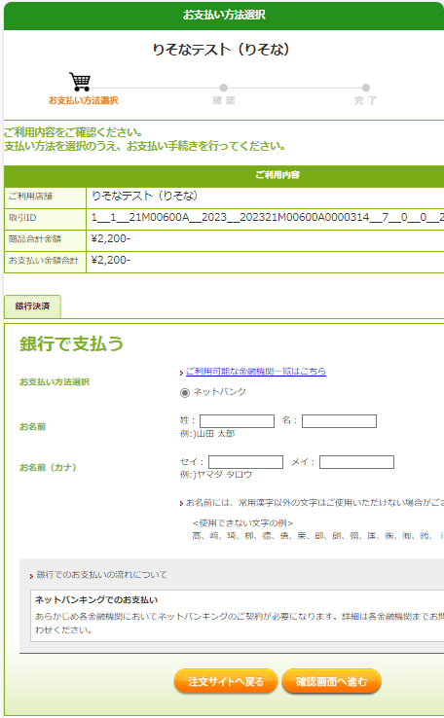

Fill in each of the items required to pay with an online bank.

[Name]

Enter the name of the applicant.

* Please be careful not to enter the name of the parent or guardian who will make the payment.

[Name (Kana)]

Enter the applicant's name in full-width katakana.

After filling in all the items, press the “Confirm” button.

* If you press the "Return to the website to order" button, you will return to the screen of the online application system without making a payment.

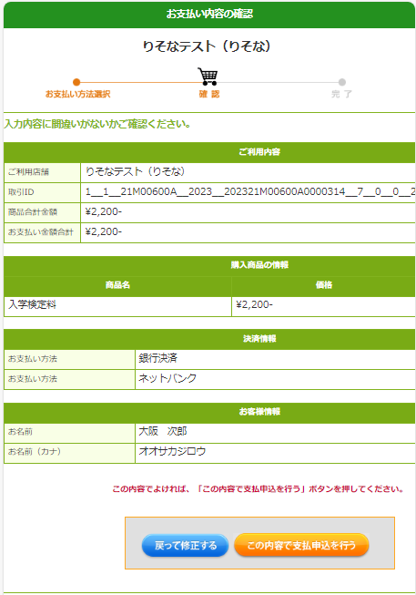

A confirmation screen will be displayed, so after confirming the contents, press the “Pay” button.

If there is a mistake in the entry, press the "Correct the entry" button.

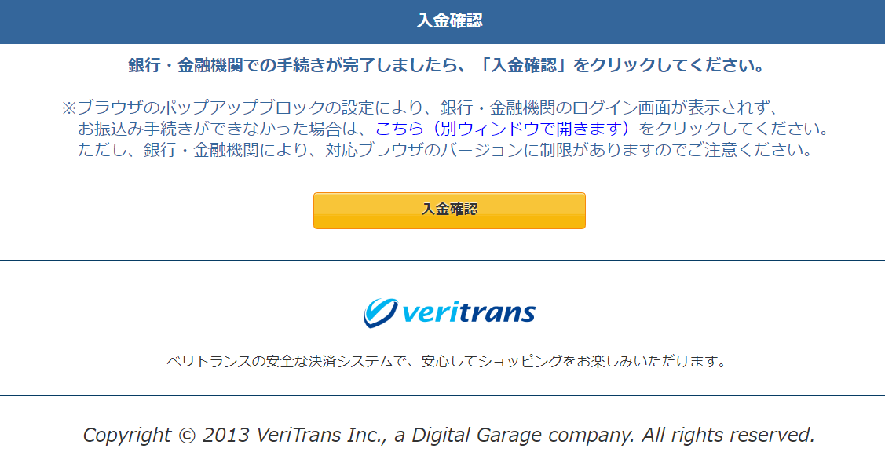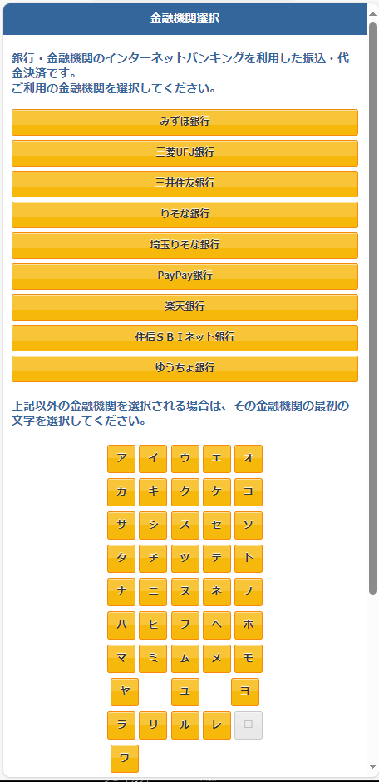

You will be prompted to select the online bank you want to make the payment from. When you select the name of a bank, you will proceed to its payment website and follow the instructions on the screen to process the payment.

Download the admission ticket

# STEP１

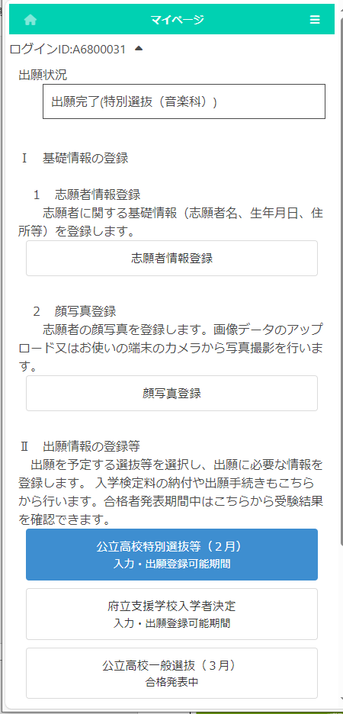

On the My Page screen, press the button for the selection you have applied for in "II. Register Application Information."

(In the figure on the left, Special Selection for public high schools (February))

# STEP２

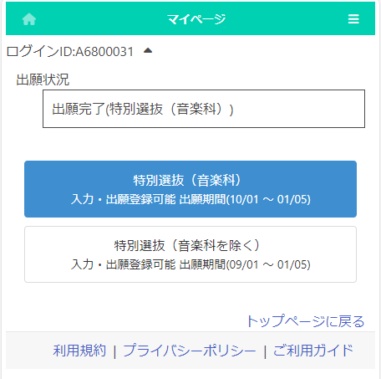

The course, department, etc. of the selection will be displayed, so select the one to be output.

(In the figure on the left, Special Selection (Music Department))

# STEP３

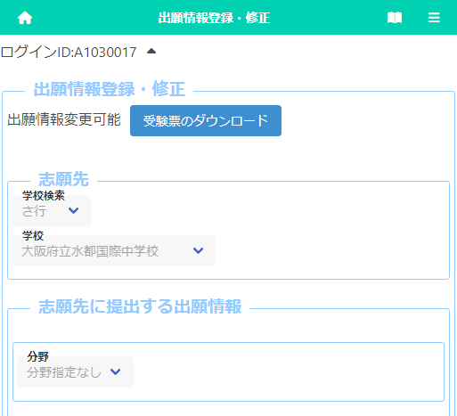

　When the application registration screen is displayed, press the download button for the admission ticket.

(This button can be pressed when the admission number is given by the school to which you are applying.)

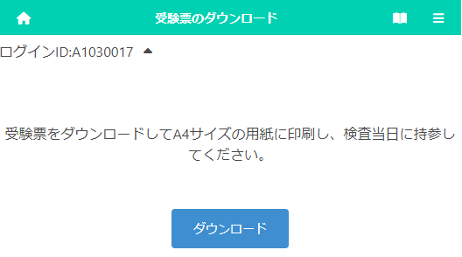

When you press the download button, the admission ticket will be output as a PDF file.

**A printed admission ticket is required on the day of the test and be sure to bring the printed one. The ticket can be printed at home or at a convenience store. (The paper size is A4.)**

* If platform dependent characters are used in the applicant's name, they will be displayed blank or in different characters on the admission ticket. In that case, please write your name by hand, and bring it with you on the day of the test.

**How to download and print the admission ticket**

Please download and save your admission ticket and print it out in black and white or color on A4 size paper by the day of the test. Please be sure to bring the printed ticket with you on the day of the test.

Here's how to download and print: If you do not have a printer at home, proceed to step 2 to save, then proceed to [If you do not own a printer] and print using a multi-function copier at a convenience store. Printing on the multi-function copier is charged.

[For computers]

1. When you press the "Download Admission Ticket" button, the admission ticket (PDF file) will be open in a new tab of your browser (Microsoft Edge, Google Chrome, Safari, etc.).
2. To save a PDF file,  
   for Windows press Ctrl + s on your keyboard,

for macOS press ⌘+ s on your keyboard and select a folder.

1. When printing from a printer connected to your computer,  
   for Windows press Ctrl + p,

for macOS ⌘+ s and select the printer.

Select A4 paper size and print the ticket without scaling, in black and white or color.

* For details on how to operate the printer, refer to the manual or the manufacturer's website.

[For smartphones] (The screen differs depending on the model, etc.)

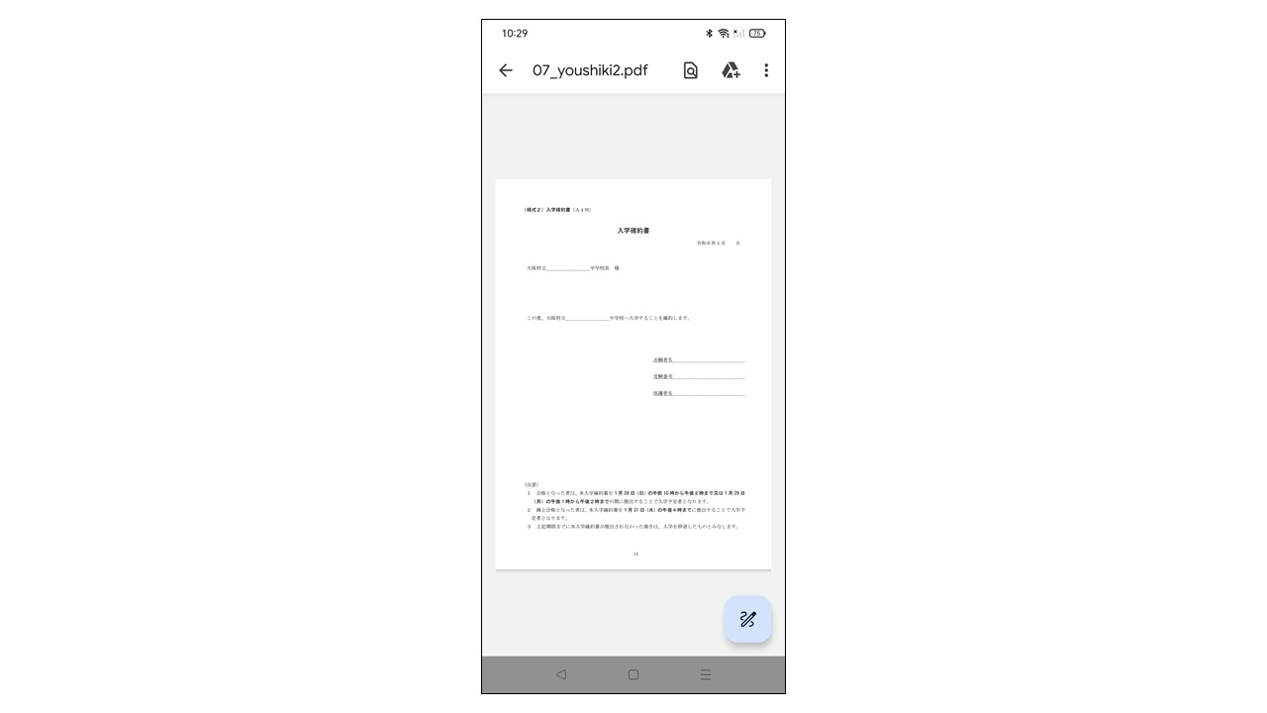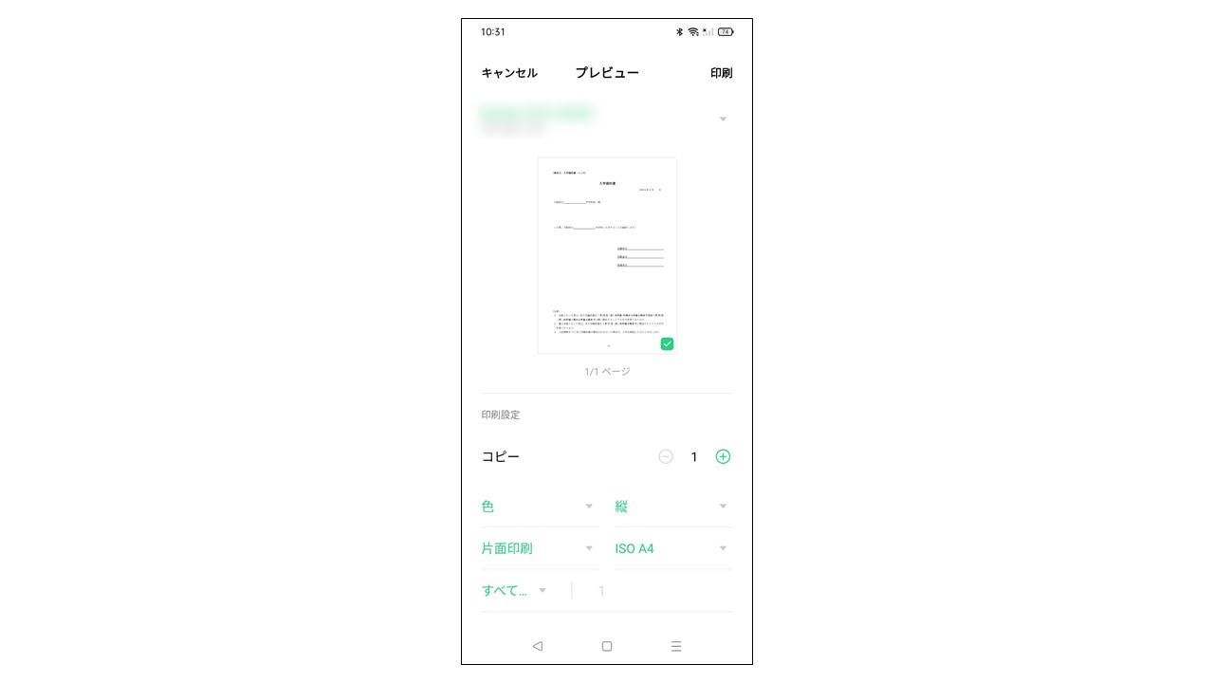Android:

1. When you press the "Download Admission Ticket" button, the admission ticket (PDF file) will be open in a new tab of your browser (Google Chrome, etc.).

Screen 1

1. [Screen1] Select ⁝ in the upper right and select Download.

Screen 3

1. 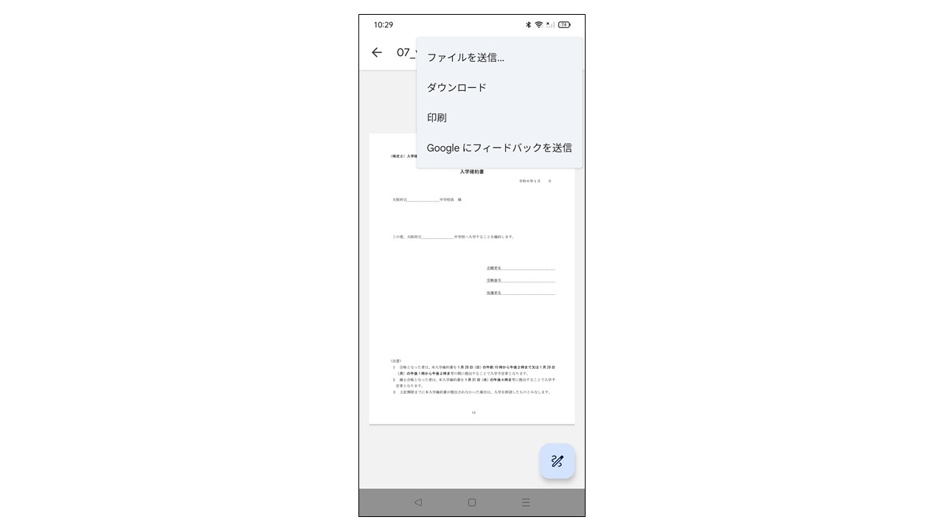[Screen1 & 2] If you're printing from a Wi-Fi printer available for Android, select ⁝ in the upper right, select Print.

[Screen 3] Select the printer, select black and white or color, A4 for the paper size, and select "Print."  
* Please print without enlarging or shrinking.

Screen 2

* For details on how to operate the printer, refer to the manual or the manufacturer's website.

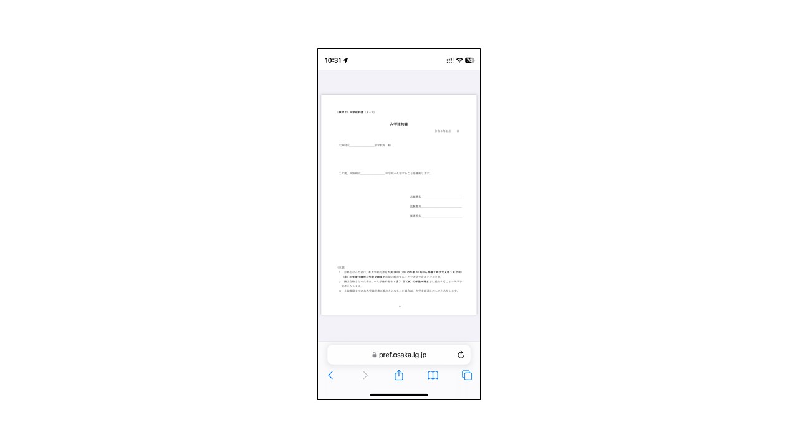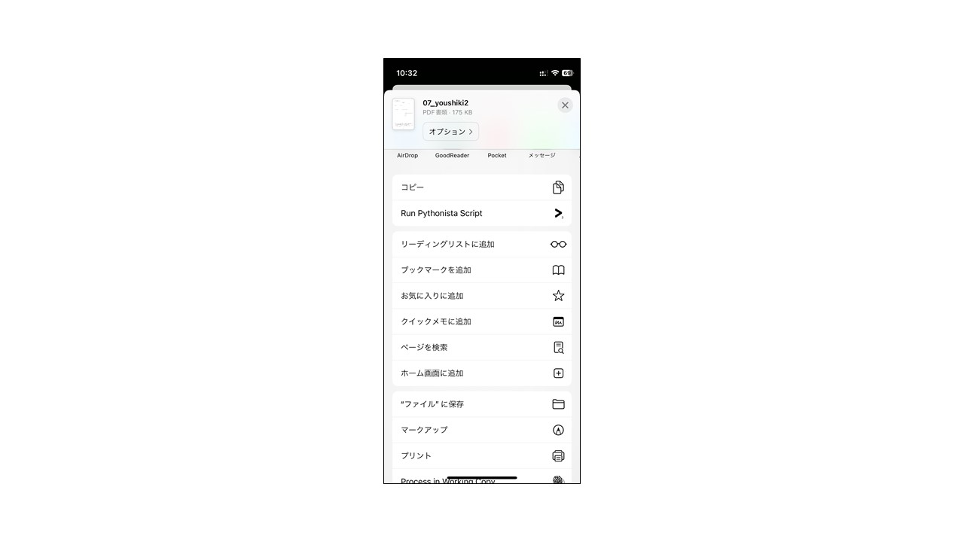iPhone:

1. When you press the "Download Admission Ticket" button, the admission ticket (PDF file) will be open in a new tab of your browser (Safari, etc.).

Screen 1

Screen 2

1. [Screen 1 & 2] Select the Share button

 at the bottom of the screen.

[Screen 3] Select Save to File, then Save.

1. [Screen 1 & 2] If you're printing a Wi-Fi printer available for iPhone, select the Share button at the bottom of the screen.
2. 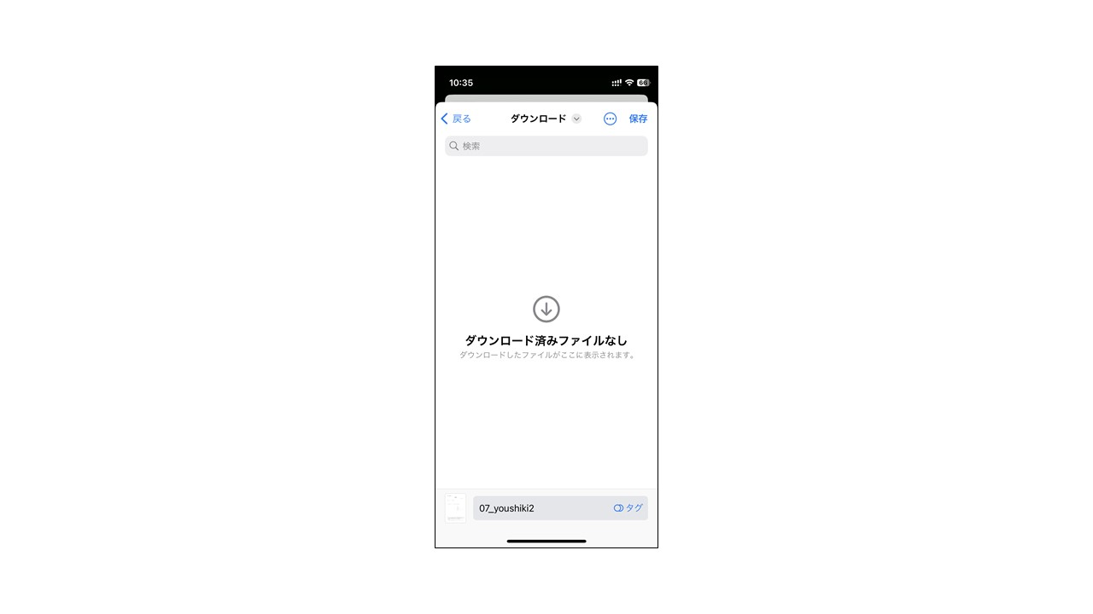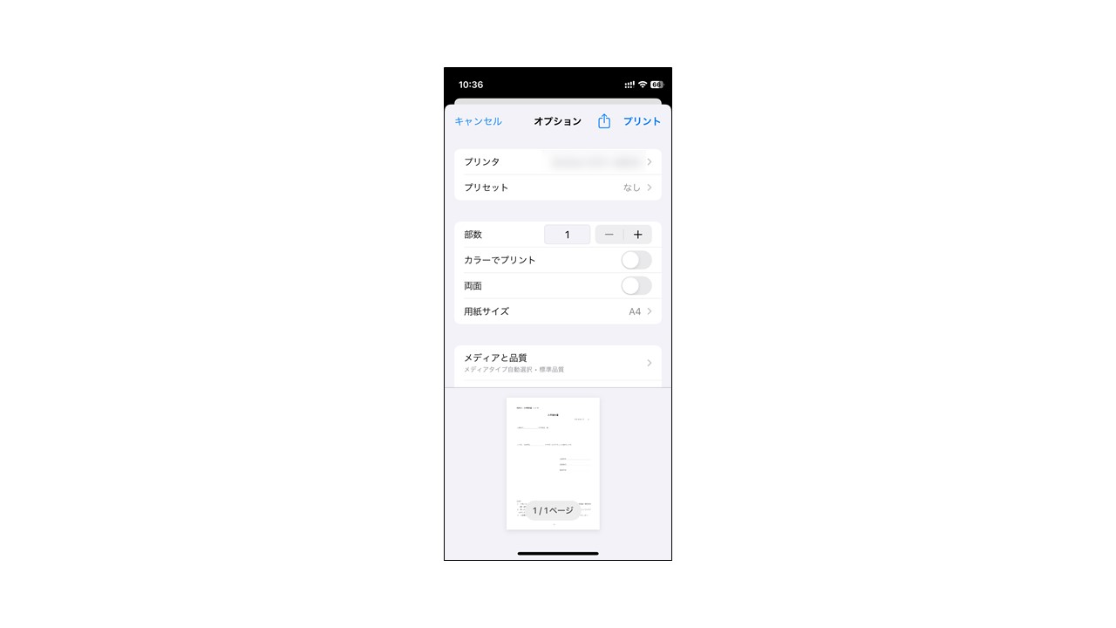[Screen 4] Select the printer, select A4 for the paper size, and select "Print."  
   * Please print without enlarging or shrinking.

* For details on how to operate the printer, refer to the manual or the manufacturer's website.

Screen 3

Screen 4

[If you don't own a printer]

1. Please print using a multi-copy machine at a convenience store such as Seven-Eleven or FamilyMart. Printing on the multi-function copier is charged.

* If you save your admission ticket on your computer, you can bring a PDF file using a USB memory stick and print it, but here we will show you how to upload the data to the Internet and print it using an iPhone.

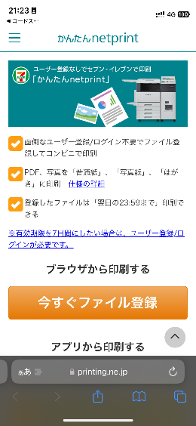[In the case of Seven-Eleven]

1. Access the "Easy netprint" web page.

(<https://www.printing.ne.jp/support/lite/index.html>).  
[Screen 1] Select "Register File Now."

Screen 1

1. [Screen 2] After confirming the consent of netprint, Select "Choose File", upload the PDF file.

* For information on how to upload a PDF file, see How to attach a file.

1. 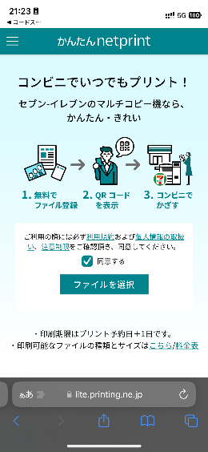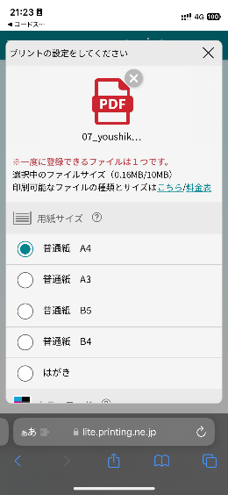[Screen 3 & 4] The paper size is A4, the color mode is color or black and white, and for the smaller size, select "Never" and select "Register."

Screen 3

* Setting a PIN is optional, but you should set it to protect your personal information.

Screen 2

1. [Screen 5] When registration is completed, the print reservation number will be displayed, so make a note of it.

* In the case of smartphones, you can also use a QR code instead of a reservation number.

1. 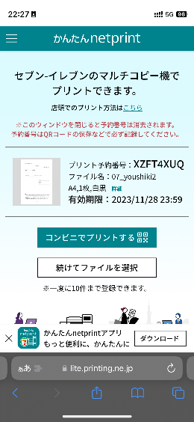On the Seven-Eleven multi-copy machine, press the "Print" button and select "Net Print" as the print type.
2. 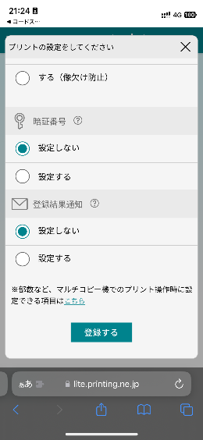Follow the on-screen instructions and enter the print reservation number in Step 5. Enter your PIN if it’s set, pay the fee, and press "Start Printing" to print.

Screen 5

Screen 4

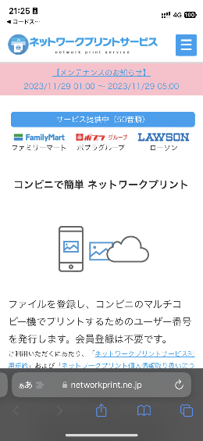

[FamilyMart]

Screen 1

1. [Screen 1 & 2]Access the "Network Print Service" web page.

(<https://networkprint.ne.jp/Lite/>)  
After confirming the consent of network print, click "Select File" and select the PDF file to upload.   
* For information on how to upload a PDF file, see How to attach a file.

1. 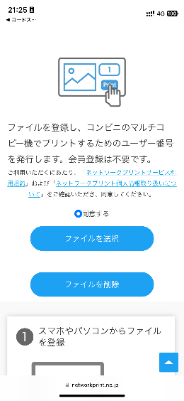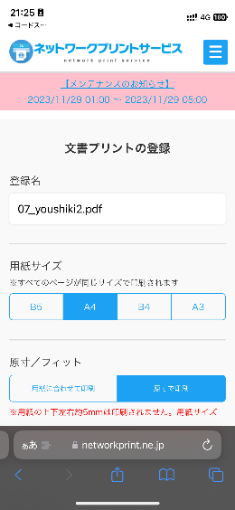[Screen 3 & 4] The paper size is A4, and the original size/fit should be the original size. Select "Register File."

Screen 3

* Setting a PIN is optional, but you should set it to protect your personal information.

Screen 2

1. [Screen 5] When the registration is completed, the user number will be displayed, so make a note of it.
2. On the FamilyMart multi-function copier, press the "Print Service" button and select "Network Print" as the print type.
3. Follow the on-screen instructions and enter the user number in Step 5. Enter your PIN if it’s set, pay the fee, and click "Start Printing" to print.

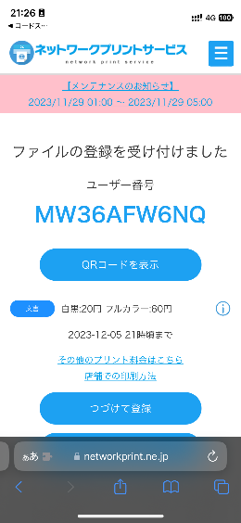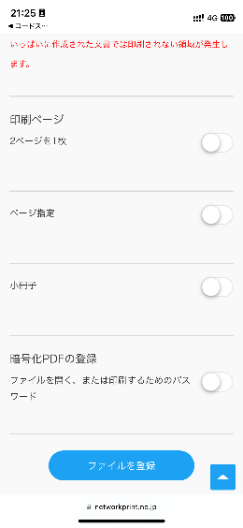

Screen 4

Screen 5

Announcement of successful applicants  
(junior high School)

# STEP１

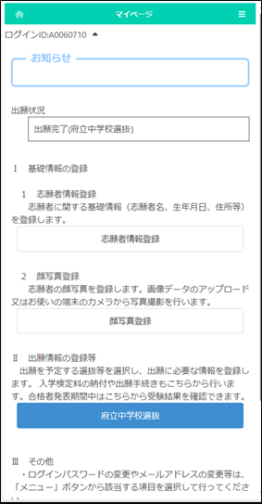

On the My Page screen, select the name of the selection from "II. Register Application Information."

(In the figure on the left, the prefectural junior high school selection button.)

# STEP２

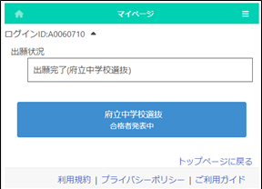

Select the name of the selection with "Announcement of successful applicants" indication.

# STEP３

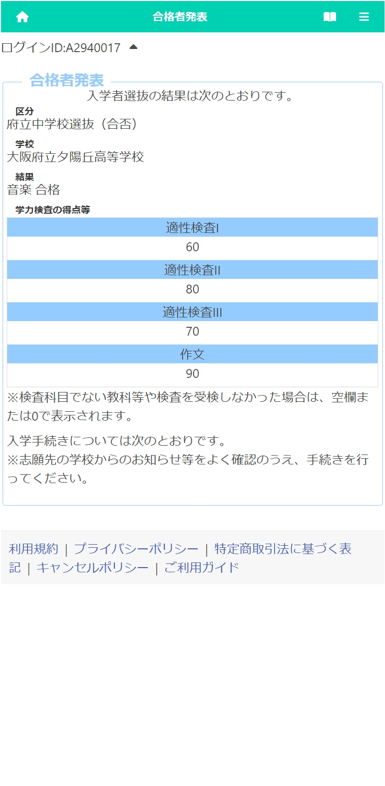

The results of the selection will be displayed.

[Category] and [School] display the name of the selection and the school where you applied for.

[Result] displays the pass/fail result.

The "Test Scores" shows the scores of each test.

Announcement of successful applicants  
(High School)

# STEP１

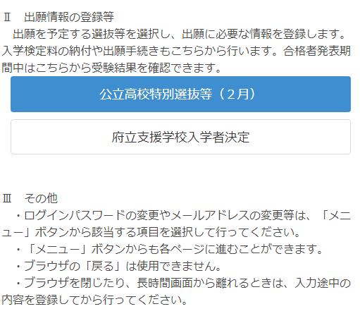

On the My Page screen, select the name of the selection from "II. Register Application Information."

(On the left, the Public High School Special Selection (February)）

# STEP２

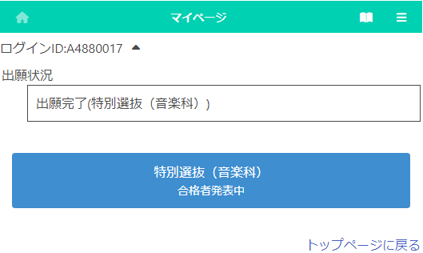

Select the name of the selection with "Announcement of successful applicants" indication.

# STEP３

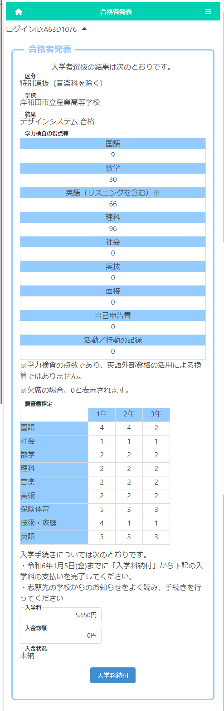

The results of the selection will be displayed.

[Selection] and [School] display the name of the selection and the school where you applied for.

[Result] displays the pass/fail result and the department and the field that you pass.

The “Test Scores” shows the scores of each test.

The "School Report" shows the evaluation submitted by the school in which the applicant is enrolled.



"Application Qualification Screening Approval Form" (available only if "Yes" is selected on the applicant information screen) In the "Admission Application Special Circumstances Approval Form", if applicable, the approval letter will be attached from the button.

* Please refer to here for file attachments.

If applicable, enter the approval number and submit the approval letter for "Approval of Accommodation for Disabilities" and "Approval Letter for Accommodation for Japanese Instruction".

Attach from the button.

* Please refer to here for file attachments.

# STEP4

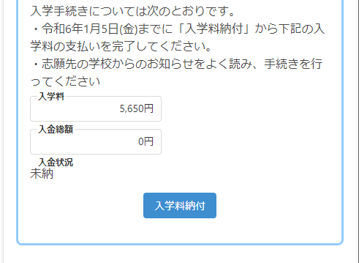

In the case of passing, if the "deadline for payment of admission fee" and "admission fee" is displayed at the bottom of the screen, please press Payment Admission Fee button and complete the payment by the stated date.

**How to attach a file**

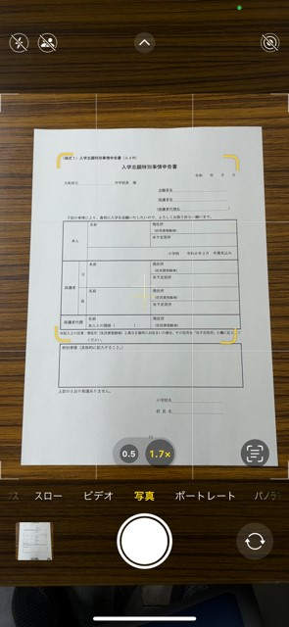[For computers and tablets]

1. Click and select the folder where the file is stored.
2. Click the file you want to attach.

[For smartphones] (The screen differs depending on the model, etc.)

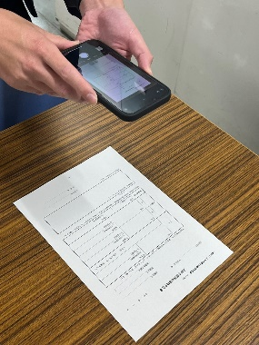* Precautions when taking pictures of documents

◎ Please take a picture of the document from the top so that the entire document can be clearly seen.

○ Please make sure that it is not reflected by light and cannot be seen by shadow.

○ Be careful not to blur the text on the document due to camera shake.

○ Please take a picture as straight as possible.

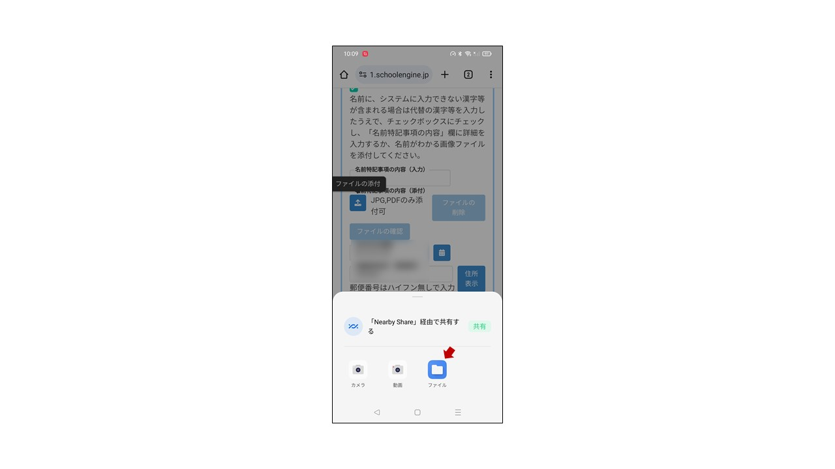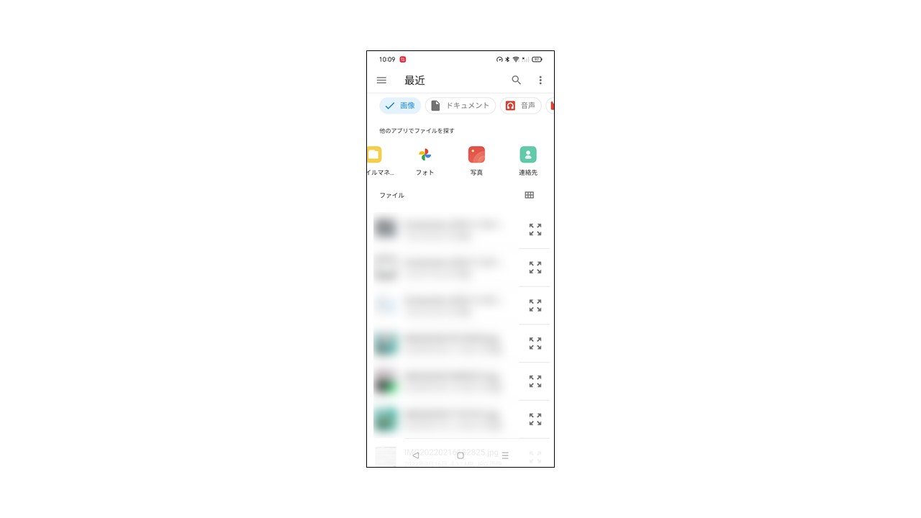

Android：

<To attach the document photographed with the camera>

1. [Screen 1] Click and select "File."

Screen 1

Screen 2

1. [Screen 2] Select "Image" or "Photo" and select a photo taken using the camera app.

<To attach a file stored on your phone>

1. [Screen 1] Click and select "File".



1. [Screen 2] Select the location where the recently added files are stored.
2. [Screen 2] Select the file you want to attach.

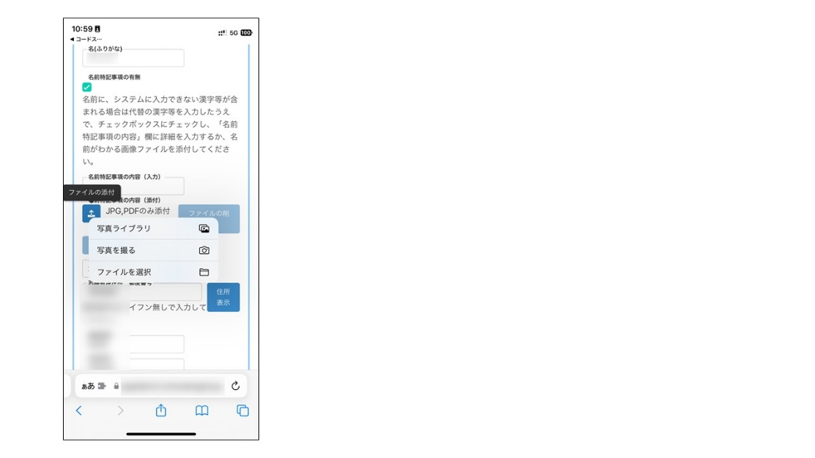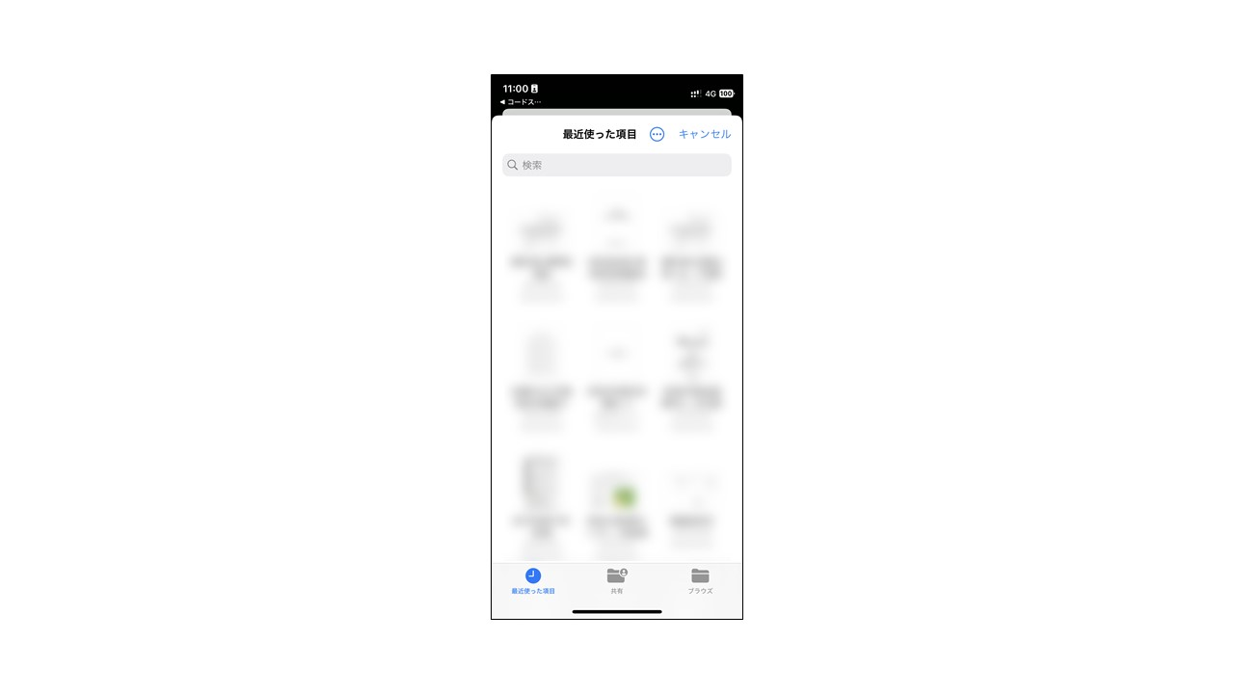iPhone:

<To attach the document photographed with the camera>

1. [Screen 1] Click and select "Photo Library."

Screen 1

Screen 2

1. Select a photo taken using the camera app.

<To attach a file stored on your phone>

1. [Screen 1] Click and select "Choose File."
2. [Screen 2] On the "Browse" screen, select the location where the file is stored.
3. [Screen 2] Select the file you want to attach.

After attaching the file, you can check the contents of the attached file with the check file button.

You can delete the attached file with the delete file button.