The Osaka Edition Roadmap and the Action Plan
toward the Social Implementation of
the Air Mobility Revolution

Osaka Round Table
toward Air Mobility Revolution Social Implementation
March 2022

Contents
I. Establishing the Society with Advanced Air Mobility in Osaka 2
II. Our Approach toward “the Creative City of Urban AAM-Business Model” 4
III. The Osaka Edition Roadmap and the Action Plan 5
Detailed Action Plan: Establish Foundation for Social Implementation of AAM 9
Action Plan #1. Encourage to Conduct PoC 10
Action Plan #2. Develop Vertiport Network 12
Action Plan #3. Develop Business Environment 15
Action Plan #4. Ensure Social Acceptability 20
Detailed Action Plan: Collaborate with Stakeholders 23
Action Plan #5. Collaborate with the National Government 24
Action Plan #6. Collaborate with Local Governments in Osaka Prefecture and the Kansai Region 26
Action Plan #7. Collaborate with Companies Based in Osaka and Participating in Green & Orange Table of Osaka RT 28

I. Establishing the Society with Advanced Air Mobility in Osaka
- Potential of Advanced Air Mobility
Advanced Air Mobility (hereinafter referred to as “AAM”) has the potential to bring new value to people's lives and cities as a daily and short-distance transportation because compared to airplanes and helicopters, AAM requires no runways, makes less noise, emits no greenhouse gases when driven, and is cheaper to maintain than engine-based aircraft. It is expected that AAM will be utilized in various fields, including urban transportation (passenger transport), tourism & leisure, emergency medical services, and disaster response.
As the next-generation mobility, AAM is also expected to significantly impact industry and business, including the creation of new products and services.
Therefore, in August 2018, " the Public-Private Committee for Advanced Air Mobility" was established as a national-level conference body where stakeholders from the public and private sectors participate and discuss.
On December 20 2018, the committee published "Roadmap towards Air Mobility Revolution," which is the world's first roadmap for the social implementation of AAM.
- Potential of Osaka and the Kansai Region
Toward the "expansion of practical application" of AAM in the 2030s, implementing the commercial flight operation of AAM at the Expo 2025 Osaka, Kansai, Japan (hereinafter referred to as "Expo2025") is a shared milestone among the public and private sectors. Expo2025 will be an excellent opportunity for many people to experience AAM.
In addition, Osaka and the Kansai Region is a promising market because of its diverse historical, cultural, and natural attractions, including many World Heritage Sites, hot spring resorts, and the integrated resort project at the land adjacent to the Expo2025 venue. Moreover, with Expo2025 venue and airports, the bay area is blessed with a geographical location which is ideal for demonstration and implementation of AAM.
- Osaka Round Table toward Air Mobility Revolution Social Implementation
In November 2020, Osaka Prefecture launched Osaka Round Table toward Air Mobility Revolution Social Implementation (hereafter referred to as “Osaka RT”), with the immediate goal of implementing commercial flights at Expo2025.
One of the primary missions of Osaka RT is to promote practical discussions and proof of concepts (hereafter referred to as “PoC”) that will contribute to system design and rulemaking at the national level, to identify specific and real issues, and to make proposals for the social implementation of AAM.
Although there are many challenges to overcome to implement AAM, we will promote effort with the cooperation and collaboration among government, academia, and industry especially businesses who aim to implement business plans in Osaka. We also care for the consistency with the national government and Japan Association for the 2025 World Exposition by sharing information and functions.
- Toward the Social Implementation of Advanced Air Mobility
The economic impact of the implementation of AAM will spill over to not only aircraft development and aviation-related services but also surrounding industries such as training of pilots and mechanics, maintenance of aircraft, maintenance and operation of vertiports, air traffic control, and insurance to support commercial operations.
Once the specifications for an aircraft that meets safety and environmental standards are determined, the economic impact of AAM will also extend to industries where Osaka has strengths such as the manufacturing of materials and parts.
Furthermore, in the expansion stage, business opportunities will emerge in various scenes of life in Osaka such as unprecedented services focusing on the feature of AAM: free movement from point to point in the sky.
In FY2021, Osaka RT established four working groups and have discussed devising "the Osaka Edition Roadmap," which will serve as a timetable for future efforts toward the implementation of AAM in Osaka, with conducting PoC.
From FY2022 onward, based on the Osaka Edition Roadmap, the members of Osaka RT will carry out their role roles and steadily promote the efforts toward the implementation of AAM in Osaka by 2025.

II. Our Approach toward “the Creative City of Urban AAM-Business Model”
Osaka RT has adopted the concept of "“the Creative City of Urban AAM-Business Model " as the basis for the Osaka Edition Roadmap and shared the vision that " Osaka will steadily develop as a city that creates new mobility-based business models."
Based on these concept and vision, we define three steps of business expansion and development as "Start-up Phase," "Expansion Phase," and "Maturity Phase."
- "Start-up Phase" (around FY2025)
"Start-up Phase" is the stage whose shared immediate goal is implementing commercial flights at Expo2025. In this phase, we aim to implement commercial operations on fixed flight routes with pilots on board so that many people can feel the reality of new service with AAM and disseminate what AAM looks like to the world.
- "Expansion Phase" (around FY2030)
"Expansion Phase" is the stage in which flight operations will shift to automatic & autonomous unmanned and on-demand operations, including various area within urban areas. In this phase, we aim to expand the use of AAM in daily life and develop related businesses and innovations that support these services.
- "Mature Phase" (around FY2035)
"Mature Phase" is the stage in which enlargement of size, diversification of type, mass production and expanding the range of services is expected. In this phase, we aim to familiarize the use of AAM for daily movement, to improve quality of life (QOL) for prefectural residents, and to develop Osaka's industry and economy.
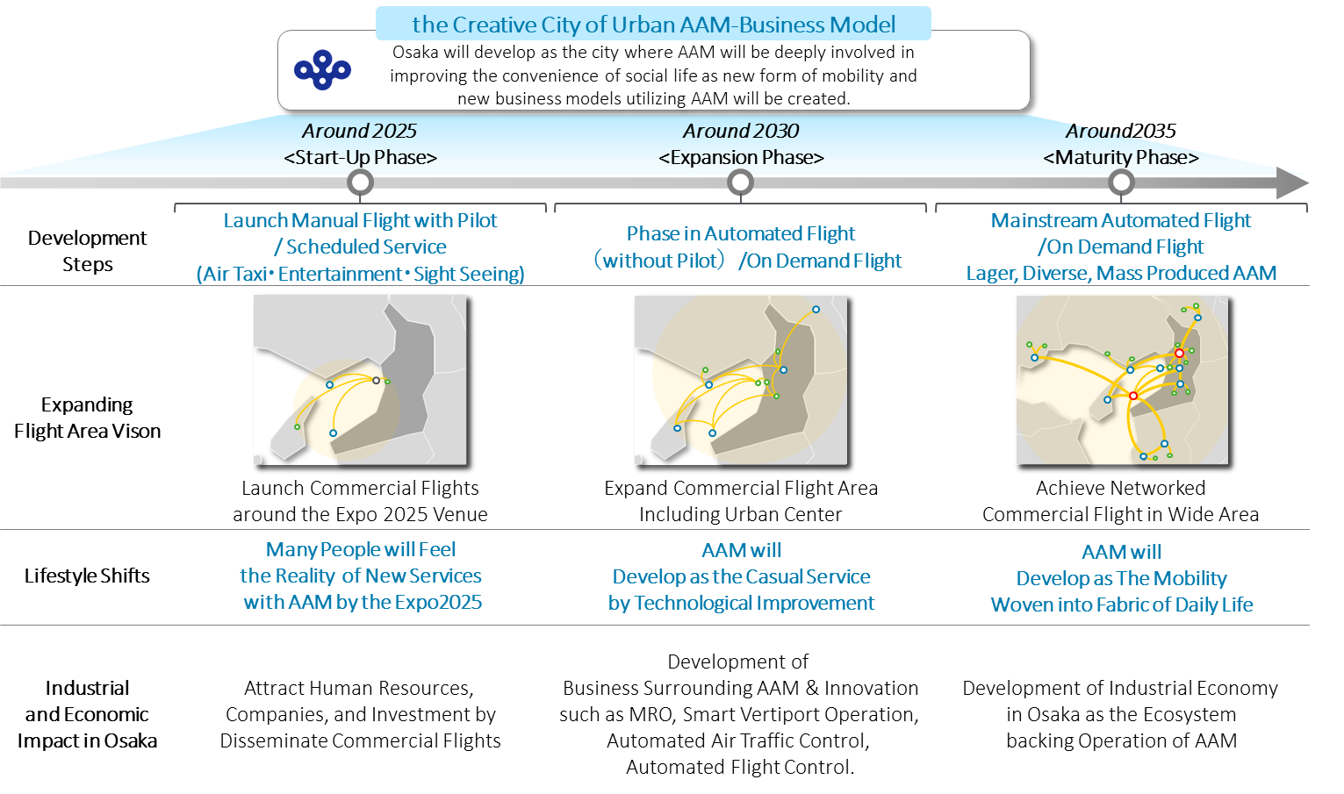
Figure 1 : The Concept of the Osaka Edition Roadmap

III. The Osaka Edition Roadmap and the Action Plan
"Roadmap towards Air Mobility Revolution," a roadmap formulated by the Japanese government, outlines the future process of establishing regulations and standards for aircraft safety and skill certification, as well as technological development to ensure and to certify safety and reliability, and technologies for automatic flight, air traffic control, and electric propulsion.
The Osaka Edition Roadmap is consistent with the national roadmap and provides the course of actions for the public and private sector to make efforts toward the social implementation in Osaka Prefecture.
The Osaka Edition Roadmap outlines the steps for social implementation up to Expo2025. FY2022 is positioned as a period of business preparation and consolidation to accelerate business development and demonstrations in the FY2023 and beyond. It also includes the action plan that outlines specific actions to be taken in each fiscal year.
Each action plan shows the measures to be taken based on the roles and responsibilities of the Osaka Prefectural Government, local municipalities, and private sector. We also hope for the creation of opportunities for co-creation and collaboration among the various stakeholders.
The Osaka Edition Roadmap and action plan are based on the consensus of the members of Osaka RT as of March 2022. In addition, the roadmap and action plan will be updated in line with technological development trends and social conditions related to AAM.
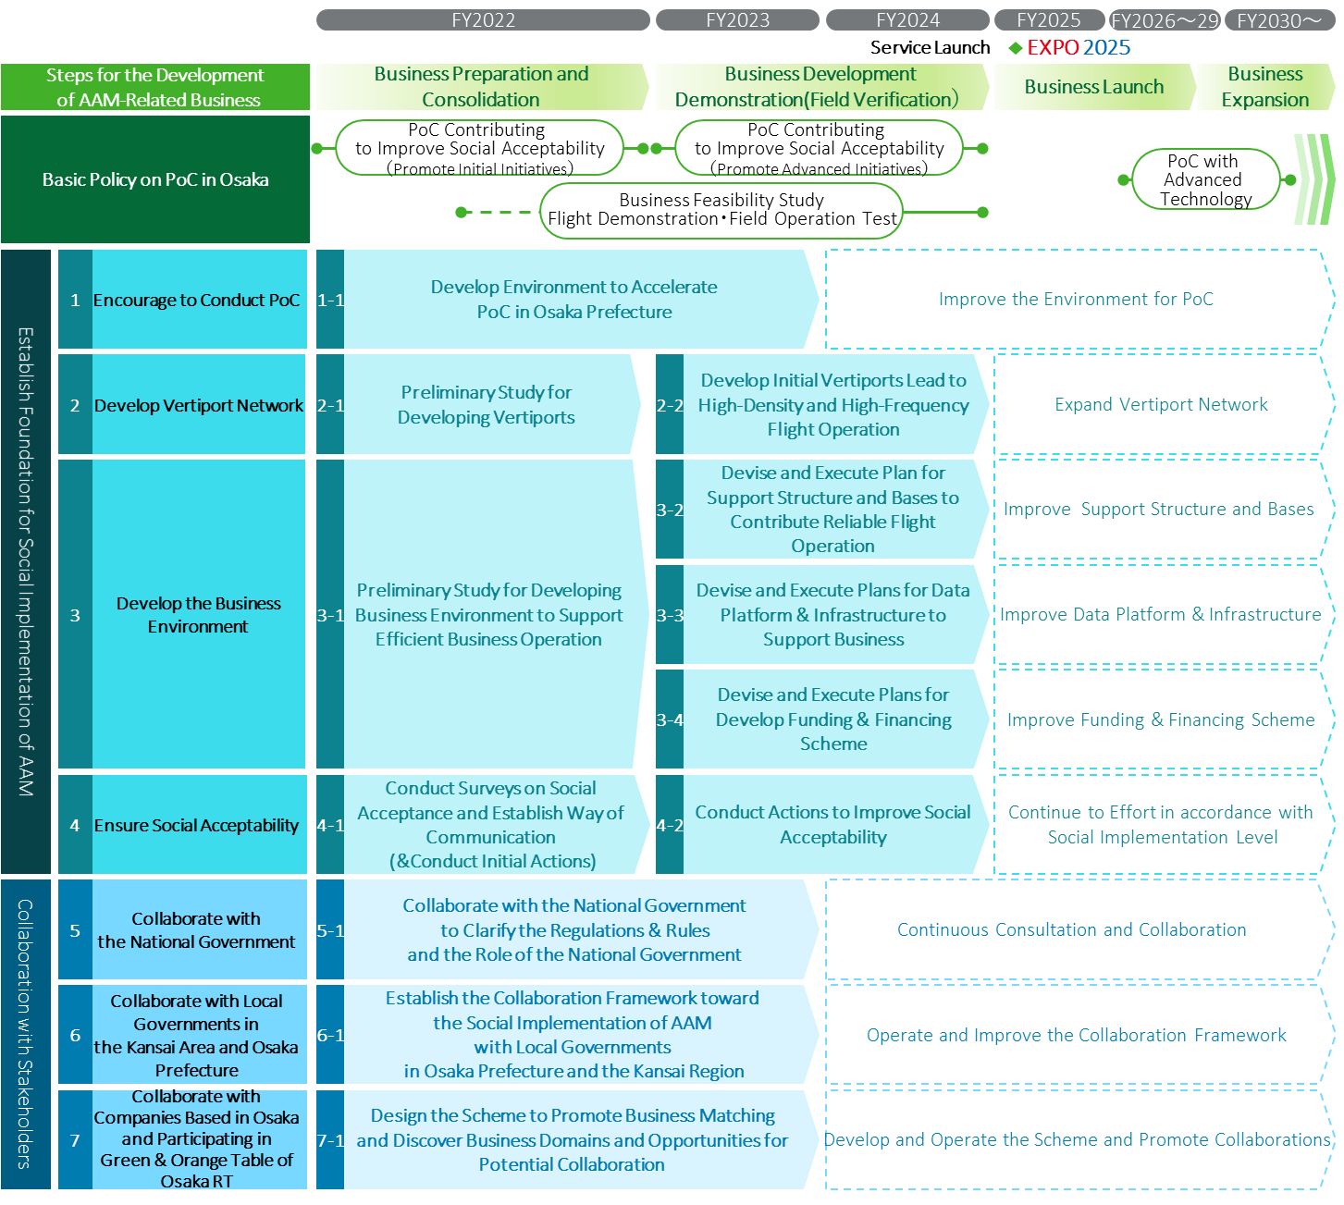
Figure 2 : The Osaka Edition Roadmap
- Overview of Actions to Establish Foundation for Social Implementation of AAM
The followings are overview of the items to be addressed to improve environment for the social implementation of AAM. .
1-1 | Develop Environment to Accelerate PoC in Osaka Prefecture | Develop environment for PoC, through clarifying the requirements of private sector to conduct PoC in Osaka Prefecture and establish support scheme for PoC such as test fields and administrative support.
2-1 | Preliminary Study for Developing Vertiports | Clarify the course of action to develop vertiports through studying the requirements and functions of facilities and equipment necessary for vertiports and investigating potential locations for vertiports and ensuring the locations for vertiports installation.
2-2 | Develop Initial Vertiports Lead to High-Density and High-Frequency Flight Operation | Devise and execute plans for developing vertiports based on the course of action devised in the action #2-1.
3-1 | Preliminary Study for Developing Business Environment to Support Efficient Business Operation | Research business model for AAM based on expected flight routes & use case and clarify the course of action to develop "to-be business environment” which is composed of essential element for AAM-related business such as MRO hub, emergency evacuation facility, training and education center, data platform & infrastructure, and finance scheme.
3-2 | Devise and Execute Plans for Support Structure and Bases to Contribute Reliable Flight Operation | Devise and execute plans for developing support structure and bases (such as MRO hub, evacuation facility, training center, and human resource pool) based on the course of action devised in the action plan #3-1.
3-3 | Devise and Execute Plans for Data Platform & Infrastructure to Support Business | Devise and execute plans for the development of data platform & infrastructure based on the course of action considered in the action #3-1.
3-4 | Devise and Execute Plans for Develop Finance Scheme | Devise and execute plans for the development of finance scheme based on the course of action considered in the action plan #3-1.
4-1 | Conduct Surveys on Social Acceptance and Establish Way of Communication  (&Conduct Initial Actions) | Conduct surveys such as study on the current level of social acceptance and case study of leading initiatives in Japan and foreign countries that contribute to consider the measures to improve social acceptability. In addition, develop communication platforms that contribute to sharing opinions and information from diverse perspectives and effective and efficient communication with the local communities and citizens.
4-2 | Conduct Actions to Improve Social Acceptability | Improve social acceptability by investigating and announce various facts and data that contribute to improving social acceptability, as well as implementing measures to improve the benefits and minimize the negative impact of AAM on communities and citizens.

- Overview of Actions for Working with Stakeholders
The followings are overview of the items to be addressed to enhance cooperation with the national government, local governments in and outside of the prefecture, businesses, and organizations toward the social implementation of AAM.
5-1 | Collaborate with the National Government to Clarify the Regulations & Rules and the Role of the National Government | Request that the national government promote necessary actions toward the social implementation of AAM based on the discussions at Osaka RT and promote collaborative initiatives toward the social implementation of AAM in the Expo2025.
6-1 | Establish the Collaboration Framework toward the Social Implementation of AAM  with Local Governments in Osaka Prefecture and the Kansai Region | Devise and execute the policy to establish the collaboration framework with local governments in Osaka Prefecture and the Kansai Region, regardless of the status of their attempt to promote actions for the social implementation of AAM.
7-1 | Design the Scheme to Accelerate Business Matching | Design the scheme to increase the interest of private sector to enter the business and create opportunities of collaboration among domestic and foreign companies in Osaka Prefecture and the Kansai Region.

Detailed Action Plan:
Establish Foundation for Social Implementation of AAM

Encourage to Conduct PoC
- Develop environment and to encourage PoC to promote service and technology development related to AAM in Osaka Prefecture and the Kansai Region to attract and ensure smooth implementation of PoC in Osaka Prefecture.
The Approach of Action Plan #1
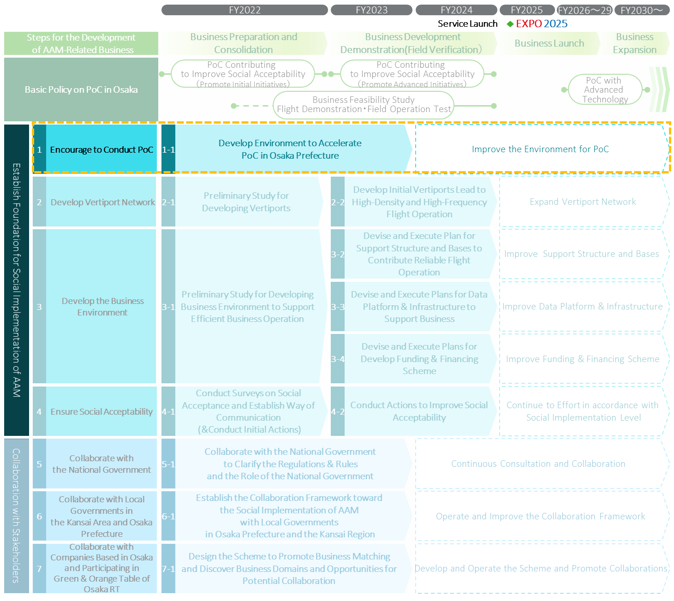

  - Develop Environment to Accelerate PoC in Osaka Prefecture
Timeframe
- FY2022～FY2023
Action Details
- Clarify the requirements on environment for PoC such as test fields, administrative support for PoC, based on the opinion of companies and organizations who intend to conduct PoC to implement the commercialization of AAM-related business in Osaka Prefecture and the Kansai Region.
- Improve environment and scheme to support various PoC in Osaka Prefecture including making candidate list of public and private properties that can be leased or offered as test fields.
The example of Consideration
Requirements on Environment for PoC | Potential Locations for Test Fields
- Potential contents of PoC.  - Requirements on test fields and environment to conduct PoC such as requirements on land, flight area, surrounding environment.  - Requirements on administrative support. | - Information about existing and potential location of test fields owned by public and private sectors, including information about the current availability and future potential development plan.  - Tolerance of stakeholders around the potential locations of test fields for the PoC.
Primary Roles for Each Party
Osaka Prefectural Government | - Osaka Prefectural Government will consider support package for PoC such as financial support and coordination with related organizations based on the leading cases of support for PoC conducted by the national government and local municipalities.  - Osaka Prefectural Government will support conducting surveys on the opinion of private sector about the requirements for test fields.  - Osaka Prefectural Government will support investigation on properties that can be utilized as test fields.  - Osaka Prefectural Government will consider supporting package for private sector that intends to develop its test fields, by leasing public properties owned by Osaka Prefectural Government.
Local Municipalities | - Local municipalities will consider measures to support PoC such as financial support and coordination with related organizations  - Local municipalities will conduct surveys toward improving environment for PoC such as surveys on the willingness of private sector to conduct PoC or the willingness of landowners to lease or offer their property for test fields.  - Local municipalities will consider supporting package for private sector, which intends to develop its test fields by leasing public properties owned by Osaka Prefectural Government.
Private Sector | - Private sector will support the surveys to develop test fields conducted by Osaka prefectural government and local municipalities.  * This plan does not prevent private sector from developing own test fields for the PoC in cooperation with local municipalities.

Develop Vertiport Network
- Clarify the course of action for efficient and effective development of vertiports network for AAM to realize the future vision of high-density, high-frequency operations of AAM in Osaka Prefecture and the Kansai Region.
- Promote the construction of vertiports incorporation with private sector, Osaka Prefectural Government, local municipalities, and other stakeholders based on the course of action.
The Approach of Action Plan #2
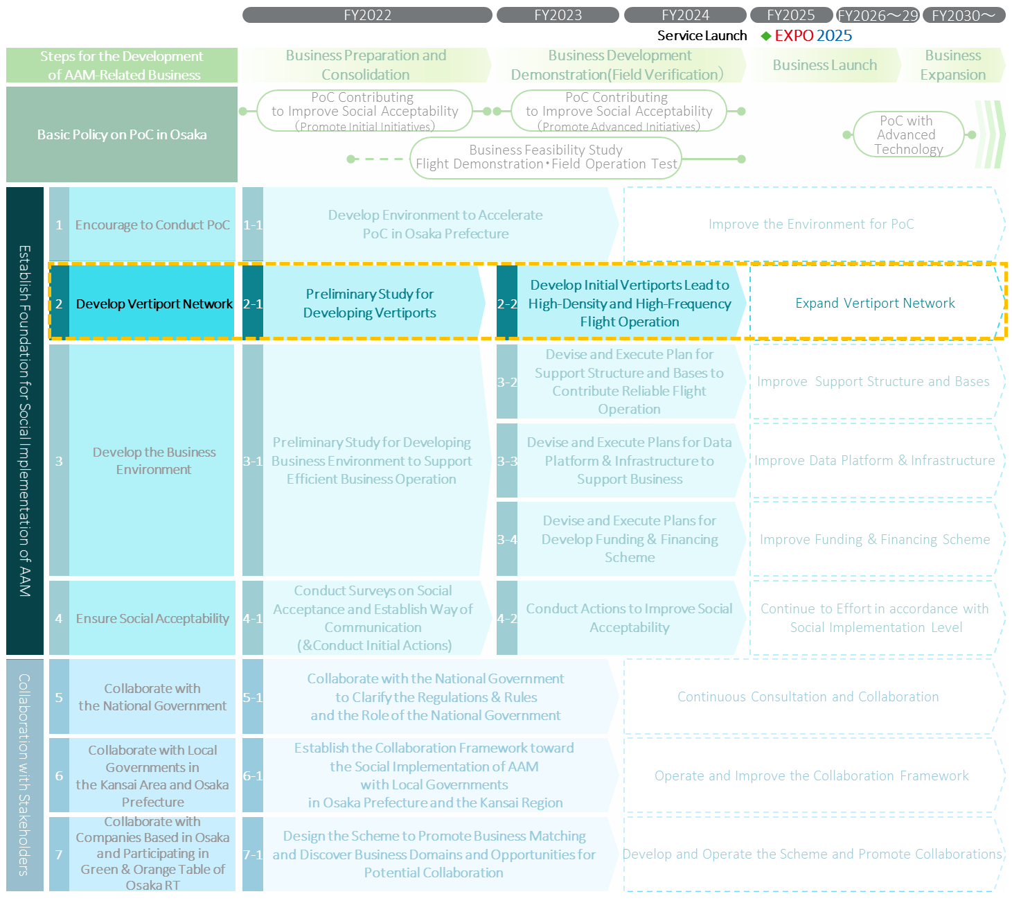

  - Preliminary Study for Developing Vertiports
Timeframe
- FY2022
Action Details
- Clarify the course of action to develop vertiports in Osaka Prefecture and the Kansai Region by studying the requirements and function of facilities and equipment necessary for vertiports.
- Consider the necessary measures to ensure locations for vertiports installations.
The Example of Considerations
The Requirements and Function of Vertiport | Potential location for Vertiport Installation
- The requirements and function of facilities and equipment necessary for vertiports.  - Number of vertiports required.  - The criteria to determine the location of vertiports with priority.  - The requirements and criteria of location suitable for vertiports. | - Specific candidate locations for vertiports installation.  - Possibility for related businesses such as construction companies or real estate companies to participate in vertiports development, and willingness of landowners to provide lands for vertiports installation.  - Willingness of local municipalities to attract and to install vertiports to their cities and towns.
Primary Roles for Each Party
Osaka Prefectural Government | - Osaka Prefectural Government will conduct necessary preliminary studies such as studying the requirements for vertiports installation and searching candidate location for vertiports.  - Osaka Prefectural Government will also consider its roles and necessary support for the development of vertiports.
Local Municipalities | - Local municipalities will conduct necessary surveys such as searching candidate locations for vertiports and willingness of landowners to provide properties for vertiports installation.  - Local municipalities will also provide the necessary information to consider vertiports installation incorporation with Osaka Prefectural Government and other stakeholders.  - Local municipalities will consider their roles and necessary support for the development of vertiports.
Private Sector | - Private sector will support Osaka Prefectural Government and local municipalities to conduct surveys by providing knowledge and information about the requirements and criteria of location suitable for vertiports.  - Private sector will also consider the business policy to develop vertiports incorporation with Osaka Prefectural Government and local municipalities.  *This plan does not prevent private sector from conducting surveys to develop their own business.

  - Develop Initial Vertiports Lead to High-Density and High-Frequency Flight Operation
Timeframe
- FY2023～FY2024
Action Details
- Devise and execute plans for developing vertiports based on the course of action devised in the action #2-1.
Primary Roles for Each Party
Osaka Prefectural Government | - Osaka Prefectural Government will provide the necessary support for private sector such as financial support and leasing public land to encourage developing vertiports.  - Osaka Prefectural Government will also consider clarifying and accelerating the administrative permission procedure of vertiports construction, enacting necessary ordinances.  - In addition, Osaka Prefectural Government will also consider collaboration and support for local municipalities.
Local Municipalities | - Local municipalities will provide the necessary support for private sector such as leasing public land or coordinating with local community and citizens to encourage developing vertiports in accordance with fundamental policies such as town development vision.
Private Sector | - Private sector will develop vertiports incorporation with Osaka Prefectural Government and local municipalities.  *This plan does not prevent private sector from developing vertiports as their own business.

Develop Business Environment
- Clarify the course of action to consolidate “to-be business environment” (such as MRO hub, emergency evacuation facility, training center, human resource pool, data platform & infrastructure, and finance scheme, which are necessary for AAM-related business), based on the expected business model of AAM-related business in Osaka Prefecture and the Kansai Region.
- Promote the consolidation of “to-be business environment” incorporation with private sector, Osaka Prefectural Government, local municipalities, and other stakeholders Based on the course of action.
The Approach of Action Plan #3
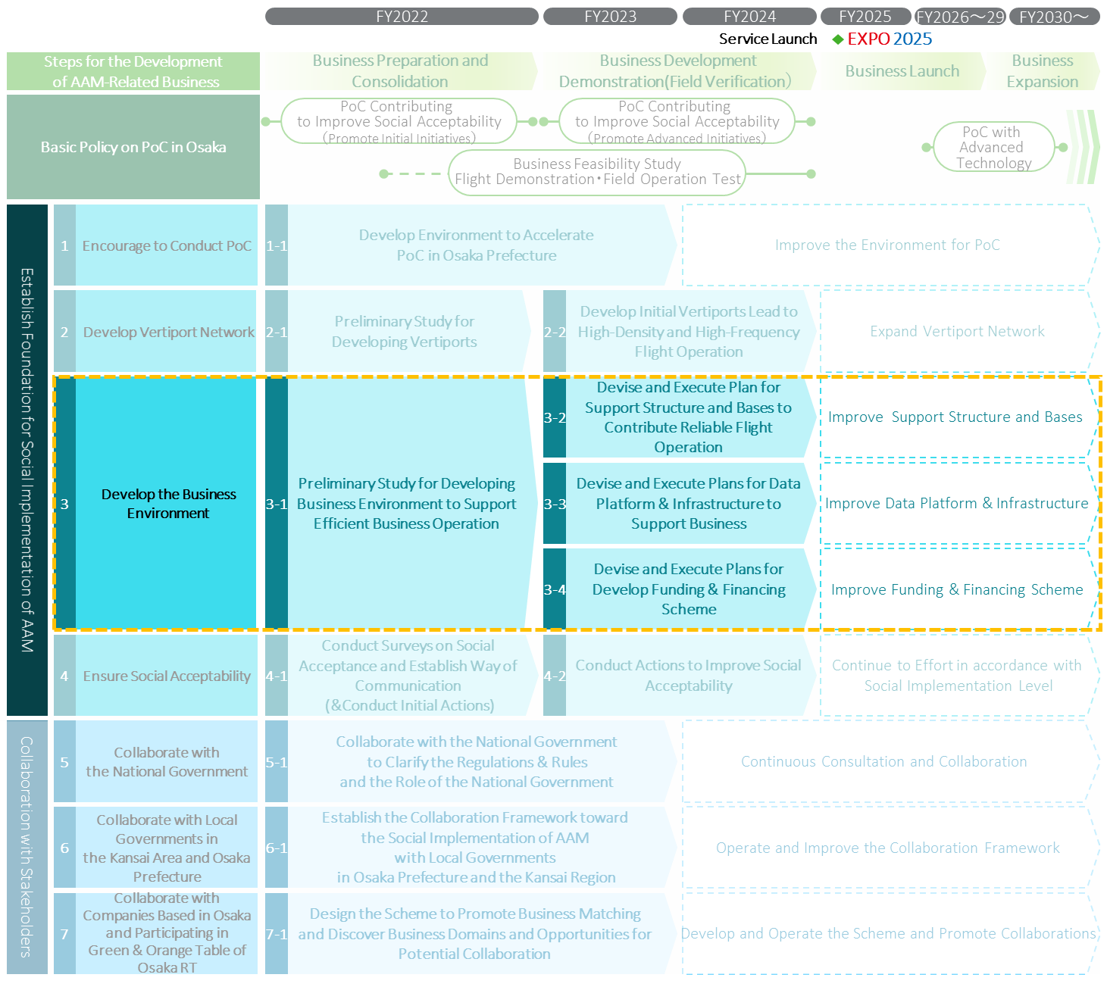

  - Preliminary Study for Developing Business Environment to Support Efficient Business Operation
Timeframe
- FY2022
Action Details
- Research business models for AAM based on expected flight routes and use cases in Osaka Prefecture and the Kansai Region.
- Clarify the course of action to develop “to-be business environment” which is composed of essential element for AAM-related business such as MRO hub, emergency evacuation facility, training and education center, data platform & infrastructure, and finance scheme.
The Example of Considerations
Study on Business Model | Research on Fundamental Information  for Environmental Development
- Expected flight routes and use cases.  - Market growth and maturity scenario.  - Typical business models.  - Business economics simulation and evaluation based on overall operational costs including electricity charging cost. | - The functional requirements for basic operational support structure and hub such as required facilities & equipment and potential locations of hub.  - The functional requirements for data platform & infrastructure such as business domains that need data platform & infrastructure and required data content.  - Finance needs and possible finance options.
Primary Roles for Each Party
Osaka Prefectural Government | - Osaka Prefectural Government will support the research that widely contributes to private sector to consider business entry.  - Osaka Prefectural Government will also consider its roles and necessary support for the development of organizations and bases which are indispensable for AAM-related business
Local Municipalities | - Local municipalities will cooperate with surveys of potential locations for fundamental support hub, including the intentions of landowners.  - Local municipalities will also consider providing data for the data platform & infrastructure and establishing their own finance scheme.
Private Sector | - Private sector will cooperate with surveys conducted by Osaka Prefectural Government and local municipalities by providing knowledge and information about the functional requirements on “to-be Business Environment” for AAM-related business.  - Private sector will also consider the course of action to develop “to-be business environment” necessary for AAM-related business.

  - Devise and Execute Plans for Support Structure and Bases to Contribute Reliable Flight Operation
Timeframe
- FY2023～FY2024
Action Details
- Devise and execute plans for developing support structure and bases (such as MRO hub, evacuation facility, training center, and human resource pool) based on the course of action devised in the action plan #3-1.
The Example of Considerations
Plans for Developing Support Structure and Bases
- Detailed policy for developing support structure and bases such as specific locations for bases, number of bases required, and priority for developing and constructing.
- The entity responsible for development and operation of support structure and bases.
- The timeline for the development and construction of support structure and bases and the roles and responsibilities among stakeholders.
Primary Roles for Each Party
Osaka Prefectural Government | - Osaka Prefectural Government will provide the necessary support for private sector such as financial support or leasing public land to promote developing support structure.  - Osaka Prefectural Government will also consider collaboration and support for local municipalities who support private sector.
Local Municipalities | - Local municipalities will provide the necessary support for private sector such as leasing public properties.
Private Sector | - Private sector will devise the plan to develop basic operational support structure and bases incorporation with Osaka Prefectural Government and local municipalities  * This plan does not prevent private sector from developing support structure and bases as their own business.

  - Devise and Execute Plans for Data Platform & Infrastructure to Support Business
Timeframe
- FY2023～FY2024
Action Details
- Devise and execute plans for the development of data platform & infrastructure based on the course of action considered in the action #3-1.
The Example of Considerations
Plans for the Development of Data Platform & Infrastructure
- The architecture of data platform & infrastructure.
- Detailed policy for developing and constructing data platform & infrastructure (such as detailed functional requirements and priority for development) .
- The entity responsible for development and operation of data platform & infrastructure.
- The timeline for developing data platform & infrastructure and roles and responsibilities among stakeholders.
Primary Roles for Each Party
Osaka Prefectural Government | - Osaka Prefectural Government will provide the necessary support for private sector such as financial support and providing available data that Osaka Prefectural Government retains.
Local Municipalities | - Local municipalities will provide the necessary support for private sector such as providing available data that Local municipalities retain.
Private Sector | - Private sector will devise the plan to develop data platform & infrastructure and to implement measures to develop data platform & infrastructure incorporation with Osaka Prefectural Government and local municipalities  *This plan does not prevent private sector from developing data platform & infrastructure as their own business.

  - Devise and Execute Plans for Develop Finance Scheme
Timeframe
- FY2023～FY2024
Action Details
- Devise and execute plans for the development of finance scheme based on the course of action considered in the action plan #3-1.
The Example of Considerations
Plans for the Development of Finance Scheme
- Detailed policy for the development of finance scheme such as finance method.
- Businesses that are expected to be the recipients of funds by business scale and business contents.
- Targeted volume of funding.
- The timeline for the development of finance scheme.
Primary Roles for Each Party
Osaka Prefectural Government | - Osaka Prefectural Government will devise the concept of finance scheme and development policy and develop finance scheme in cooperation with local municipalities and private sector.  - In addition, Osaka Prefectural Government will also promote cooperation with the national government in this area.
Local Municipalities | - Local municipalities will consider the concept and development policy of their own finance scheme that contributes to the implementation of flights in their city and town, and implement measures to develop finance scheme in cooperation with Osaka Prefectural Government and private sector.
Private Sector | - Private sector will devise and execute the plan to develop finance scheme incorporation with Osaka Prefectural Government and local municipalities.  *This plan does not prevent private sector from developing data platform & infrastructure as their own business.

Ensure Social Acceptability
- Establish way of communication to improve social acceptability necessary for the social implementation of AAM in Osaka Prefecture and the Kansai Region.
- Promote actions to improve social acceptability toward the social implementation of AAM and build a trusted relationship with local communities and citizens.
The Approach of Action Plan #4
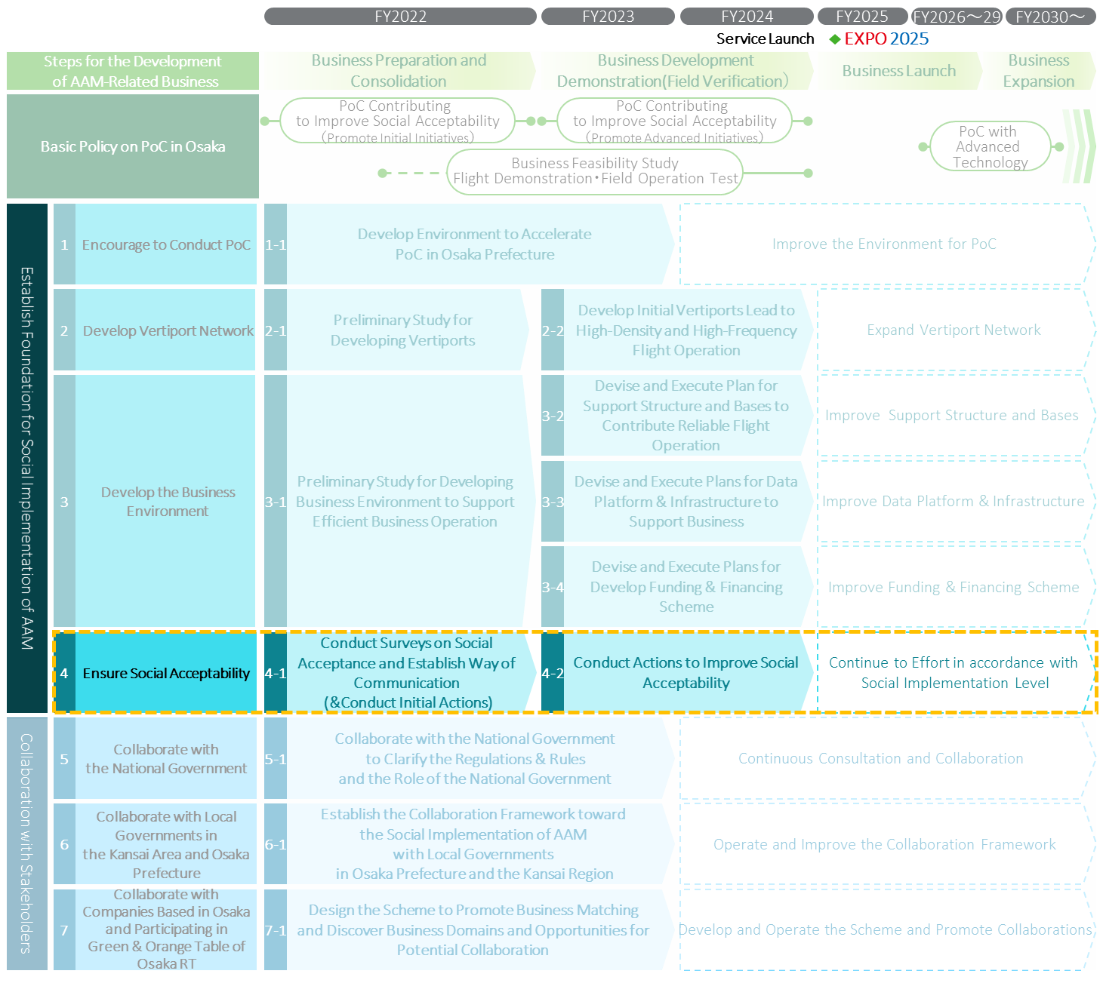

  - Conduct Surveys on Social Acceptance and Establish Way of Communication (&Conduct Initial Actions)
Timeframe
- FY2022
Action Details
- Conduct surveys contributing to consider the measures to improve social acceptance such as study on the current level of social acceptance in Osaka Prefecture and its vicinity and case study of leading initiatives to improve social acceptability in Japan and foreign countries.
- Develop communication platforms that contribute to sharing opinions and information from diverse people including experts, and to communicating with local communities and citizens.
- Implement the initial actions as to improve social acceptability.
The Example of Considerations
Surveys on The Current Level of Social Acceptance and Possible Measures to Improve Social Acceptance | Communication Platforms
- Surveys on the current level of social acceptance in Osaka Prefecture and the Kansai Region.  - The segments that needed to be focused on to improve social acceptance level such as business operators and citizens living under the flight routes and around vertiports.  - Possible measures to improve social acceptability based on examples of leading initiatives to improve social acceptance in Japan and foreign countries. | - Effective communication platforms for each segment such as professional media, symposiums, seminars, and public relations facility.  - The timeline for developing communication platforms and roles and responsibilities among stakeholders.
Primary Roles for Each Party
Osaka Prefectural Government | - Osaka Prefectural Government will conduct survey on the current level of social acceptance toward AAM in local communities and citizens.  - In addition, Osaka Prefectural Government will consider its roles and necessary support for developing communication platforms.  - Osaka Prefectural Government will also support the initial actions promoted by business operators in this area.
Local Municipalities | - Local municipalities will conduct a survey on the current level of social acceptance toward AAM in local communities and citizens.  - Local municipalities will consider their roles for developing communication platforms and necessary support, including cooperation with municipal councils and neighborhood associations.
Private Sector | - Private sector will conduct surveys incorporation with Osaka Prefectural Government and local municipalities.  - Private sector will also consider the initial actions to improve social acceptability.  *This plan does not prevent private sector from conducting surveys and promoting actions for their own business.

  - Conduct Actions to Improve Social Acceptability
Timeframe
- FY2023～FY2024
Action Details
- Investigate and announce various facts and data contributing to the improvement of social acceptability such as the facts and data showing positive benefits and littleness of negative impacts on local communities and citizens by social implementation of AAM.
- Implement measures to increase benefits and minimize negative impact on local communities and citizens.
Primary Roles for Each Party
Osaka Prefectural Government | - Osaka Prefectural Government will promote actions to improve social acceptability.  - In addition, Osaka Prefectural Government will support the actions conducted by private sector and local municipalities.
Local Municipalities | - Local Municipalities will promote actions to improve social acceptability.  - In addition, Local Municipalities will support the actions conducted by private sector.
Private Sector | - Private sector will promote actions to improve social acceptability in cooperation with Osaka Prefectural Government and local municipalities.  *This plan does not prevent private sector from promoting actions as their own business.

Detailed Action Plan:
Collaborate with Stakeholders

Collaborate with the National Government
- Request the national government to promote necessary actions for the social implementation of AAM.
- Promote the collaborative initiatives to build momentum toward the social implementation of AAM in Expo2025.
- Promote continuous collaboration based on the discussion at Osaka RT, including requesting additional action based on the results of various actions.
The Approach of Action Plan #5
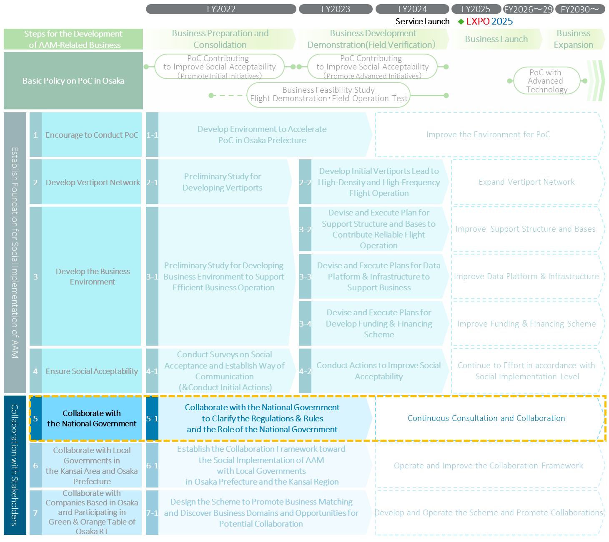

5-1. Collaborate with the National Government to Clarify the Regulations & Rules and the Role of the National Government
Timeframe
- FY2022～FY2023
Action Details
- Request that the national government promote necessary actions based on the discussions at Osaka RT: establishing the regulations, rules, and guidelines; promoting deregulations; offering definite vision especially about air traffic control and telecommunication; promoting standardization; providing financial support for related projects; and enhancing the partnership with local governments to improve social acceptability.
- Promote the collaborative initiatives to build momentum toward the social implementation of AAM in Expo2025.
The Example of Requests
Request Items to the National Government
- Request for developing the regulation, rules, and guidelines, and for promoting deregulation about design and production, test flight, flight service, air traffic control, and constructing and operating vertiports.
- Request for clarifying the vision as the Japanese government, especially about air traffic control and telecommunication.
- Request for promoting standardization.
- Request for providing financial support.
- Request for promoting collaborative initiatives to improve social acceptability.
Primary Roles for Each Party
Osaka Prefectural Government | - Osaka Prefectural Government will lead requesting and collaborating with the national government based on discussions at Osaka RT.  - Osaka Prefectural Government will promote the collaborative initiatives to build momentum toward the social implementation of AAM in Expo2025.
Local Municipalities | - Local municipalities will support requests and collaborative initiatives with the national government led by Osaka Prefectural Government by sharing the issues to request the national government to promote necessary actions with Osaka RT.
Private Sector | - Private sector will support request and collaborative initiatives with the national government led by Osaka Prefectural Government through sharing the issues which they want to request to the national government, with Osaka RT.

Collaborate with Local Governments in Osaka Prefecture and the Kansai Region
- Enhance the collaboration to facilitate communication among local governments in Osaka Prefecture and the Kansai Region regardless of the status about their attempt to promote social implementation of AAM.
- Based on the collaboration, promote the collaborative initiatives to boost momentum, share the knowledge of developing vertiports and flight routs, and improve social acceptability.
The Approach of Action Plan #6
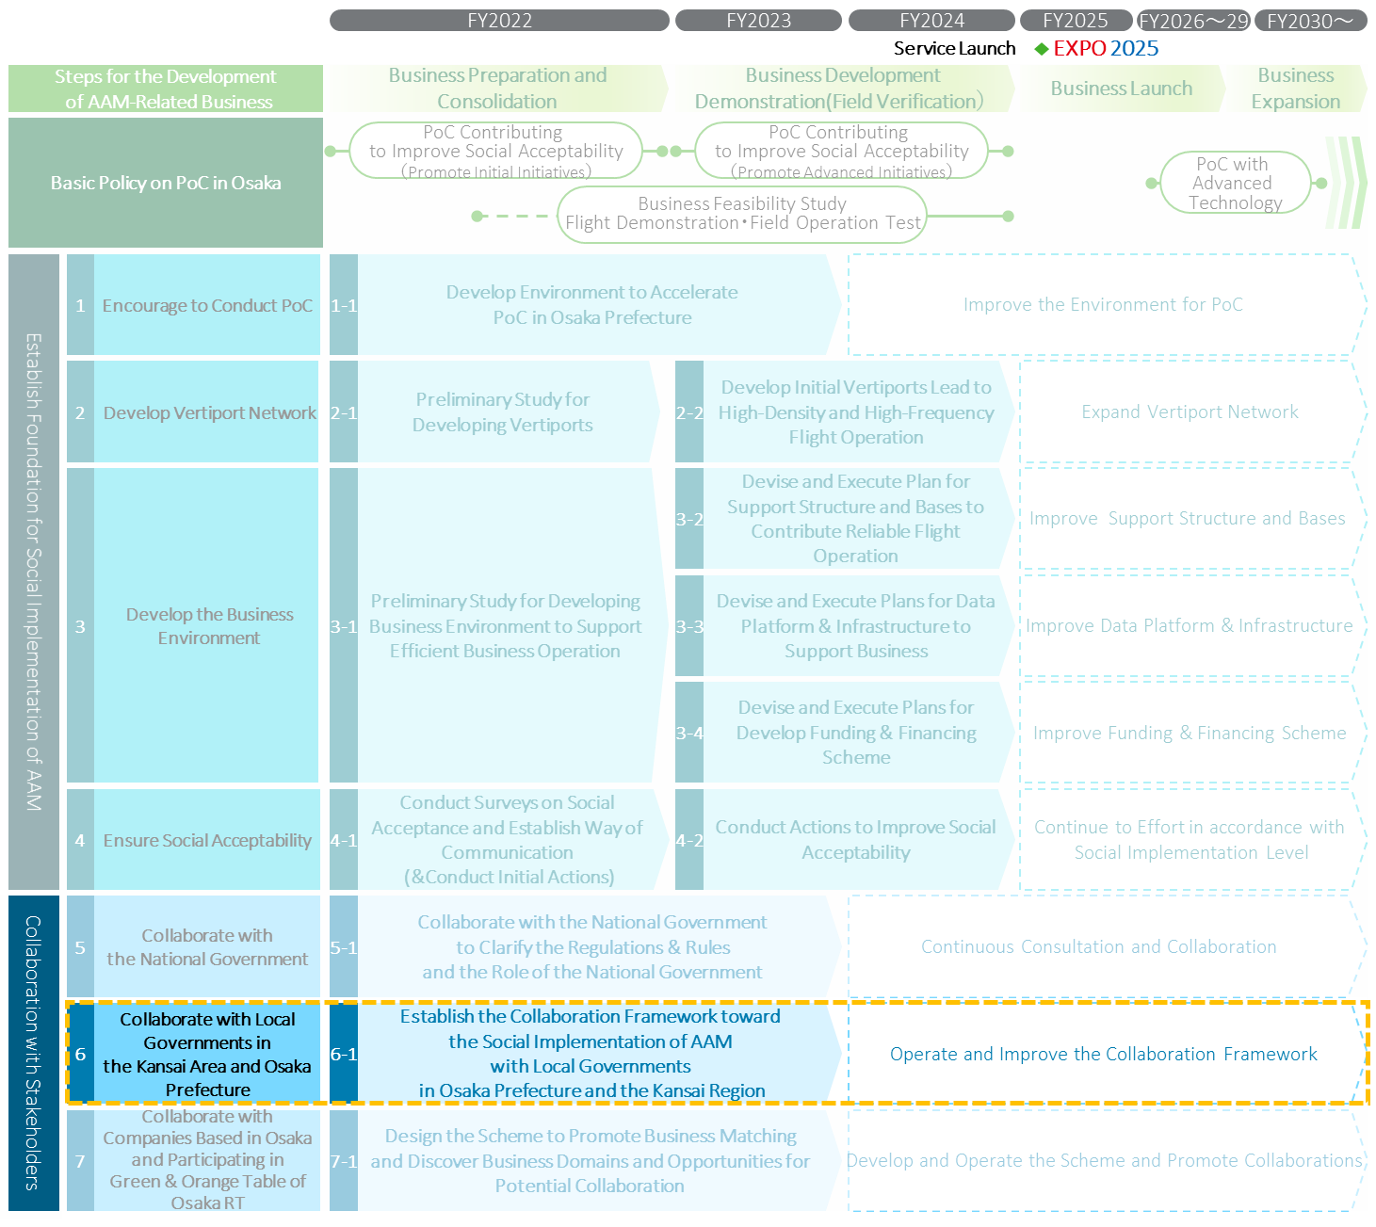

6-1. Establish the Collaboration Framework toward the Social Implementation of AAM
with Local Governments in Osaka Prefecture and the Kansai Region
Timeframe
- FY2022～FY2023
Action Details
- Devise the policy to establish the collaboration framework with local governments in Osaka Prefecture and the Kansai Region such as establishing a conference body within Osaka RT and communication platform using online tools.
- Call for the local governments in Osaka Prefecture and the Kansai Region, regardless of the status of their attempt to promote actions for the social implementation of AAM.
The Example of Items of Corporation
Items of Corporation toward the Social Implementation of AAM
- Sharing information about the PoC.
- Discussion on implementing PoC in the Kansai Region.
- Sharing information about the development of vertiports and flight routes.
- Discussion on optimizing the disposition of vertiports and flight routes from inter-city perspective.
- Discussion on collaborative initiatives to improve social acceptability.
Primary Roles for Each Party
Osaka Prefectural Government | - Osaka Prefectural Government will devise the policy to establish the collaboration framework with local governments in Osaka Prefecture and the Kansai Region.  - Osaka Prefectural Government will call for the local governments in Osaka Prefecture and the Kansai Region, regardless of the status of their attempt to promote actions.
Local Municipalities | - Local municipalities will participate in the collaboration framework in response to the call from Osaka Prefectural Government.
Private Sector | - The Private Sector will support establishing the collaboration framework by providing information about the consideration of their own business.  - The Private Sector will approach the local governments in Osaka Prefecture and the Kansai Region to participate in the collaboration framework.

Collaborate with Companies Based in Osaka and Participating in Green & Orange Table of Osaka RT
- Design the scheme contributing to discover new business domains of potential collaboration and promoting collaboration between companies based in Osaka having advantages in elemental technologies of AAM and domestic and foreign companies to promote the development of AAM-related industry in Osaka Prefecture.
The Approach of Action Plan #7
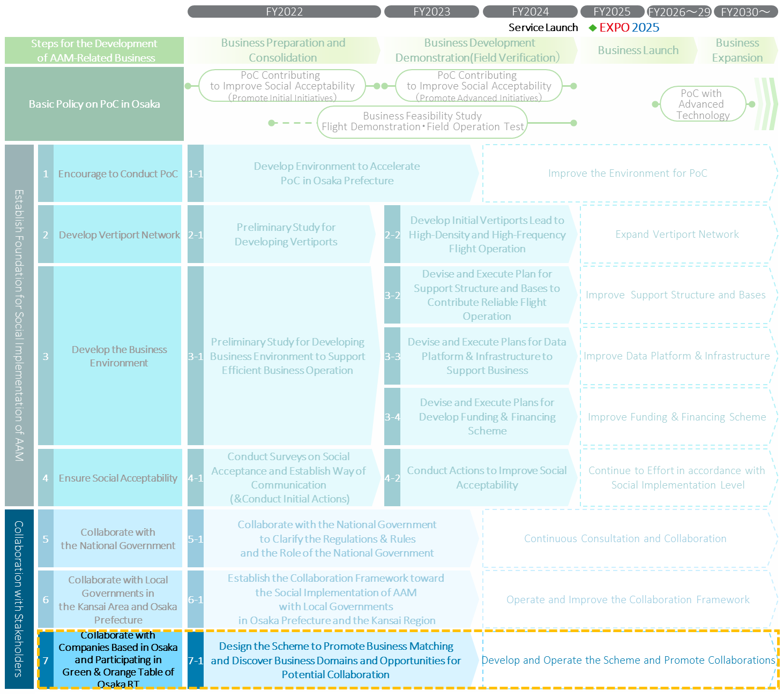

7-1. Design the Scheme to Accelerate Business Matching
Timeframe
- FY2022～FY2023
Action Details
- Conduct a survey to clarify business domains related to AAM with high potentiality for collaboration and consider the business domains which should be promoted collaboration intensively.
- Design the scheme to increase the interest of private sector to enter the business and create opportunities of collaboration among domestic and foreign companies in Osaka Prefecture and the Kansai Region
The Example of Considerations
Business Matching Scheme to Discover New Business Domains and Opportunities for Collaboration
- Domains related AAM with high potentiality for collaboration and consider the business domains in which should be promoted collaboration intensively.
- Potential measures to create opportunities for collaboration.
- Potential measures to increase the interest of private sector to enter the business in Osaka Prefecture and the Kansai Region.
- Scheme to create opportunities for collaboration between the companies which are interested in participating in AAM-related business within Osaka Prefecture and the Kansai Region.
Primary Roles for Each Party
Osaka Prefectural Government | - Osaka Prefectural Government will conduct surveys to clarify the intention of local companies to enter AAM-related business and their technical and business needs and seeds.  - In addition, Osaka Prefectural Government will design business matching scheme to discover new business domains and opportunities for collaboration.
Local Municipalities | - Local municipalities will conduct surveys on the intention of local companies to enter AAM-related business.  - In addition, local municipalities will support the surveys conducted by Osaka Prefectural Government.
Private Sector | - Companies and organizations participating in Osaka RT with the plan to develop AAM-related business in Osaka Prefecture and the Kansai Region will support the surveys conducted by Osaka Prefectural Government regardless of the status of their involvement in aviation- related industries.

