Introducing Osaka – the burgeoning Asian financial hub

We're delighted to announce that we’re working with Osaka Prefecture in Japan to help promote its “Global Financial City OSAKA” initiative.

Famed for its modern architecture, vibrant nightlife, and hearty street food, Osaka is the largest city in western Japan. A familiar name on the Japanese tourist circuit, located in close proximity to Kyoto, Kobe, and Nara – which are home to several World Heritage sites – Osaka is also one of Japan’s most important business hubs, with the region birthing some of the biggest companies in all of Japan – including Panasonic, Suntory, Itochu, Sharp, Takeda, and many more.

The 'Umekita 2nd Project', a new urban development in front of Osaka Station. (Courtesy: Developer of Umekita 2nd Project)

Now, Osaka is looking to boost its presence as a globally competitive financial frontrunner, becoming a ‘global city’ by attracting finance, talent & business from Asia and the rest of the world – and we’re thrilled to be working with them in support of the initiative.

Our work with Osaka

We will be hosting a webinar on the 24th February 2022, joined by many key players from Osaka’s ecosystem such as local agencies and foreign companies which have successfully set up a business in the area.

If you’re interested in learning more about the opportunities available in Osaka, and in joining a friendly Q&A session with a range of panellists who have experience doing business in Osaka, please register for the webinar on the 24th February here, or by clicking on the below image.

Why Osaka needs you

Osaka is proud to be the host city of the 2025 World Expo, centred around the theme of “Designing Future Society for Our Lives”. The event marks the third time Osaka has hosted a global exhibition, having previously hosted the 1970 World Expo and the 1990 Horticultural Expo.

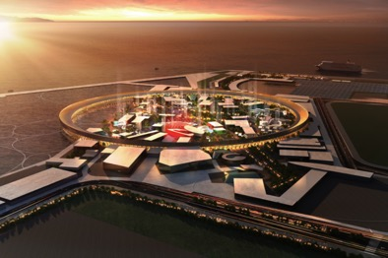
A visualisation of Expo 2025 Osaka. (Courtesy: Japan Association for the 2025 World Exposition)

In anticipation of the estimated 28 million visitors who will attend the event, Osaka has launched a range of initiatives in a consolidated effort to cement Osaka’s position on the global stage. In addition to “Global Financial City OSAKA”, the city has also announced multiple large-scale urban development projects, and has been designated as a “Global Startup City” by the Japanese government.

To fulfil these goals, Osaka is now actively looking to attract foreign companies and startups to the region – and is providing a range of complementary services for any company with an interest in considering the region.

The launch of Osaka’s ‘Global Finance One-Stop Support Center’

On the 15th of December 2021, Osaka officially launched a ‘One-Stop Support Center’ for overseas financial corporations and foreign investors who want to enter Osaka, providing consultation service for specific finance, business, or relocation inquiries.

Specific benefits include information and support on financial-related legal policies and procedures, and introductions to financial experts, financial service agencies, and lawyers – all free of charge.

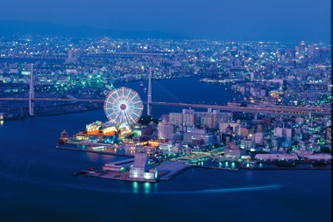
Osaka at night

Other support on offer

In addition to the One-Stop Support Center, Osaka is establishing a wide range of other kinds of support for foreign companies interested in the region (offered by Osaka Business & Investment Center etc):

- Networking with Entrepreneurs, Mentors, Technologies and Companies
- Mega Events such as Hack Osaka, Global Innovation Forum, and pitch events
- Industry & Academia Open Innovation support
- PoC design and Testing system support
- Accelerator Programs
- Startup Visas
- Government Support

Furthermore, Osaka boasts great value for money in comparison with Tokyo, with savings of approximately 38% on office rent, and 13% on labour costs on average.

If your company is interested in doing business in Osaka, or learning more about our upcoming webinar, please do not hesitate to get in touch with the Osaka Global Finance One-Stop Support Center at f-onestop@global-financial-city-osaka.jp.

