宿泊療養されるみなさまへ
To patients receiving treatment at the facility

大阪府
Osaka Prefecture

1 Introduction

For the time being, you will receive medical attention at the accommodation facility.
In order to ensure the safety and security of your stay, we would like to ask for your understanding and cooperation with the information contained herein.
Please do not hesitate to contact us if you have any problems or concerns about your daily routine or your health.
<Contacts>
< Health concerns such as cough and fever consultations (nursing staff)>

TEL：(Internal line)
*You can contact us 24/7. However, as this is a dedicated healthcare consultation service, emergency calls from people whose condition has suddenly changed are also accepted here. Please refrain from contacting this line if your concern is not directly related to your health.

< Consultation regarding daily living problems (hotel staff)>

TEL：(Internal Line)
*Please not that as a general rule, the office is open from to every day.

<IMPORTANT> *In order to prevent the spread of infections, we ask for your strict adherence to these rules.
○Please do not enter any restricted areas.
○You may not exit the building. If you do, the police will be notified.
○However, in the event of a fire or other emergencies, please give priority to your evacuation. (Follow the instructions via the announcements inside the building and evacuate. When evacuating, follow the instructions and do not use elevators).
○After entering your room, first make sure to check and confirm the evacuation routes (at the back of the entrance).
○If you exit the room, please make sure to wear a mask.
○If you need to speak directly to a staff member, please call in advance, as we need to prepare protective clothing, etc.

２ Things that would be useful during your stay
-Extension cord
Because the outlets are positioned high
-Pocket Wi-Fi
Those who will be teleworking or playing online games are strongly recommended
to have one, because Hotel Wi-Fi might be interrupted or delayed.
-Reusable shopping bags
Your meals and drinks will be handed out at a designated place. You can use reusable bags to carry these items to your room.

3. Precautions during your stay
(1) Health status reports (Daily reports, emergencies)
-Perform your self-check three to four times a day every morning, afternoon, evening, and before going to bed, etc., referring to the attached sheet 1.

To those who have been diagnosed with COVID-19 by a doctor
Check your body temperature twice a day, around 8:00 am and 4:00 pm. Input the results into your self-check data record together with your blood oxygen saturation level (SpO2) and your general condition using your smartphone or PC.
*We will explain how to record your data when your stay begins.
Nursing staff will call and ask about each room’s occupant’s condition, starting from those who have had any change in their condition.

To those who have not been diagnosed by a doctor but have had a positive result from a test kit
Check your body temperature twice a day, around 10:00 am and 4:00 pm. Please inform nursing staff of your general condition, including body temperature and SpO2 when they call you.
-Online health consultations and medical exams will be provided as necessary.

-If you have any change in your condition (especially in the case you have a fever), call nursing staff immediately even at night. Be sure to contact a nurse in your hotel, and refrain from calling for an ambulance by yourself.

(2) Other precautions
If you don’t answer the phone or we need to confirm your safety, we may enter your room
without your permission.

-Alcohol drinking and smoking are prohibited throughout the facility (both inside and outside the rooms)

*If you are found smoking within the hotel, you will be charged a cleaning fee.
-It is prohibited to bring alcohol, cigarettes, and any hazardous materials into the hotel.
If you are found having these things, they will be kept at the hotel during your stay.
-Beverages such as water will be delivered.
- Please keep your valuables safe by yourself.

- You can’t meet your family or friends during your stay in the hotel nor receive calls from outside.

-If your condition worsens due to food or drink received from outside, it will be your own responsibility.

-Please note you can’t call outside from your room telephone.

-Hotel staff can’t buy any supplies on behalf of you.

-Refrain from posting the name of your hotel on social media.

Please refrain from taking photos and videos with your smartphone (including the appearance and neighboring view of your hotel).

-When your recuperation period ends, you are to go home by yourself. Please prepare your travel expenses.

(3) Consent form
After confirming this leaflet, please fill out the attached Consent Form with the date, your name, address, and the phone number of your mobile phone.

Please select the dinner you would like during your stay from either the A course or B course.

After filling out the consent form, please bring it to the reception on the first floor. The hotel staff will photograph it.

Please keep the consent form safe until the end of your recuperation period.

If you are under 20 years old, the public health center will explain to your parent or guardian the contents of the consent form and receive their agreement. We will also confirm their contact information as well as yours.

Thank you very much for your cooperation.

(4) Criteria for discharge
- Discharge criteria are the same as those of the national government

-< Symptomatic patients >
If seven days have passed since the onset of symptoms and 24 hours have passed since the symptoms improved, patients will be discharged on the eighth day.

-<Asymptomatic patients>
If seven days have passed since the day when you had a positive test, your isolation will end on the eighth day. If you are confirmed negative by a test kit on the fifth day during your recuperation, your recuperation may be considered finished on the sixth day. *Please note that not all the hotels can provide test kits.

-The final decision is made by the head of the Public Health Center, so please be sure to submit your everyday health condition report.

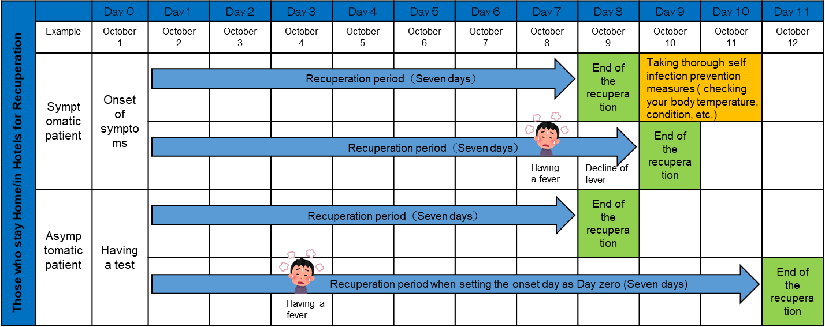
* Please record you everyday health condition.

(5) Medical expenses for COVID-19 during your recuperation
Your medical expenses for COVID-19 during your recuperation are all covered by the government.

(6) Certificates regarding your recuperation
- Certificate of negative PCR test result (Negative Certificate)
The Public Health Center doesn’t issue the Negative Certificate. (You don’t have to submit the Negative Certificate to your company when you resume working.
This policy is shared with each local government by the Ministry of Health, Labor and Welfare

Documents that certify you are or have recuperated at a hotel or at home (Certificates that are used for claiming a hospitalization allowance from a private medical insurance company)
Please ask your insurance company if recuperation at a hotel or your home is eligible for coverage.
The certificate that certifies your recuperation (Recuperation certificate) can be issued for those who were diagnosed by a doctor.

You can receive your Recuperation Certificate using “My HER-SYS” through your smartphone or PC. Those who can’t use “My HER-SYS,” the Public Health Center for your residential area will issue the certificate. Please consult with them.

For those who were not diagnosed by a doctor, a Recuperation Certificate cannot be issued.

To those recovering at the facility
（Attachment１）
-Points to keep in mind during medical treatment for patients with mild cases of the novel coronavirus infection-
We understand that you may have several concerns about your stay, but the health center and facility medical staff will give you support.
The facility medical staff will be contact you daily to check on your well-being and inquire about your condition.
Three or four times a day (morning, afternoon, evening, before going to bed, etc.), you will be asked to perform a self-check to check for any of the symptoms listed below. If you have any symptoms, please contact the accommodation's medical staff immediately. Also, you have to record your temperature and physical condition in your health records via your smartphone or computer twice a day, at 8.00 am and 4.30 pm.
If you notice any symptoms, even if it is not at the time of the self-check, please contact us immediately as urgent action is required.

● Urgent symptoms
Facial expression and appearance | ・Face color has clearly changed  ・Purple lips  ・Unusual or strange appearance
Difficulty breathing etc. | ・Heavy breathing (number of breaths taken increased)  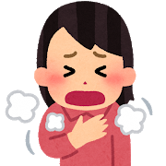  ・Sudden difficulty breathing  ・Difficulty in breathing while doing regular daily activities  ・Chest pain  ・Cannot lie down; Inability to breathe unless sat down  ・Breathing with movement of shoulders  ・Sudden wheezing (whistling sound made while breathing) (approximately within the last 2 hours)
Consciousness disorders | ・Light headed (weak response)  ・Dazed (almost unconscious)  ・Unrhythmic pulse, feeling that the rhythm of your pulse is irregular
April 27th, Reiwa 2 (2020) Ministry of Health, Labor and Welfare Contact Office
“Points to be noted in the health observation of patients with mild cases of the novel coronavirus infection during treatment at the facility and at home”

