Osaka’s Vision for SDGs

Introduction
In 2025, Osaka will host the international exposition “Expo 2025 Osaka, Kansai, Japan” under the theme of “Designing Future Society for Our Lives”. The objective of the exposition is to accelerate initiatives aimed at achieving the United Nations Sustainable Development Goals (SDGs) 2030 agenda.
Osaka’s SDGs vision is that Osaka, as the host of the Expo, will lead the world through advancing SDGs-driven initiatives with a view to promote safe, secure, and sustainable growth, as well as creating the foundation for a comfortable and affluent society for its citizens.

Overview of the Expo 2025 Osaka, Kansai, Japan
Theme:  Designing Future Society for Our Lives  Sub-themes:  - Saving Lives  - Empowering Lives  - Connecting Lives  Concept:  – People’s Living Lab –  A laboratory for a future society | Schedule:  184 days  Sunday, April 13 to Monday, October 13, 2025  Venue:  Yumeshima Island, Osaka  Projected Number of Visitors:  Approx. 28 million

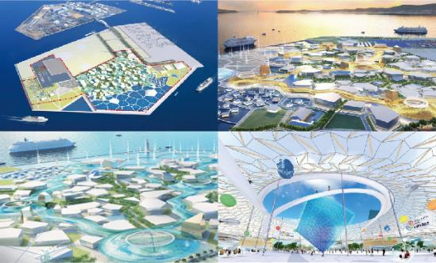
Figure 1: Expo 2025 Venue Concept (Yumeshima Island, Osaka)

Basic Concept

What are “SDGs”?
The Sustainable Development Goals (SDGs) of the 2030 Agenda for Sustainable Development were adopted by world leaders in September 2015 at a historic UN Summit. The 17 goals and 169 targets will stimulate action over the next 15 years to achieve a sustainable, diverse and inclusive society while ensuring that no one is left behind. All countries and all stakeholders, including local governments, are expected to contribute to the realization of the SDGs of the 2030 Agenda.

Basic Policy
In 2025, the “Expo 2025 Osaka, Kansai, Japan” will be held under the theme of “Designing Future Society for Our Lives”. The Expo is designed in a way for anyone around the world to discuss and co-create solutions with others about (1) how individuals can lead a mentally and physically healthy life while fully realizing their potential, and (2) how humankind can build a sustainable socio-economic system to support such diverse ways of life. This is aligned with the United Nation’s SDGs whose ultimate objective is to realize a diverse and inclusive society in a sustainable way backed with the pledge to ensure “no one will be left behind”. As the host of the 2025 Expo, Osaka is expected to become a role model for the world in implementing measures to achieve the SDGs.

Roles of Osaka Prefecture
In April 2018, Osaka Prefecture established the “Osaka SDG Promotion Headquarters”, headed by the Governor, in order to ensure a whole-of-organization approach to implement the 2030 Agenda for Sustainable Development including the SDGs in a comprehensive and effective manner. The roles of Osaka Prefecture have been defined as follows:
- To promote understanding of the SDGs to the involved stakeholders – residents, business entities, municipalities and the like
- To foster partnerships with relevant stakeholders
- To contribute to the SDGs as one of the stakeholders
- To develop a sustainable role model society as the host of the Expo, where the SDGs have already been implemented

Target Year and Strategy of the Vision
We commit ourselves to working tirelessly for the full implementation of this Vison by 2030, the target year for the SDGs.

Building a foundation to become one of the frontrunners on the SDGs (From 2020 to 2025)
- By promoting autonomous actions by all involved stakeholders in Osaka to realize a sustainable society
- By facilitating measures related to Osaka’s SDG Priority Goals (Refer to Section 3.7. for Priority Goals) to be met by solving challenges Osaka currently faces and in which many Osaka residents are interested.

Becoming a frontrunner on the SDGs by further developing the ideas and achievements as the legacy of the Expo. (From 2025 to 2030)
- By accelerating our initiatives and actions towards achieving all of the 17 goals.

SDG Priority Goals towards 2025 Expo

Setting Forth our SDG Priority Goals
We have set forth Osaka’s SDG Priority Goals as our primary challenges based on the following four perspectives:

Perspective A: Objective analysis on the present situation of Osaka
Perspective B: Obtained via surveys conducted in Osaka on the 17 SDGs Goals
Perspective C: Osaka’s potential and each goal’s relevancy to Osaka Prefecture’s policy
Perspective D: Global trends

Perspective A: Objective Analysis of Present Situation
We have analyzed current performance progress of the SDGs in Osaka as well as international assessment of Japan’s progress by utilizing existing indices of the 17 SDGs.

International Assessment of Japan’s Progress
The “Sustainable Development Report 2019” has been published by the Sustainable Development Solutions Network (SDSN) and the Bertelsmann Stiftung. This report presents the SDG Index and Dashboards, which summarizes countries’ current performance and trends on the 17 SDGs. First, we have analyzed Japan’s performance progress towards achievement on each indicator of the SDGs based on the following four categorized criteria in the report 2019.

- A score increases at the rate needed to achieve the SDG by 2030 or performance has already exceeded SDG achievement threshold
- A score increases at a rate above 50% of the required growth rate but below the rate needed to achieve the SDG by 2030
- A score remains stagnant or increases at a rate below 50% of the growth rate needed to achieve the SDG by 2030
- Decreasing score, i.e. country moves in the wrong direction

Domestic Assessment of Osaka’s Progress
The Japan’s “Institute for Building Environment and Energy Conservation (IBEC)” has published the list of localized SDGs’ indicators to make the goals adjustable to the local government level in Japan.
In this Vision, by converting each of these indicators into a scale ranging from 0 (minimum) to 100 (maximum), and we have classified each of the 17 goals into the following four categories, and analyzed domestic assessment of Osaka’s progress.

- 75 or more and 100 or less
- 50 or more but less than 75
- 25 or more but less than 50
- Less than 25

Note: The following indicators are not used for this analysis for the purpose of accuracy:
- Indicators which are susceptible to external factors such as unexpected natural disasters
- Indicators whose significance cannot be determined easily by, for example, amount of budget
- Indicators which do not exist

Brief Summary

Based on the above-mentioned international assessment of Japan’s progress and domestic assessment of Osaka’s progress, the 17 SDGs are divided into following three categories:

Challenging Goals | : Goals which Osaka may face many challenges to achieve
Advantage Goals | : Goals for which Osaka is well prepared with many relevant strengths and advantages
The Other Goals | : Other than the above two goals

Domestic Assessment of Osaka’s progress | higher | Global*: Low, Domestic**: High | Global: High, Domestic: High
 |  | 2 Zero Hunger  7 Affordable and clean energy  10 Reduced Inequality  11 Sustainable Cities and Communities  13 Climate Action  14 Life Below Water  15 Life on Land  17 Partnership for the Goals | 6 Clean Water and Sanitation  8 Decent Work and Economic Growth  9 Industry, Innovation and Infrastructure
 | lower | Global: Low, Domestic: Low | Global: High, Domestic: Low
 |  | 5 Gender Equality  12 Responsible Consumption and Production | 1 No Poverty  3 Good Health and Well-being  4 Quality Education  16 Peace, Justice and Strong Institution
 |  | lower | higher
 |  | International Assessment of Japan’s Progress

Note* : Global (international assessment on the SDGs progress in Japan)
Note** : Domestic (domestic assessment on the SDGs progress in Osaka)

Challenging Goals:  Goal 1 No Poverty  Goal 3 Good Health and Well-being  Goal 4 Quality Education  Goal 12 Responsible Consumption and Production  Goal 16 Peace, Justice and Strong Institution | Advantage Goals:  Goal 8 Decent Work and Economic Growth  Goal 9 Industry, Innovation and Infrastructure  Goal 11 Sustainable Cities and Communities

Figure 2: Details of Objective Analysis on the Current Performance Progress in Osaka

This objective analysis method for evaluating the current progress on the SDGs in Osaka was highly recognized and awarded with the “Japan SDGs Award” by the Japanese government.

<Japan SDGs Award>

The Japanese government established the SDGs Promotion Headquarters in May 2016, headed by the Prime Minister, to ensure a whole-of-government approach to implement the 2030 Agenda in a comprehensive and effective manner and to work on the SDGs Implementation Guiding Principles.

At the Third SDGs Promotion Headquarters meeting in June 2017, the Japan SDGs Award was established in an attempt to promote a wide range of actions for sustainable development. This initiative is expected to lead to the accomplishment of the SDGs. The organizations eligible for the awards are selected from companies, local governments, and NGOs/NPOs that are making outstanding efforts on sustainable development. The SDGs Promotion Headquarters determines award winners based on the opinions of a wide-range of stakeholders who have expertise in the SDGs.

In December 2019, Osaka was awarded the Deputy-Chief’s Award (by the chief cabinet secretary) in the 3rd Japan SDGs award for our efforts to analyze the SDGs progress in Osaka.

Perspective B: Subjective Survey of 17 Goals in Osaka
We have conducted surveys to find out which goals are considered most important among people and businesses in Osaka.

Overview of Survey
Table 1 below shows the details of our surveys.

 | Survey 1 | Survey 2 | Survey 3
Respondents  to Surveys | Osaka residents | Students in Osaka | Business entities  in Osaka
Number of Samples | 1,000  (ages from 18 to 90) | 273  (ages from 18 to 30) | 135 entities  (of which 68 are headquartered in Osaka)
Survey Date | October 29, 2019 | From October 21  to November 19, 2019 | November 18, 2019
Survey Method | Online questionnaires | Questionnaires in classes or seminars | Questionnaires in the seminar “Kansai SDGs Forum”
Table 1: Surveys Conducted in Osaka

Survey Results
The survey results are shown in Figures 3, 4 and 5. According to the results, Goal 3: Good Health and Well-Being and Goal 11: Sustainable Cities and Communities are considered to be highly supported, with much interest among all respondents in Osaka.

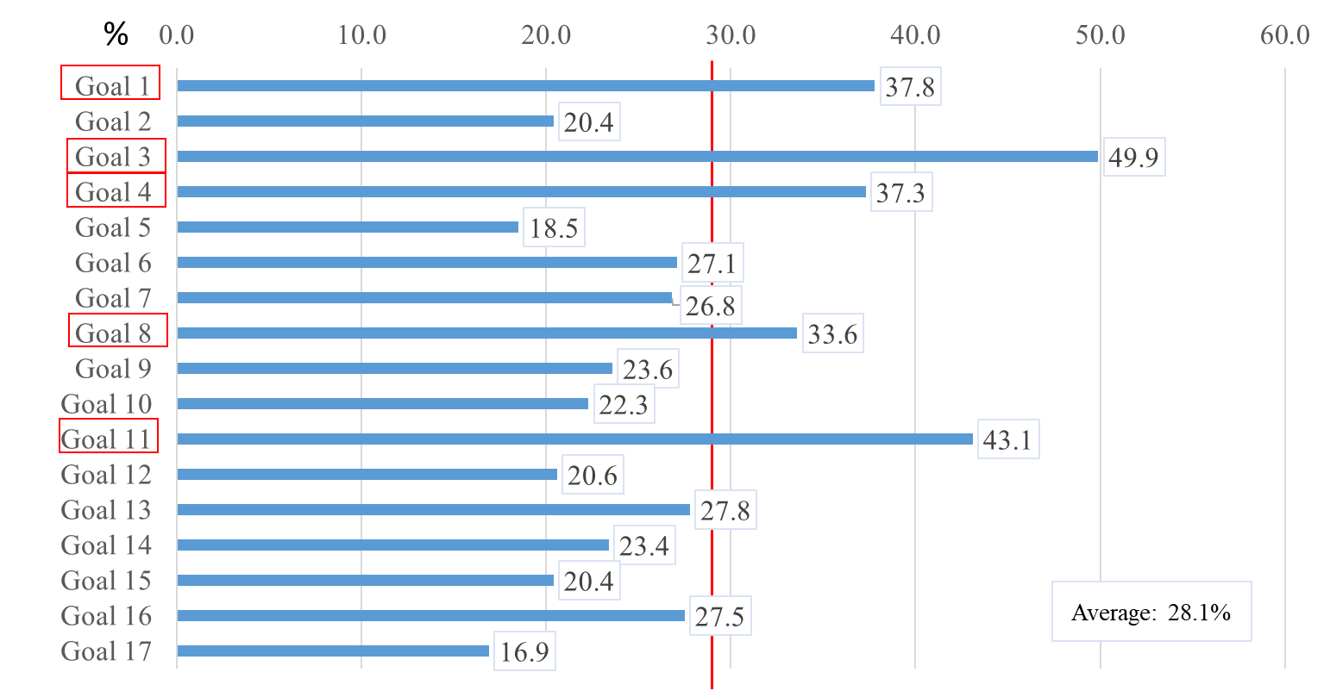
Figure 3 Survey 1 for Osaka Residents

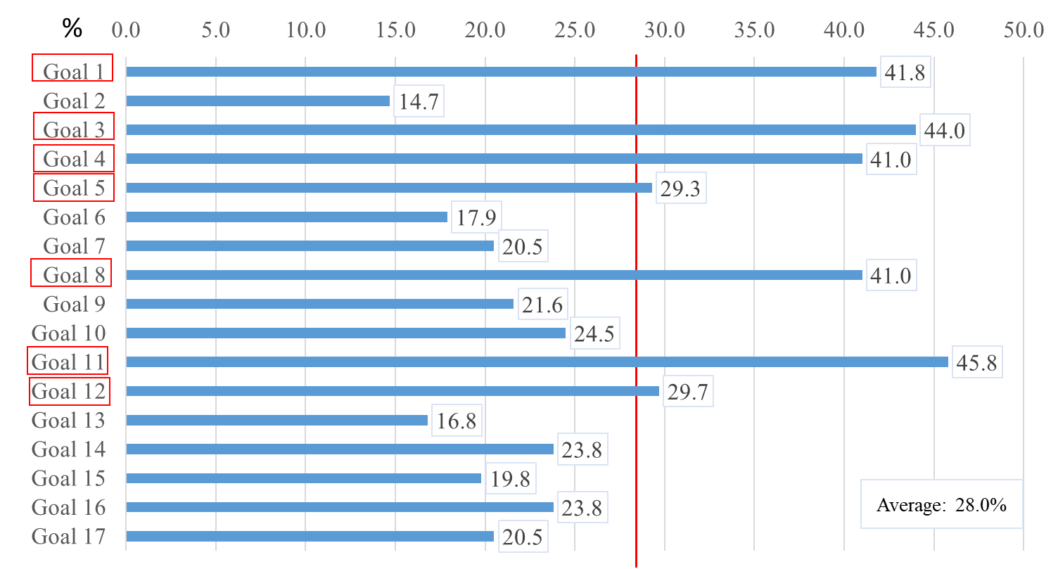
Figure 4 Survey 2 for Students in Osaka

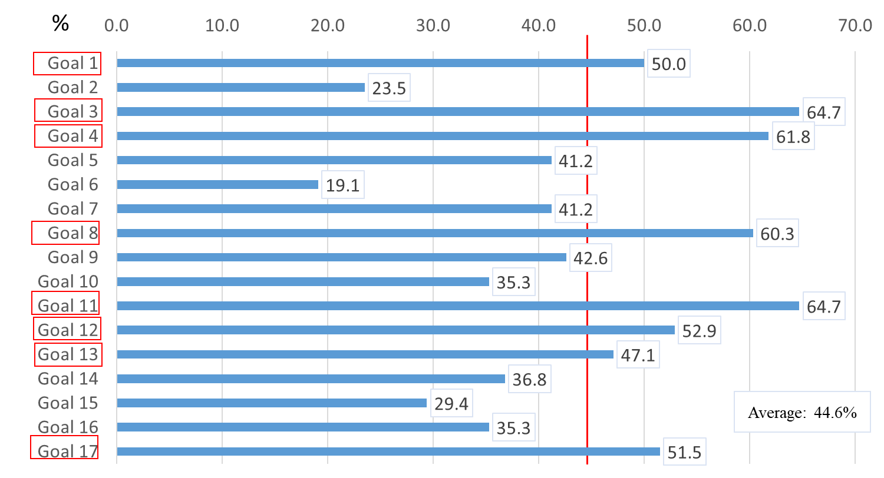
Figure 5 Survey 3 for Business Entities in Osaka

Materiality Analysis

Overview
We also conducted a materiality analysis using the results from the Perspective A analysis where we categorize the 17 goals into Challenging Goals, Advantage Goals and Other Goals and the results from the Perspective B analysis to know the degree of interest in each goal among people in Osaka.
The results of Perspective A analysis are shown on the X (horizontal) axis and the Perspective B results are shown on the Y (vertical) axis as shown in Figure 6 to identify the most relevant goals for Osaka.

Summary of the Analysis
The analysis results suggest that the following two goals are suitable to be set as our SDGs Priority Goals.
Goal 3 : Good Health and Well-being
Goal 11 : Sustainable Cities and Communities
The results also imply that Goals 1: No Poverty, 4: Quality Education, and 12: Responsible Consumption and Production are important and not less significant for Osaka to addresses.

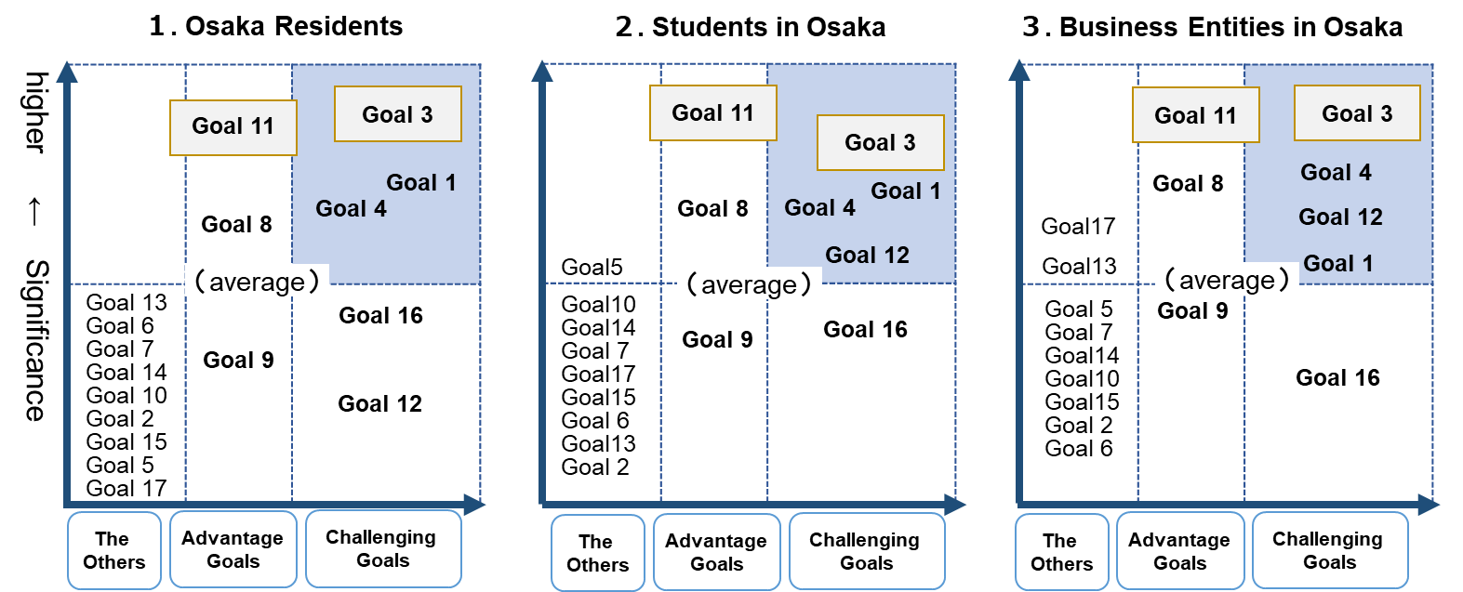

Figure 6: Results of Materiality Analysis

Perspective C: Osaka’s Potential and Each Goal’s Relevancy to our Policy

Osaka’s Potential
Ever since ancient times when it was known as “Naniwatsu”, or the port of Osaka (at around 7th century A.D.), Osaka has served as a point of contact with foreign envoys and has flourished as a key region for both internal and international affairs and as a gateway for international exchanges with Asia and the western world.
Osaka has received people and goods from in and out of the country, which allowed it to acquire various knowledge and technology (from other places). Today, Kansai International Airport, Osaka International Airport, Osaka Port and Sakai-Senboku Port provide gateways to the world.
Osaka has been famous for its medical and pharmaceutical industry. Through industry-academia cooperation, Osaka is currently promoting medical and healthcare activities aiming at practical application and commercialization of regenerative medicine and innovative pharmaceuticals developed by world leading research institutes in Osaka. Osaka also focuses on promoting development of medical devices and creating new healthcare related industries by utilizing our manufacturing strengths. These efforts and approaches have resulted in forming a world-leading life science cluster composed of a variety of health and medical facilities in Osaka.
While pursuing economic profits and valuing wealth, the people of Osaka have also embraced the value of “Sampo Yoshi” or “Three-Way-Satisfaction” meaning that business should not only benefit sellers, but also buyers and society as a whole respecting a spirit of social contribution. “Sampo Yoshi” is a business principle of merchants from Omi region (present-day Shiga Prefecture in the Kansai region) handed down to the people of Osaka.
Osaka is also renowned for its entrepreneurial spirit. It was the site of the world's first futures market in the 18th century and became an innovation and manufacturing giant providing new social systems, industries, and innovative products like instant noodles which now serve as global standards.

Osaka Prefecture’s Policy
The SDGs are highly associated with the theme of the Expo 2025 Osaka and the G20 Summit meeting held in Osaka in 2019. The strong relationships between the SDGs and our mid and long-term policies (“Future Society for Our Lives Vision”, “Growth Strategy of Osaka”, and “Annual Basic Policy of Osaka”) have also been taken into consideration when creating the Vision.

Perspective D: Global Trends (in achieving the goals)

Various stakeholders in countries and municipalities are making efforts to help achieve the SDGs.
In the Sustainable Development Report 2019, the countries which generally receive higher scores also receive higher scores in such goals like Goal 5: Gender Equality and Goal 10: Reduced Inequality.
In the subjective survey mentioned above in Section 3.3., the people of Osaka, especially young people, regard Goal 5: Gender Equality as one of the most important goals.

Osaka’s SDG Priority Goals towards 2025
Considering the analysis results of the above-mentioned four Perspectives, we have chosen Goal 3: Good Health and Well-being as one of our SDG Priority Goals, which is deeply associated with the theme of the Expo 2025, “Designing Future Society for Our Lives”.
We also recognize the following three goals related to Goal 3 as important challenges to tackle.
Goal 1 : No Poverty
Goal 4 : Quality Education
Goal 12 : Responsible Consumption and Production
We have also chosen “Goal 11: Sustainable Cities and Communities” as another Priority Goal aiming at sustainable development of Osaka since this Goal encompasses all challenges related to the other goals. In order to achieve our Priority Goals, we will fully utilize our strengths such as advanced industries, talented human resources, and innovative technologies and services we can offer. We will also continue to work on other global challenges including gender equality, human rights and climate change as shown in Figure 7 below.

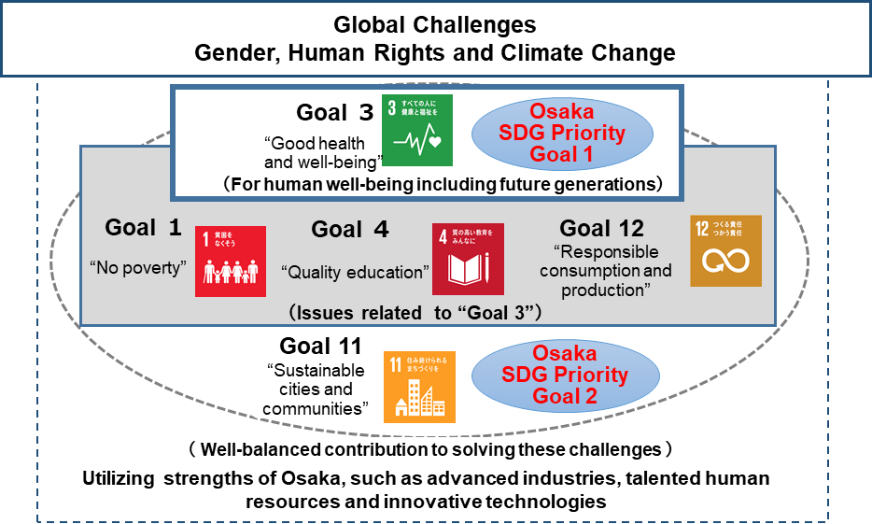

Figure7: SDG Priority Goals and Other Goals

Taking the Lead to Contribute to the SDGs Achievement
In order to become one of the leading regions in achieving the SDGs, this Vision is expected to raise people’s awareness and encourage change in their behavior with regard to the SDGs. We will continue to encourage all stakeholders including local governments, businesses and all individuals to take concrete actions and promote collaboration among them by utilizing every possible opportunity including the Expo 2025.
Through our ambitious initiatives toward 2030, the target year of SDGs, Osaka will take the lead to contribute to the achievement of the Sustainable Development Goals (SDGs).

Published in March, 2020

Planning Office,
Department of Policy and Planning,
Osaka Prefectural Government

