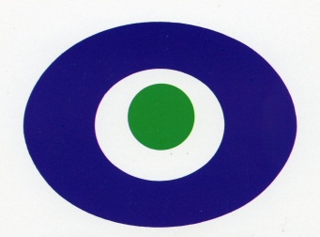
Questionnaire
Citizenship: ____________________ Age: ________

- How did you find out about Peace Osaka?
□ 1. Walking by
□ 2. Study tour
□ 3. Osaka (limited or unlimited) Pass
□ 4. Friend, Family or acquaintance
□ 5. Guide book or map
□ 6. Internet ( )
□ 7. Tourist center or Travel agent
□ 8. Others (How? )

- How many times have you visited Peace
Osaka?

□ 1. This is my First time □ 2. This is my Second time
□ 3. I have visited more than twice

- Which exhibition room(s) impressed you most?
□ 1. Exhibition A (on Floor 2) □ 2. Exhibition B (on Floor 2)
□ 3. Exhibition C (on Floor 2) □ 4. Exhibition D (on Floor 1)
□ 5. Exhibition E (on Floor 3) □ 6. Exhibition F (on Floor 3)
□ 7. Special Exhibition (on Floor 1)

- Evaluation of Peace Osaka
□ 1. Very good □ 2. Good □ 3. Poor □ 4. Very poor

- Comments, if any

※Your comments might be made public. Please understand this.
Thank you.

