Orientation for First-Year Students

A Multilingual Guide to High School Life

(Interpreter available)

Congratulations on your high school acceptance.

We will talk about important topics on high school life in Japan, such as “school rules”, “post-graduation pathways”, and “tuition fees”. Additionally, you’ll get the change to listen to alumni share their experiences. We’ll also assist you in filling out the necessary paperwork for high school enrollment. We kindly ask that your guardian accompanies you.

To join us, please sign up via the high school you’ve been accepted into.

【Date & Time】March 23, 2024(Saturday) 13:00〜15:30

【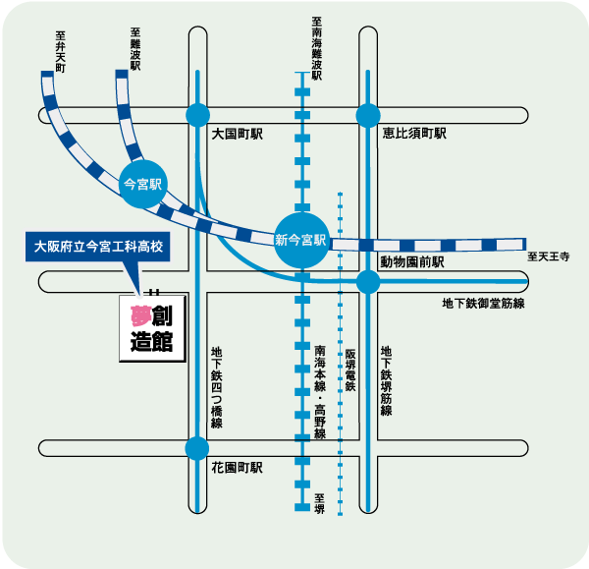Location】Osaka Prefectural Imamiya Technical High School

【Access】400meters west from Shin-Imamiya station



★Please use public transportation.

Do not come by car.

Part I:13:00〜14:30 About school life and school expenses. Alumni share their experiences.

Part II:14:45〜15;30 Creation of enrollment documents(participation for Part II only is acceptable)